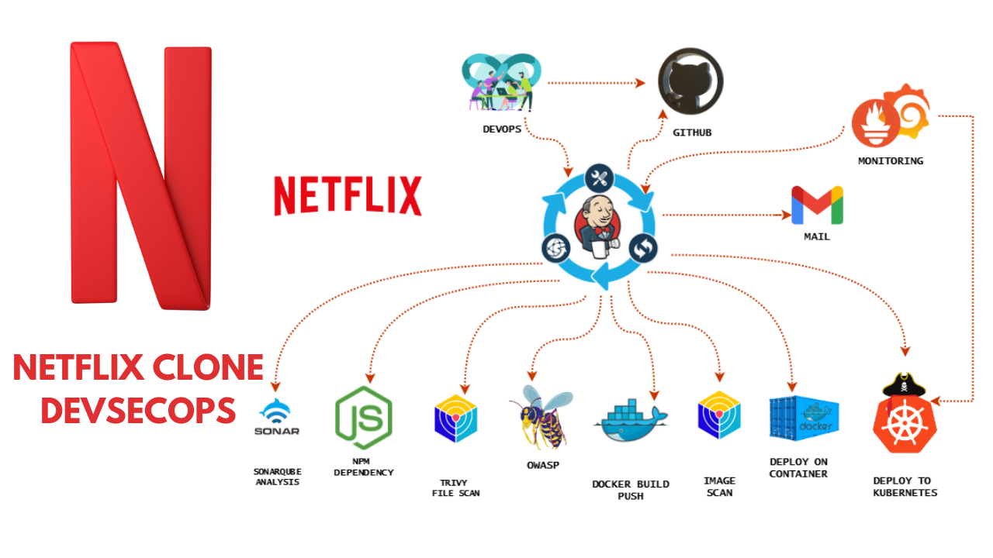

# Netflix Clone CI-CD with Monitoring | Email | DevSecOps

We will be deploying a Netflix clone. We will be using Jenkins as a CICD tool and deploying our application on a Docker container and Kubernetes Cluster and we will monitor the Jenkins and Kubernetes metrics using Grafana , Prometheus and Node exporter. I Hope this detailed blog is useful.

## **STEP1:Launch an Ubuntu(22.04) T2 Large Instance**

Launch an AWS T2 Large Instance. Use the image as Ubuntu. You can create a new key pair or use an existing one. Enable HTTP and HTTPS settings in the Security Group and open all ports (not best case to open all ports but just for learning purposes it’s okay).

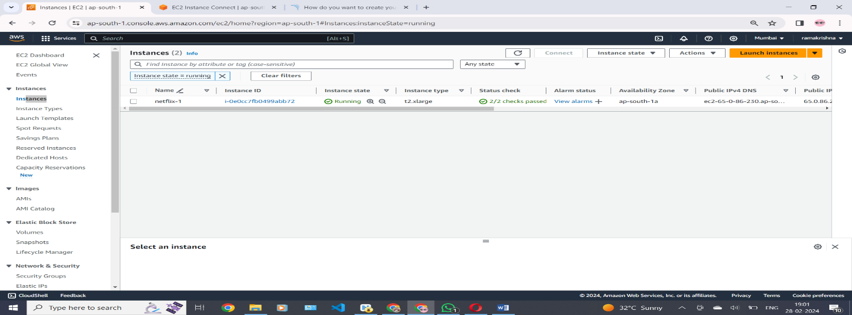

Install maven for the automate build,test ,validate and package .

**# apt install maven –y**

Install java version

**# apt install default-jdk –y**

## **Step 2 — Install Jenkins**

To install Jenkins use this bellow links . which are taken from jenkins.io official website of Jenkins

|  |
| --- |
| sudo wget -O /usr/share/keyrings/jenkins-keyring.asc \  https://pkg.jenkins.io/debian-stable/jenkins.io-2023.key  echo deb [signed-by=/usr/share/keyrings/jenkins-keyring.asc] \  https://pkg.jenkins.io/debian-stable binary/ | sudo tee \  /etc/apt/sources.list.d/jenkins.list > /dev/null    sudo apt-get update  sudo apt-get install fontconfig openjdk-17-jre  sudo apt-get install jenkins |

Jenkins installed in this bellow picture

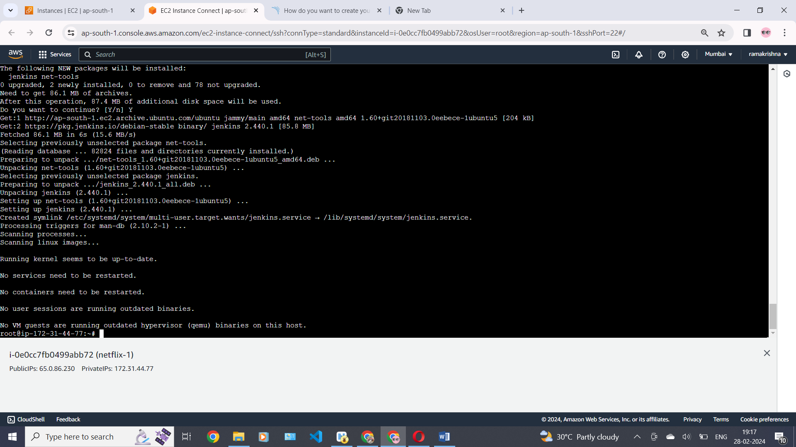

Once Jenkins is installed, you will need to go to your AWS EC2 Security Group and open Inbound port 8080, since Jenkins works on Port 8080.Now, grab your Public IP Address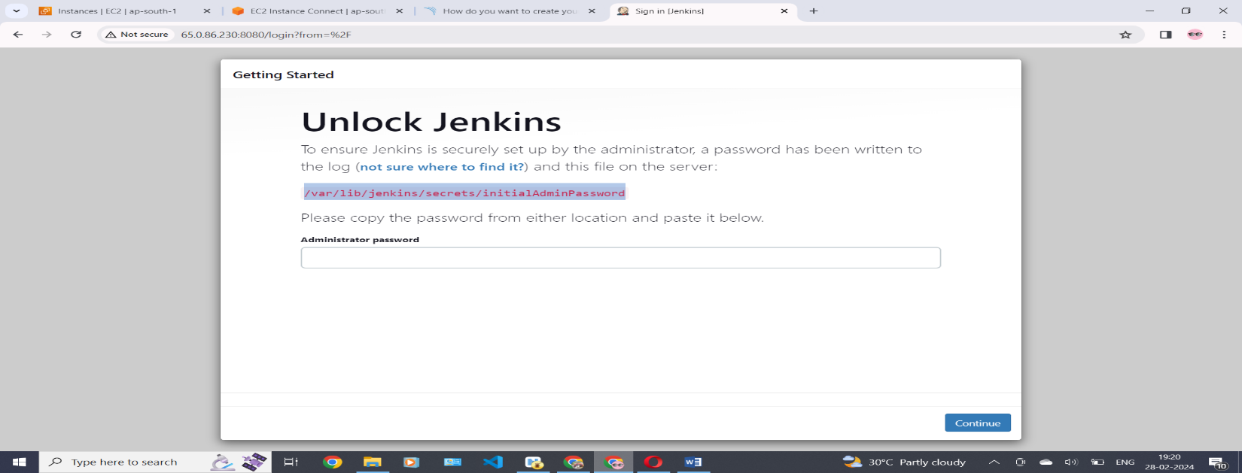

Copy this path to get administrator password for this jekins server . and paste in your aws console by using this bellow command

#cat <paste that path >

Now we will get that password. copy that password and past at this bellow picture . and click on continue .

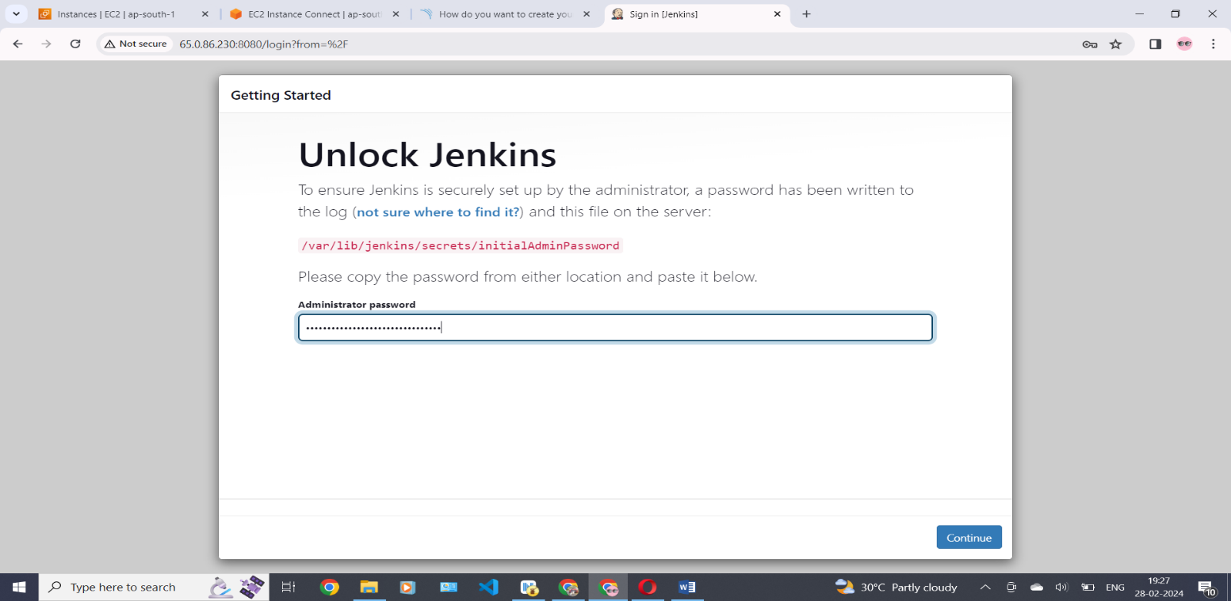

Click installed plugins .It will automatically installed for the Jenkins community.

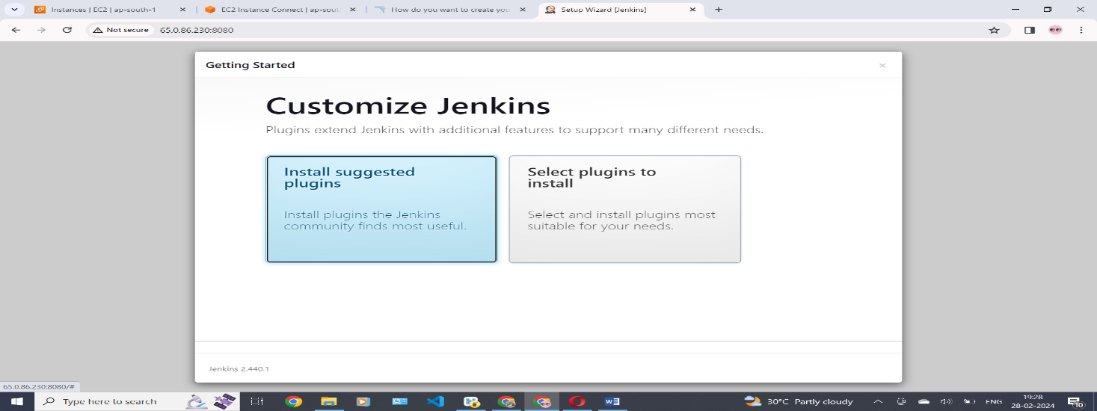  
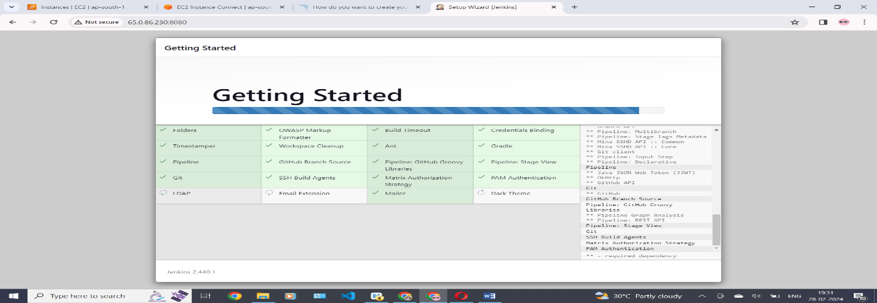

Create your name and password and login with your email id for jenkins server .In this bellow picture

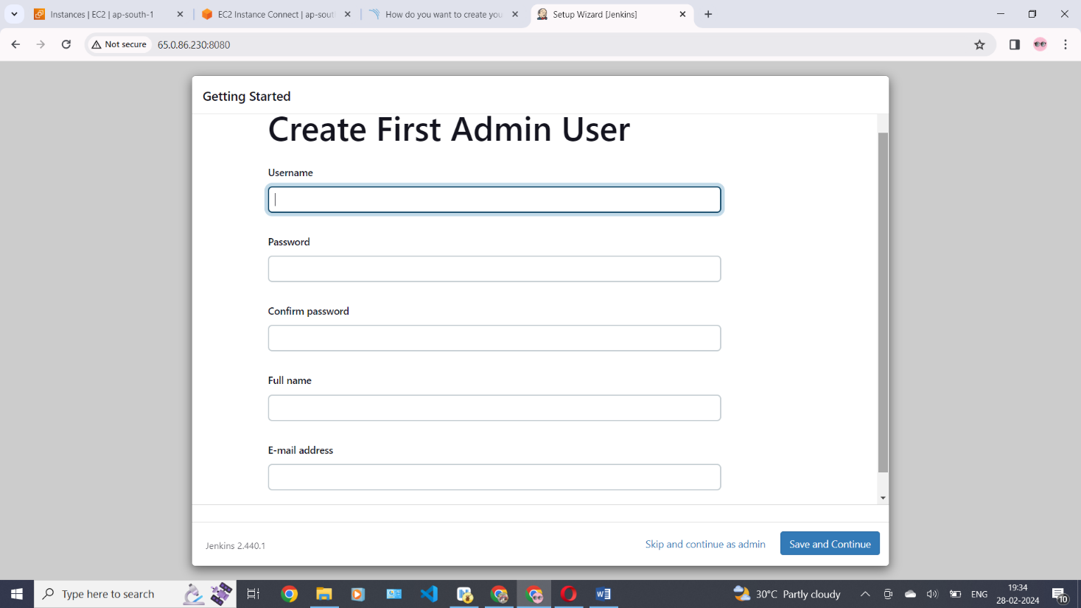

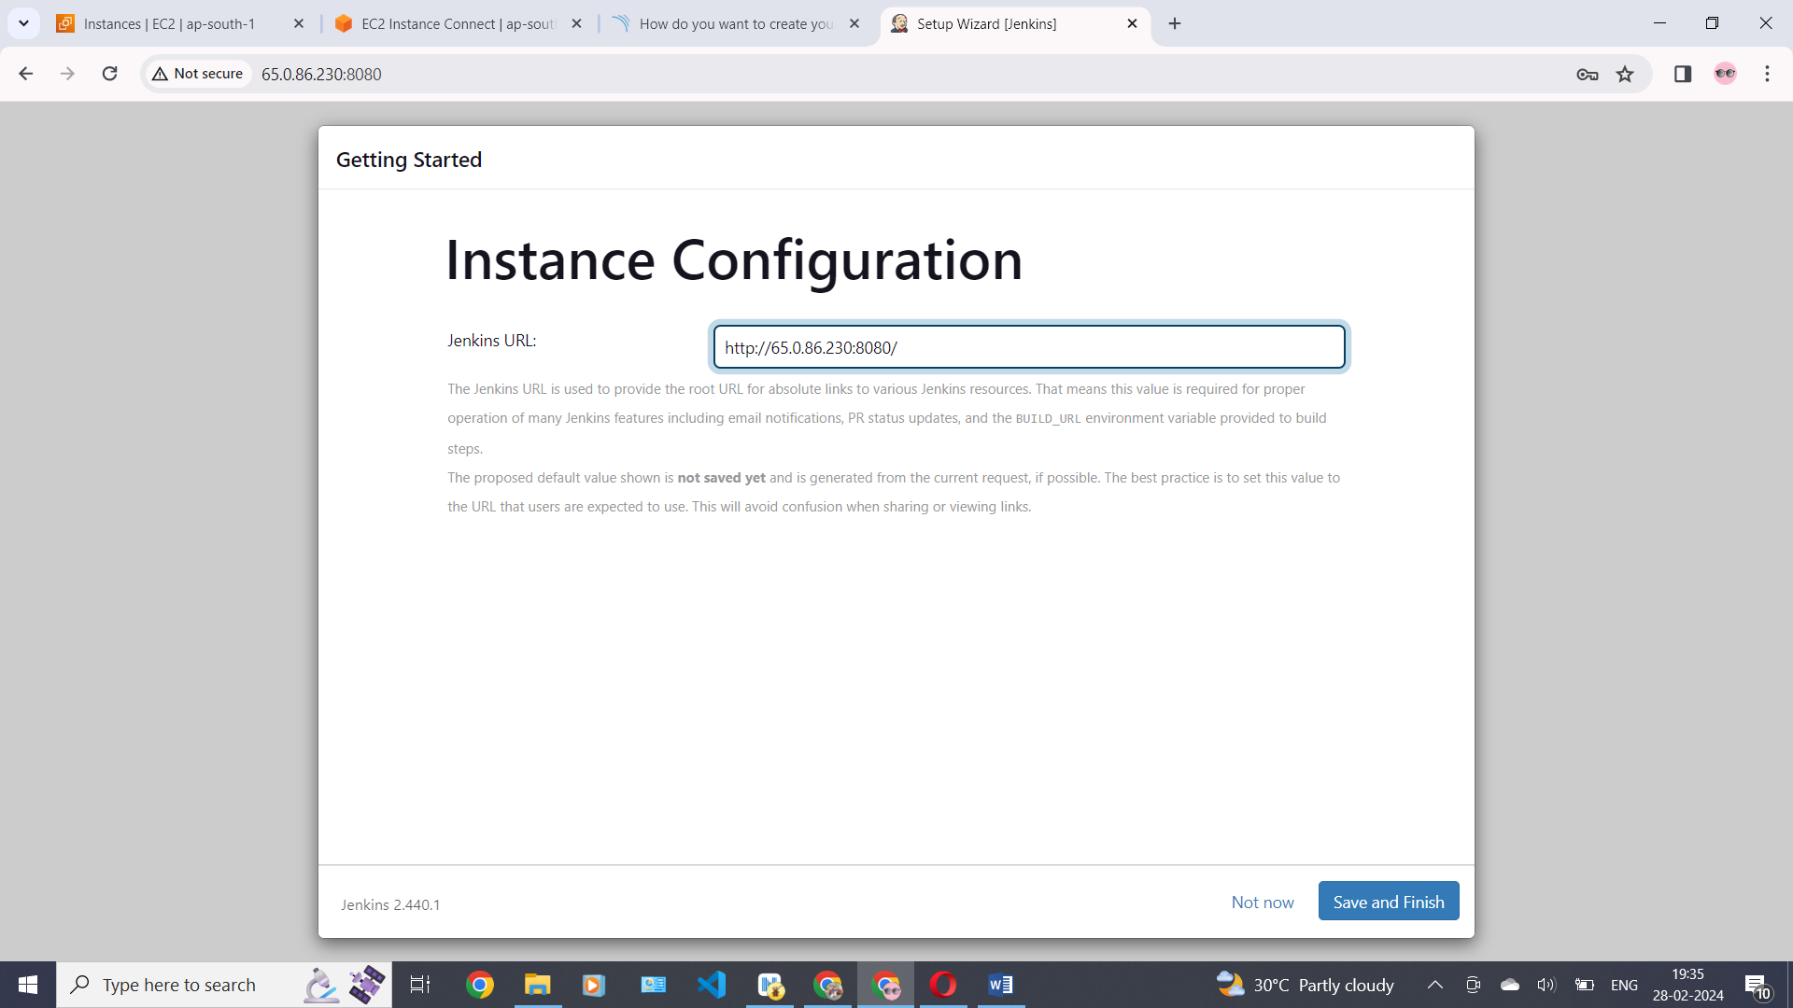

Now we can see the jenkins dashboard .

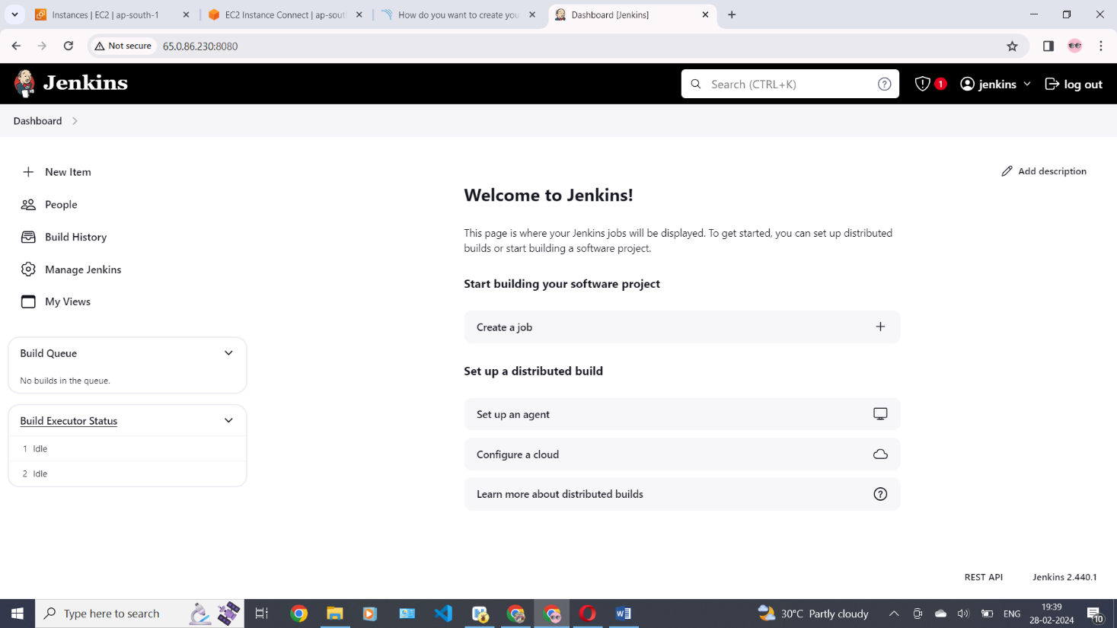

Install Docker and Run Sonarqube Container

|  |
| --- |
| **#sudo apt-get update**  **#sudo apt install docker.io -y**  **#sudo usermod -aG docker ubuntu**  **#newgrp docker**  **#sudo chmod 777 /var/run/docker.sock**  **Install sonarqube through the docker by using this command**  **#docker pull sonarqube:latest**  **# docker run –name sonar –d –p 9000:9000 sonarqube:latest -y** |

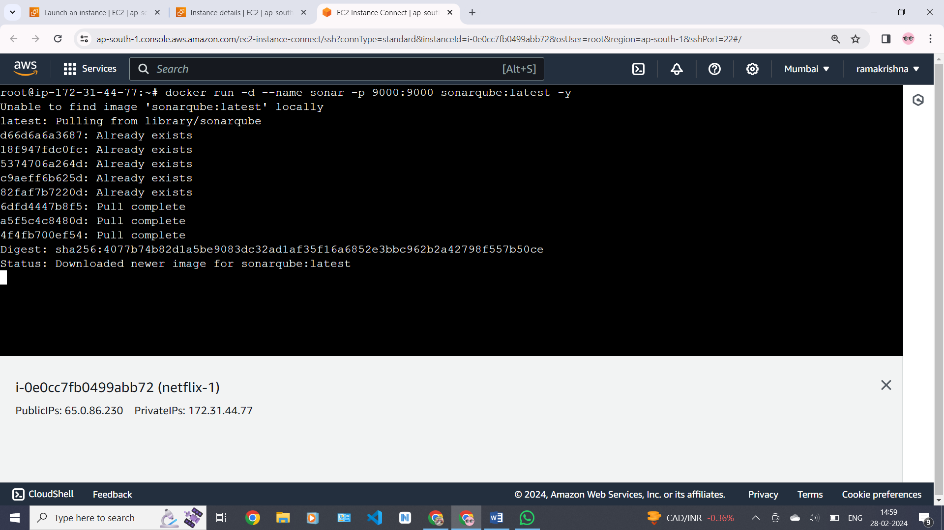

Start the sonar by using this command **# docker start sonar**

Now copy the ip- address and connect with port number of sonarqube “9000 “.

Login with default username= “admin” and password = “admin” in this bellow image

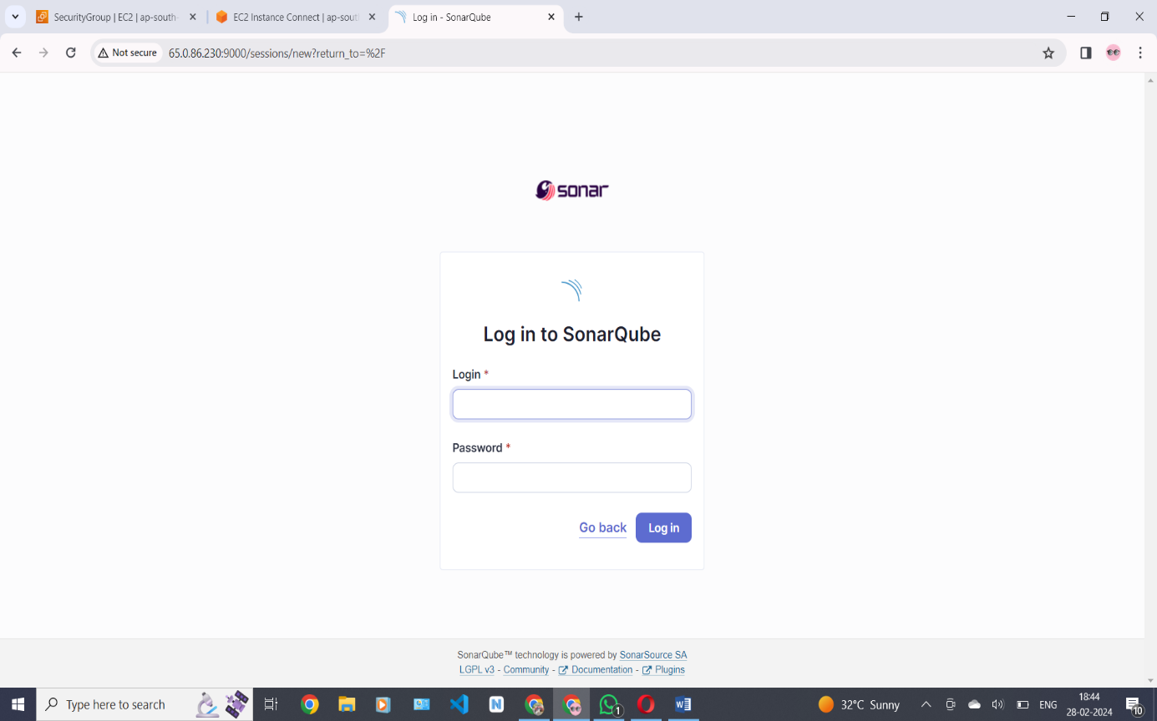

Now make your new password to the sonarqube as you wish . in this bellow image.

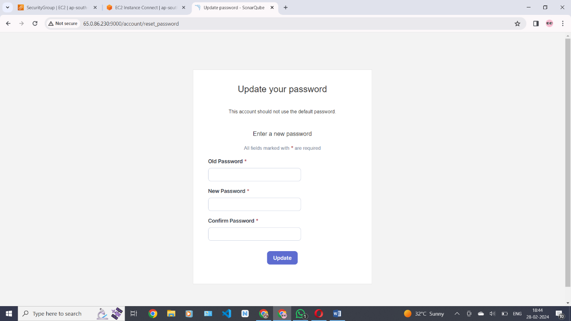

Now this is our sonarqube server desktop here in this bellow picture .

Click on projects and go down click on create a local project

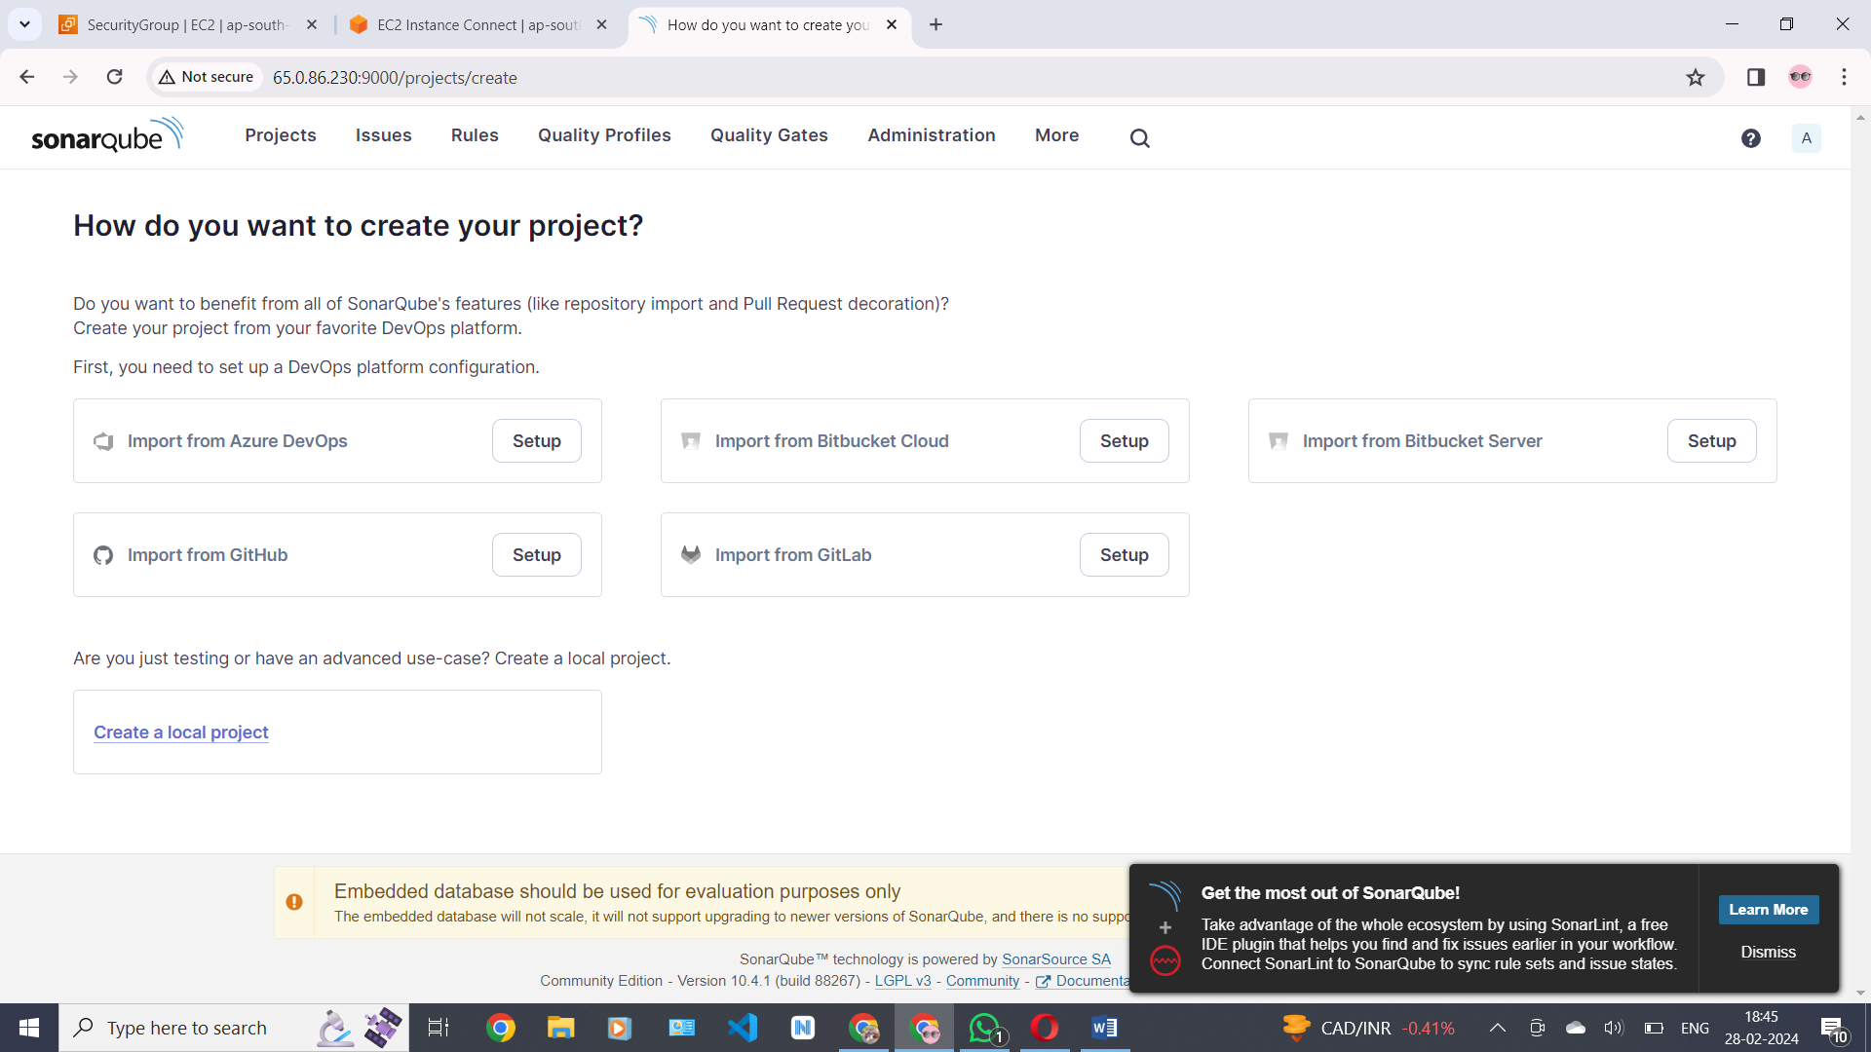

create new project with project name .

Here project name and project key both are same . click on next

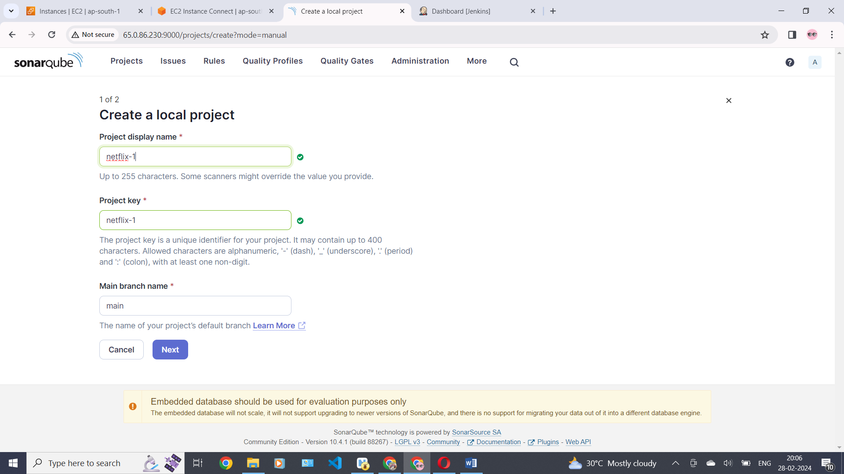

Select the user global setting and click on create project .

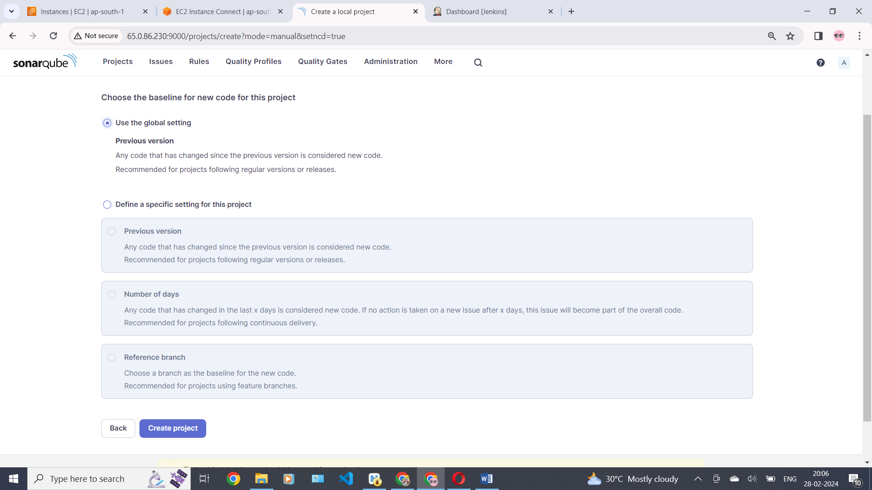

New project was created successfully with given project name in this bellow picture

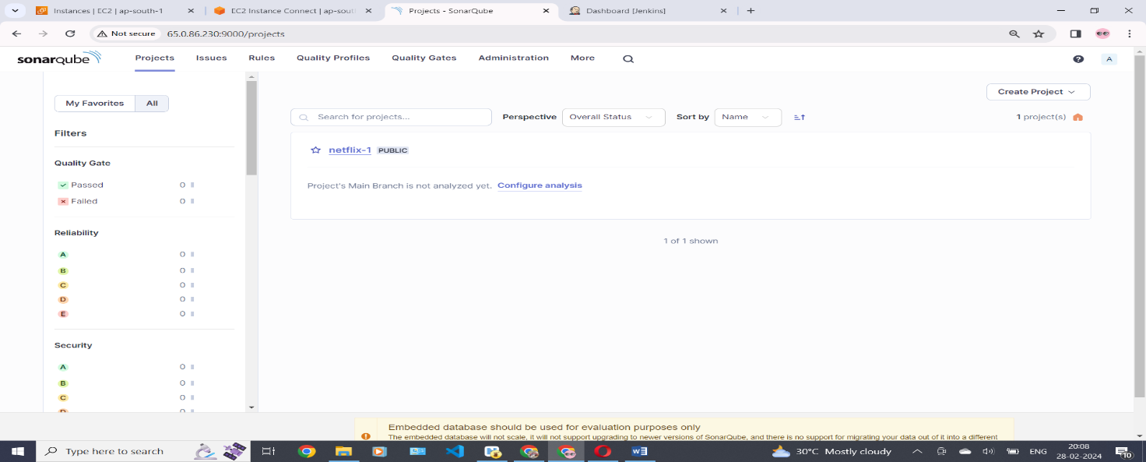

Now click on administration

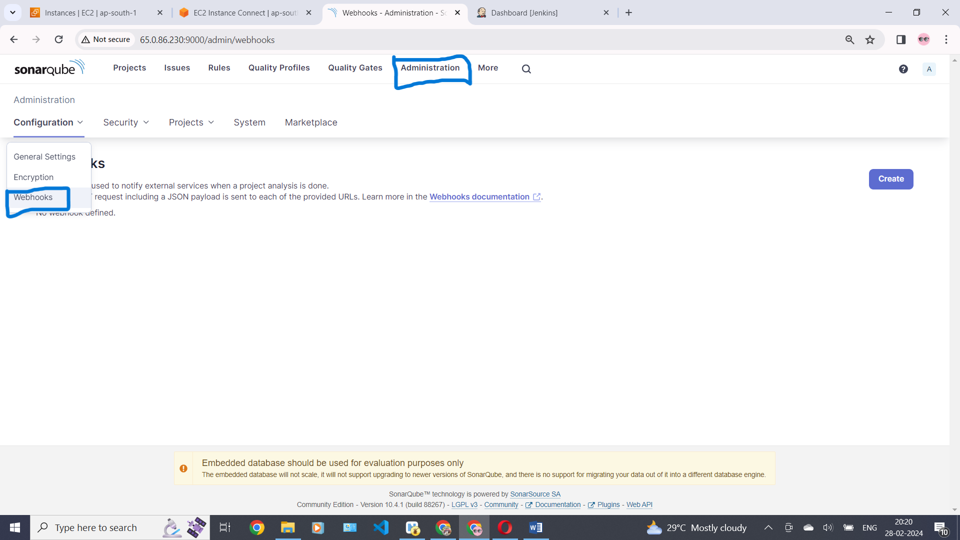

**Webhooks**

Webhooks are used to notify external services when a project analysis is done.

The Webhook administration console shows the result and timestamp of the most recent delivery of each webhook with the payload available via the list icon. Results and payloads of earlier deliveries are available from the tools menu to the right of each webhook.

Response records are purged after 30 days.

Give the name and . past jenkins URL /Sonarqube-Webhook/ click on create

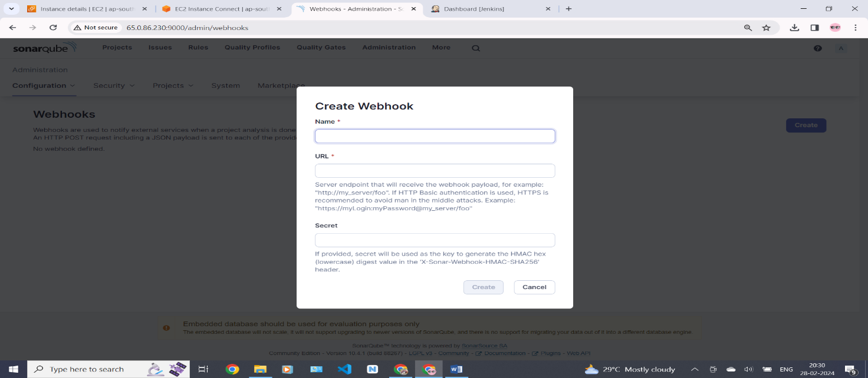

Select security and click on users click on create to create user.

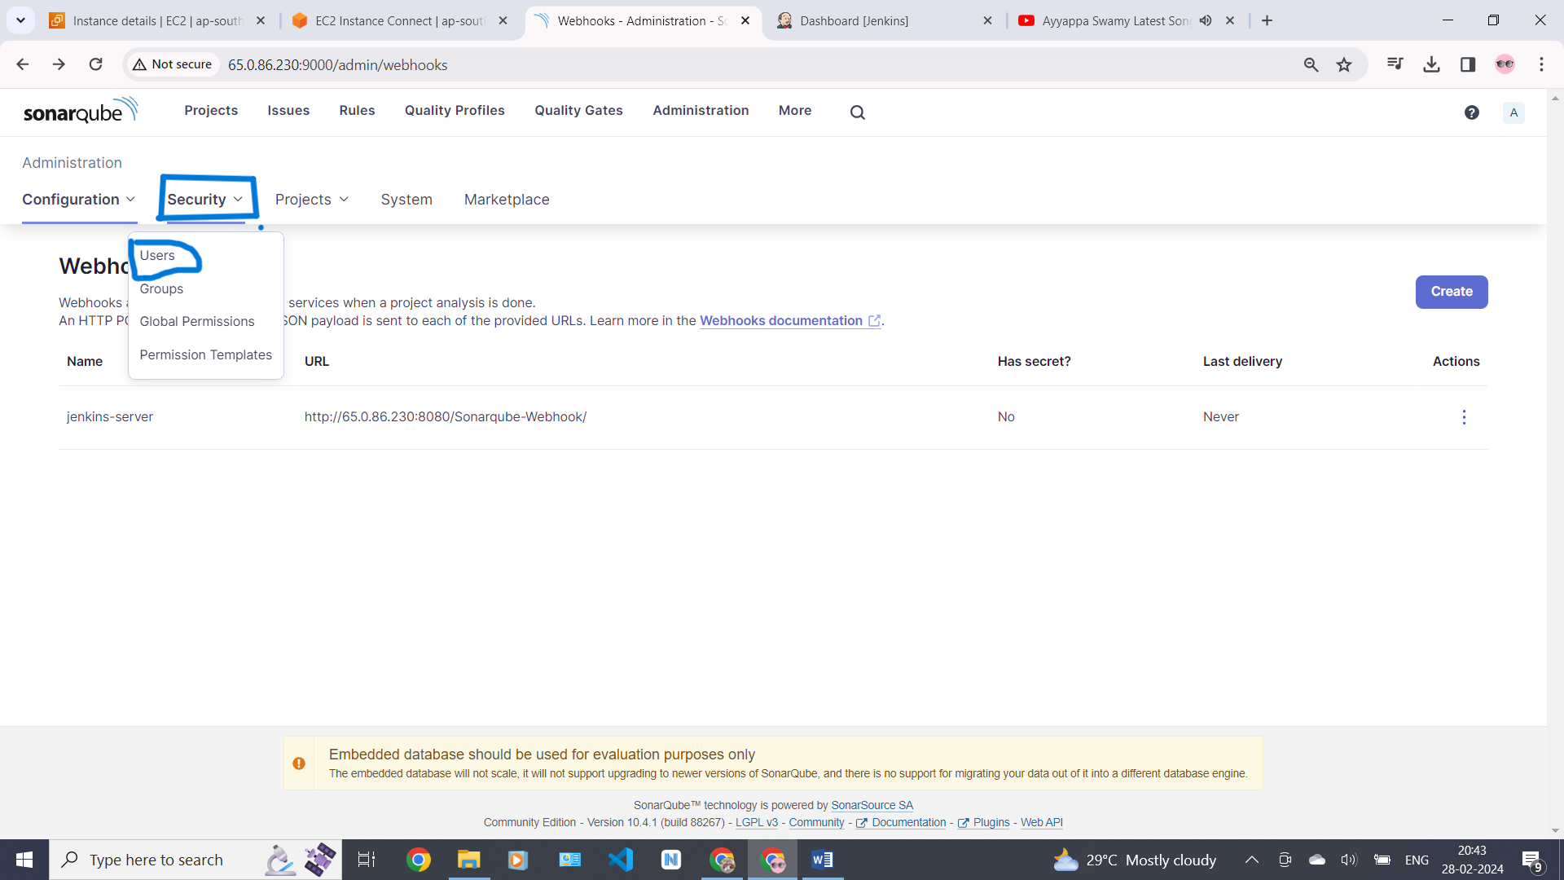

Click on tockens create tocken and then we will get tocken .

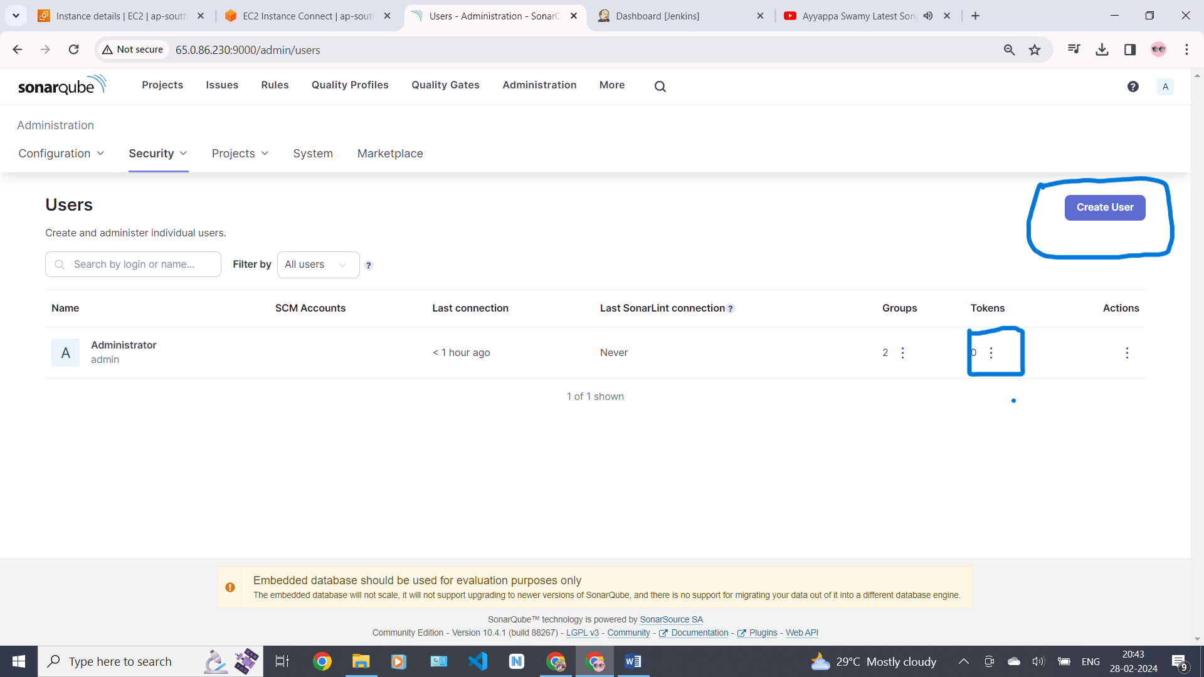

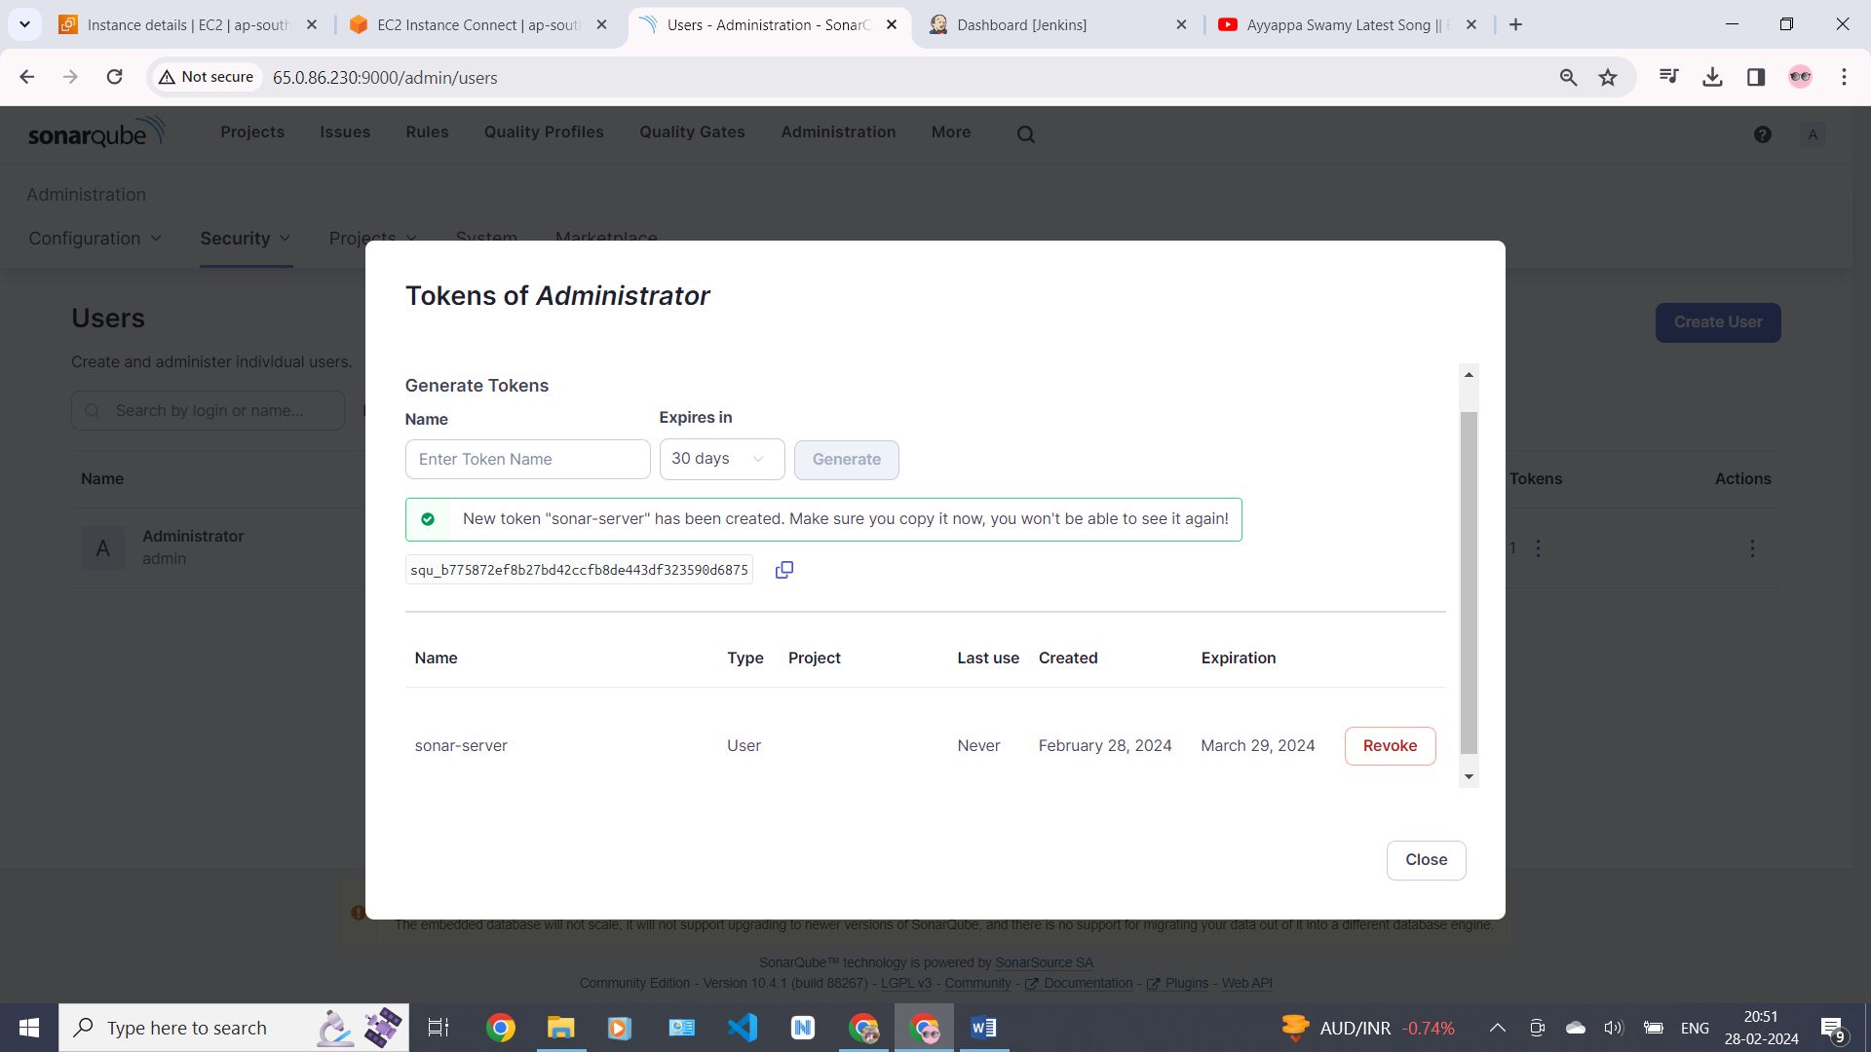

### Go to jenkins dashboard and click on manage jenkins then click on credentials .

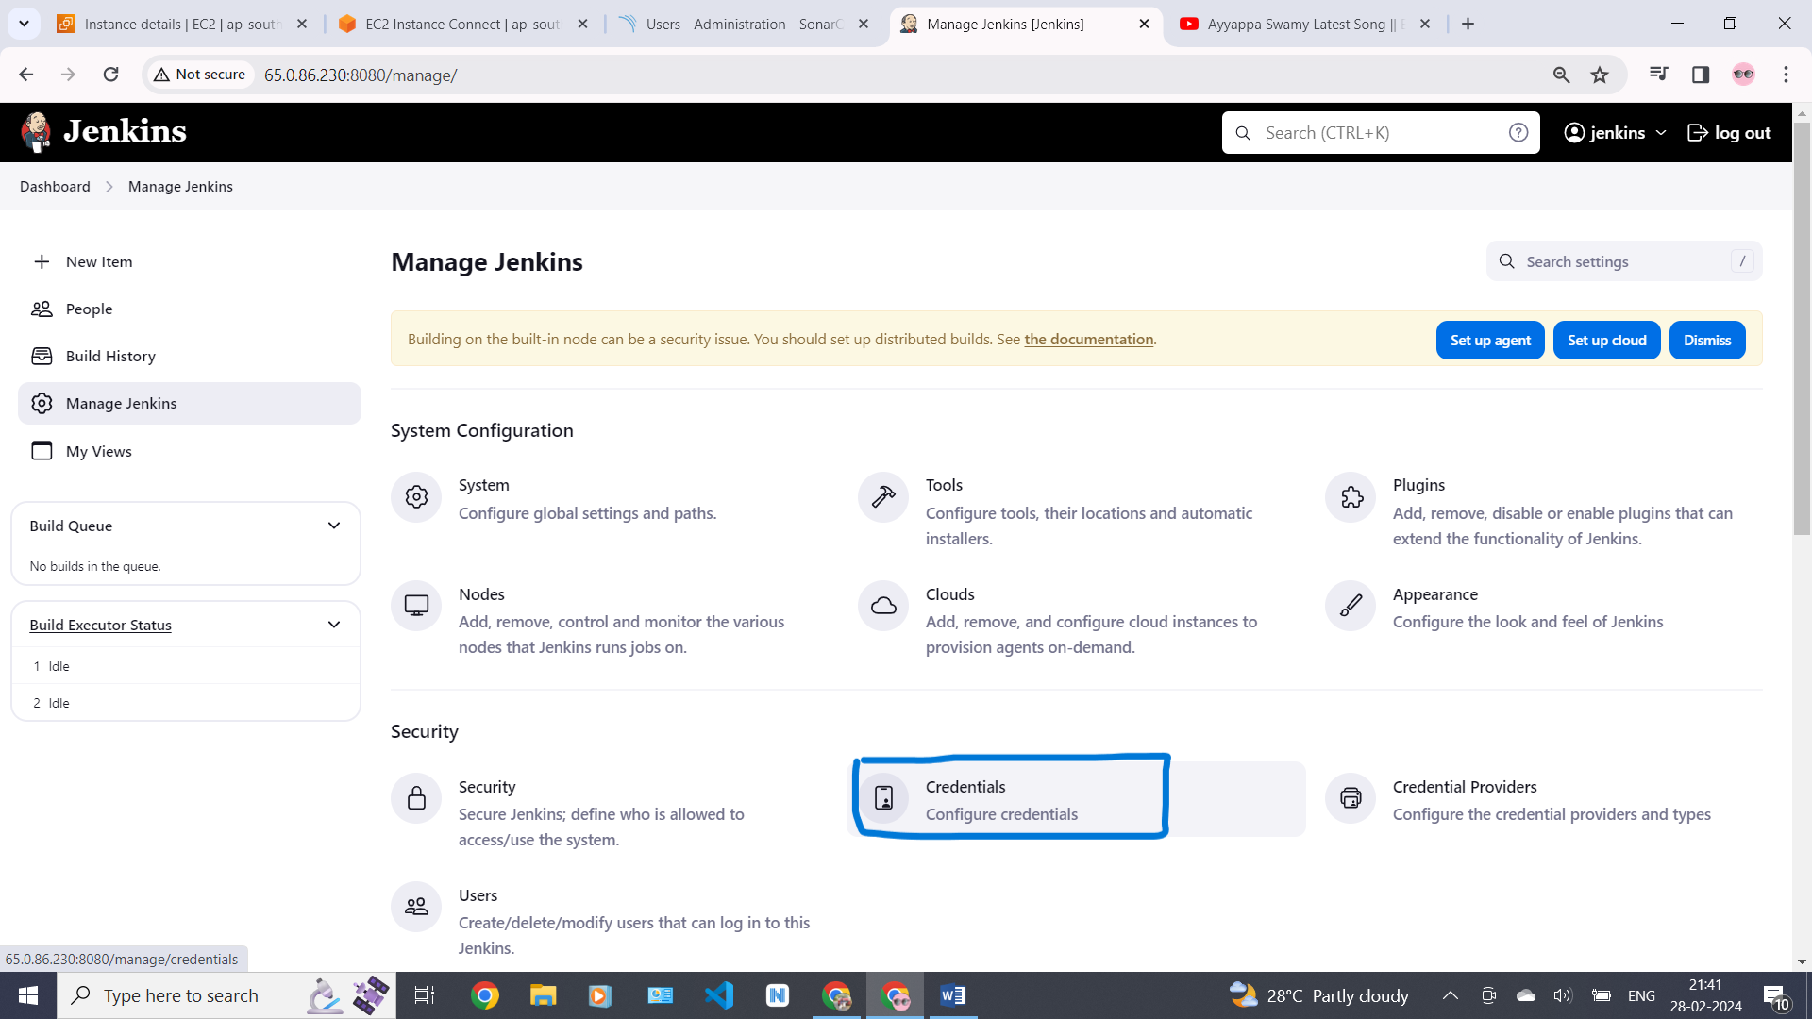

Click on global credentials

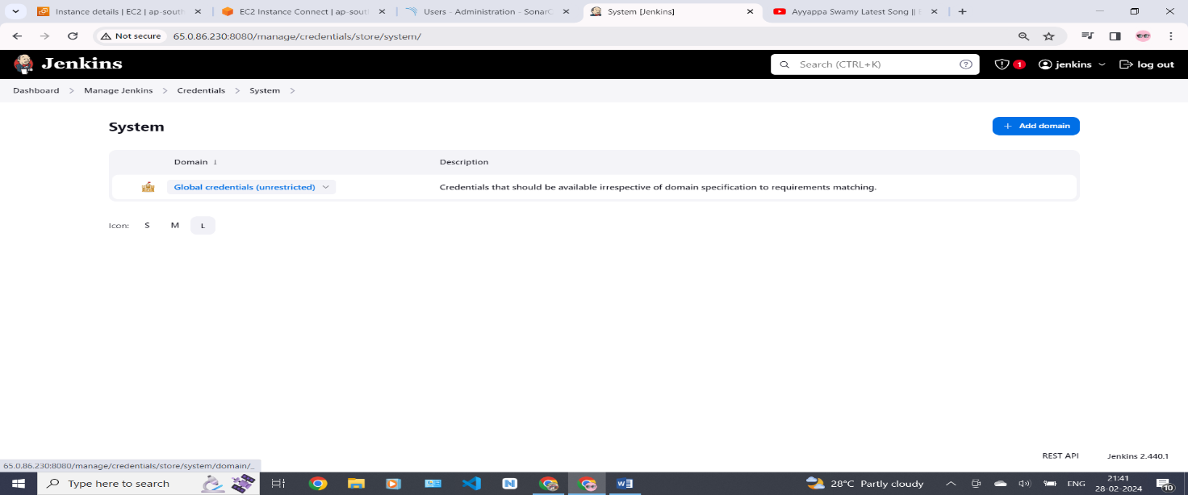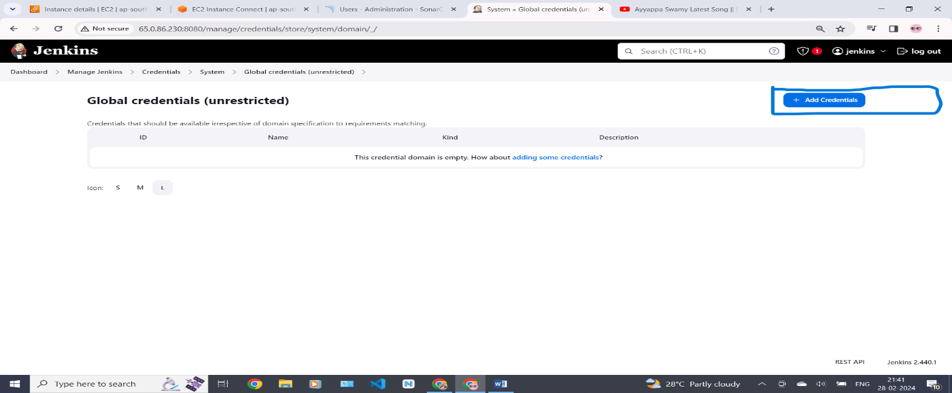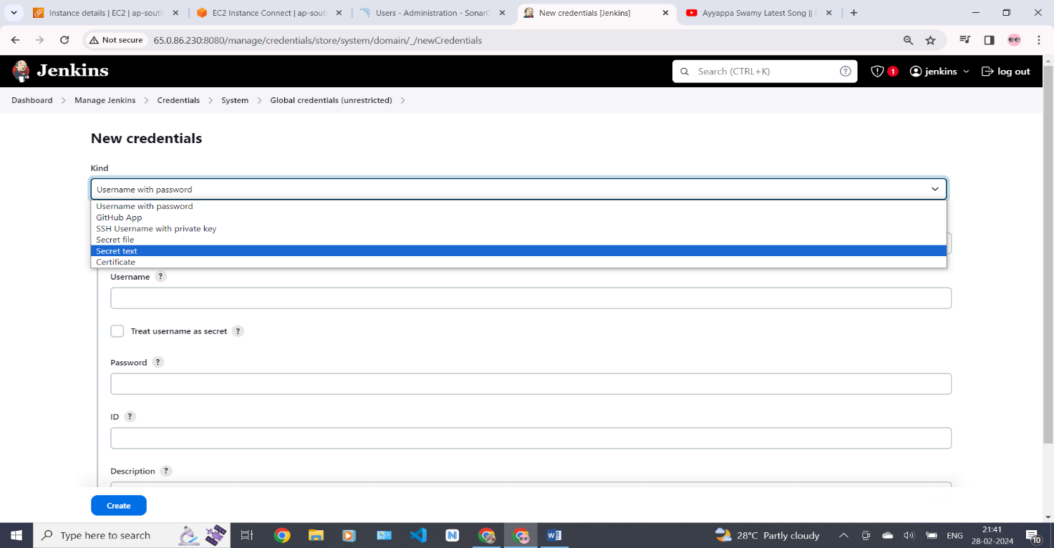

Install trivy:

Trivy scans container images and filesystems to identify security issues by comparing them against a vulnerability database.

# vi trivy.sh

|  |
| --- |
| sudo apt-get install wget apt-transport-https gnupg lsb-release -y  wget -qO - https://aquasecurity.github.io/trivy-repo/deb/public.key | gpg --dearmor | sudo tee /usr/share/keyrings/trivy.gpg > /dev/null  echo "deb [signed-by=/usr/share/keyrings/trivy.gpg] https://aquasecurity.github.io/trivy-repo/deb $(lsb_release -sc) main" | sudo tee -a /etc/apt/sources.list.d/trivy.list  sudo apt-get update  sudo apt-get install trivy –y  :wq 🡪 enter (to save and exit from the file) |

Give execute permissions to this file

#chmod +X trivy.sh

$ “sh trivy.sh”command to execute this file .

Trivy installed in this bellow picture

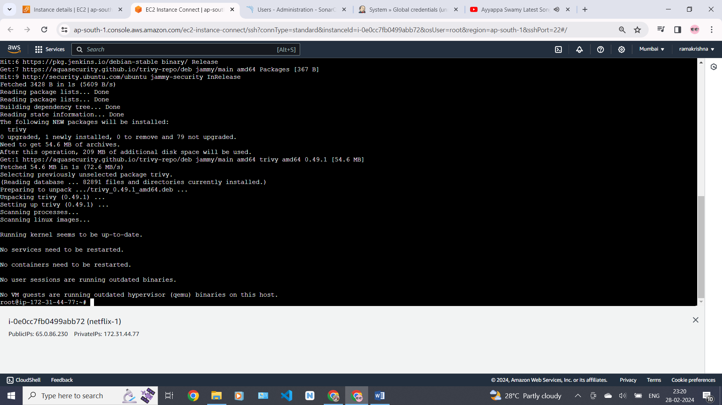

Create TMDB (the movie database) account for this project .

Go to chrome and search for TMDB click the first link

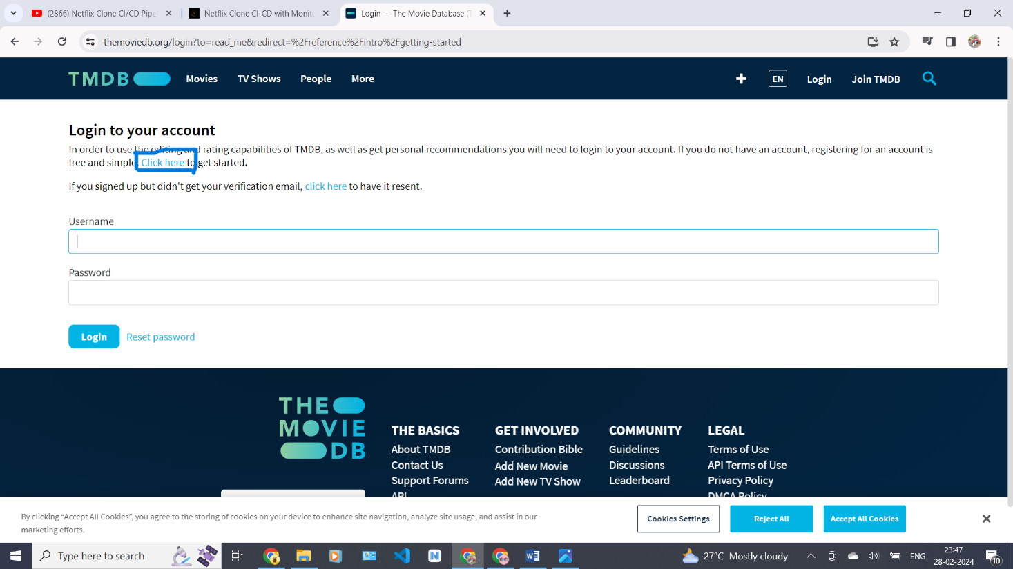

Fill the details in the bellow picture to create an account in TMDB clik and signup

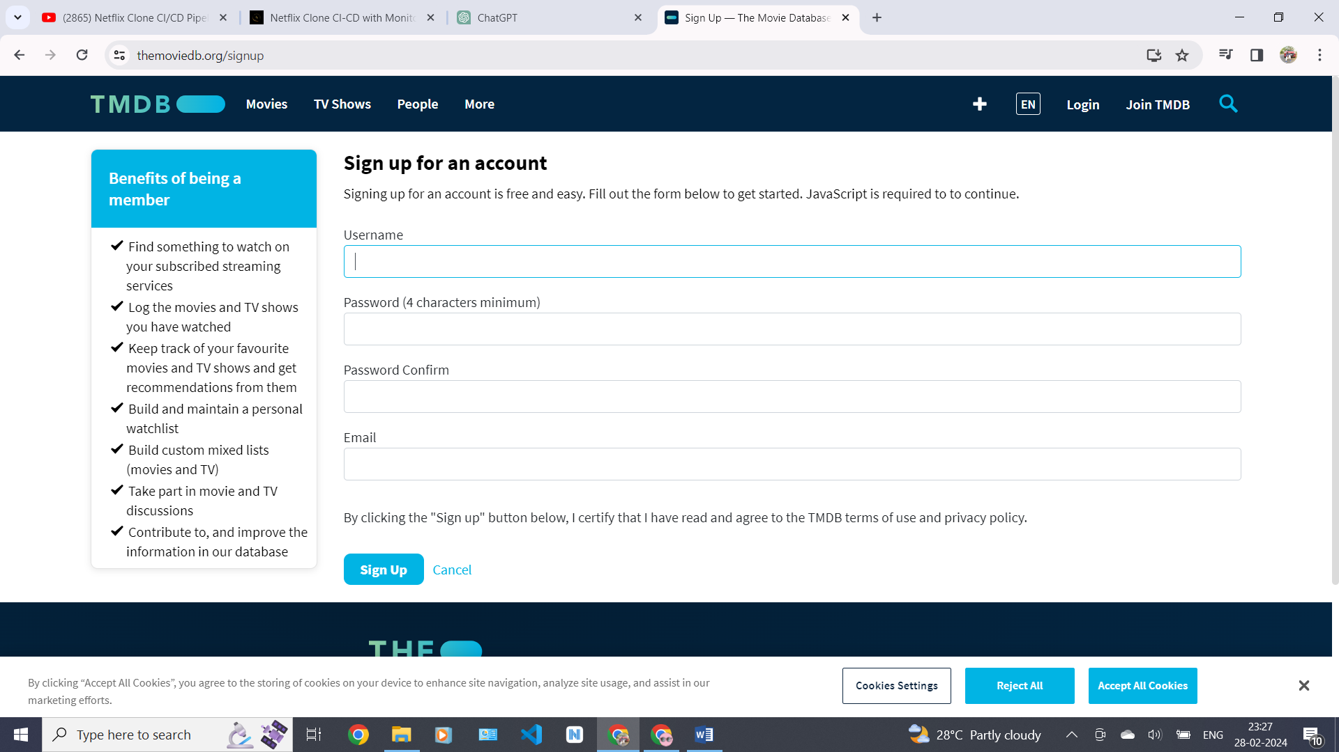

We will get our account like this and click on settings .

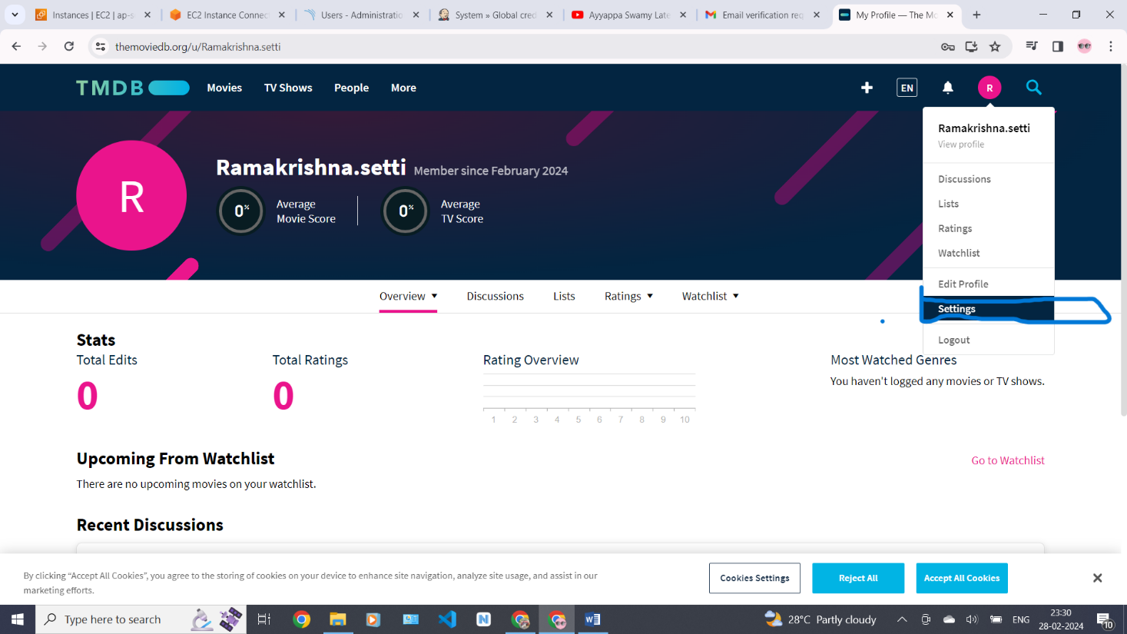

Click on Api and select create and type of API select on developer .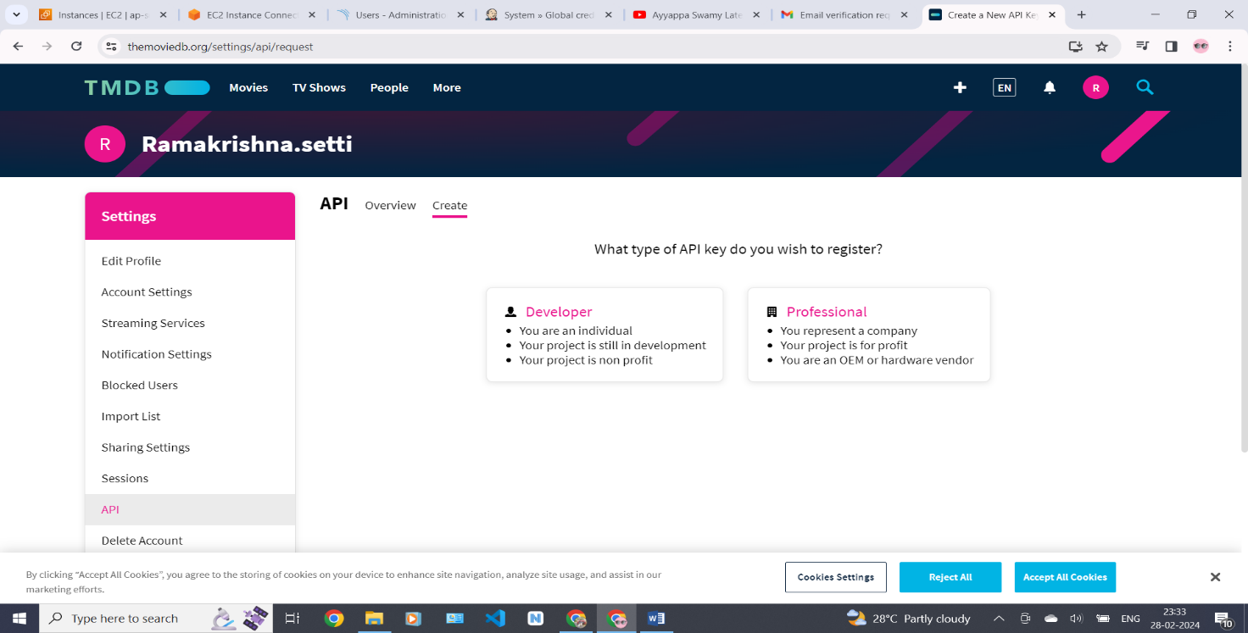

Accept all the terms and conditions click on accept

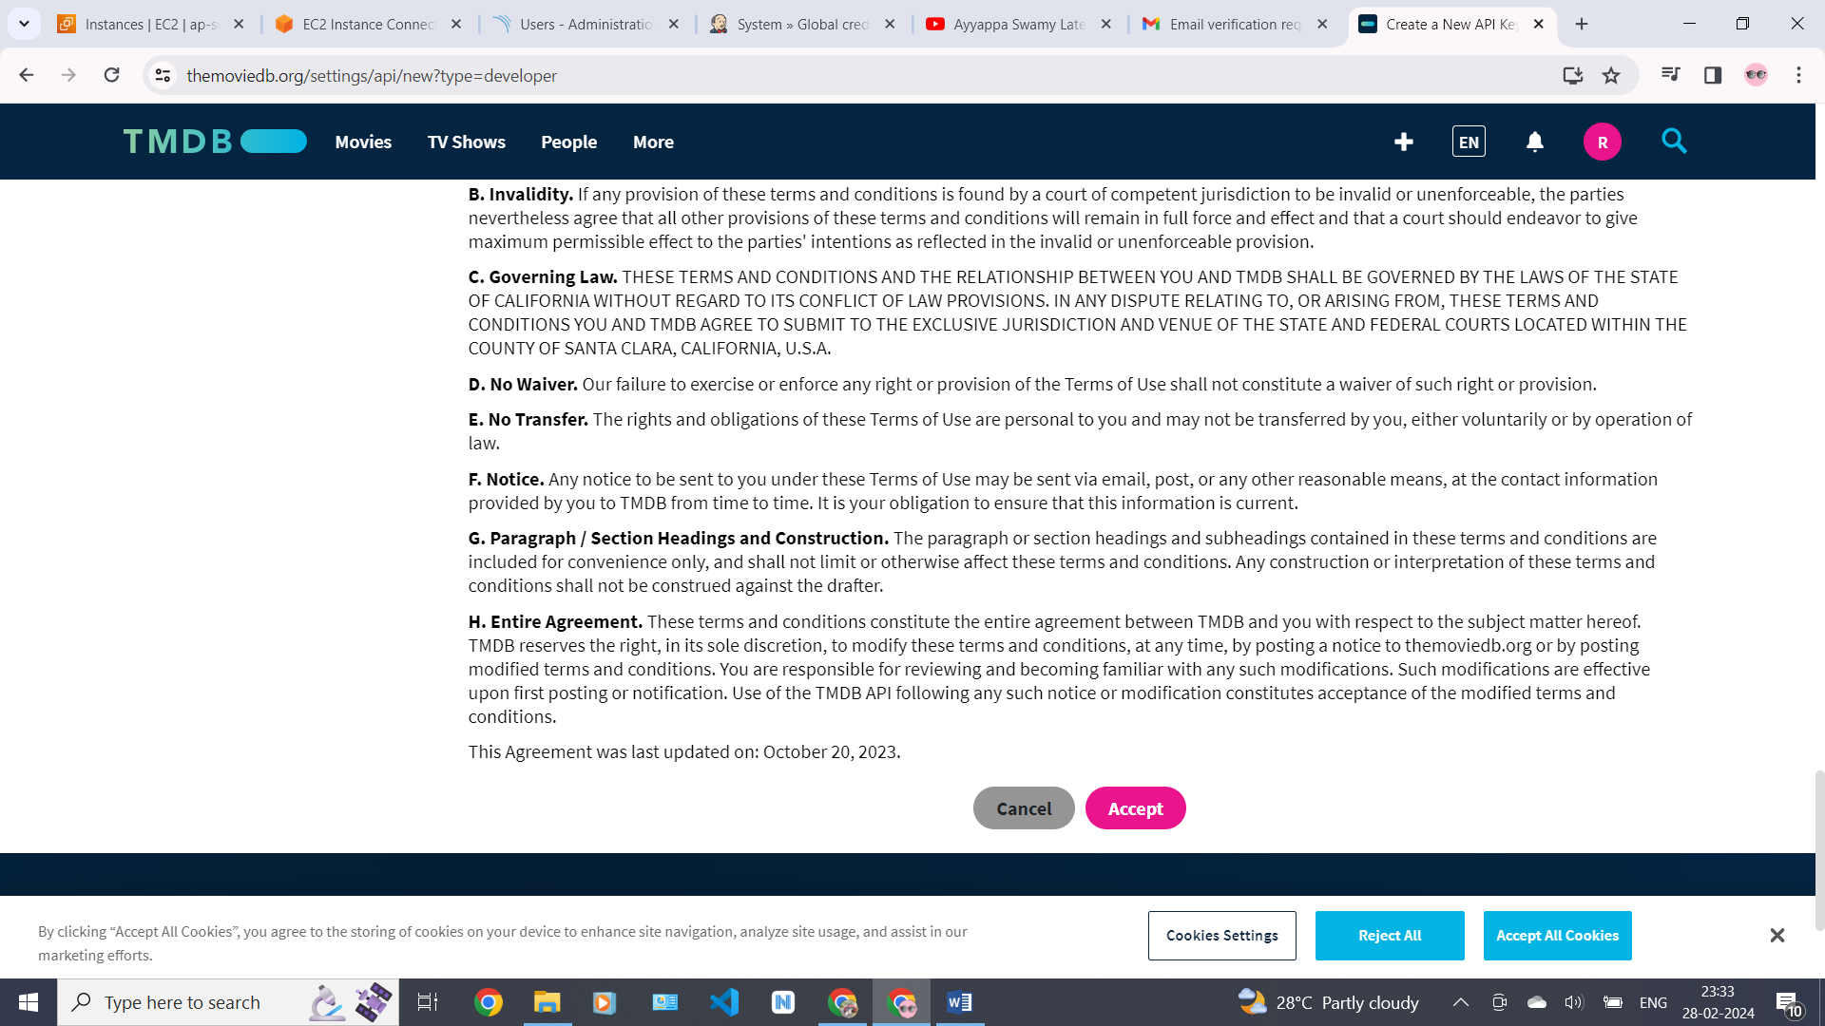

Fillup all the details like the bellow 2 images click on submit .

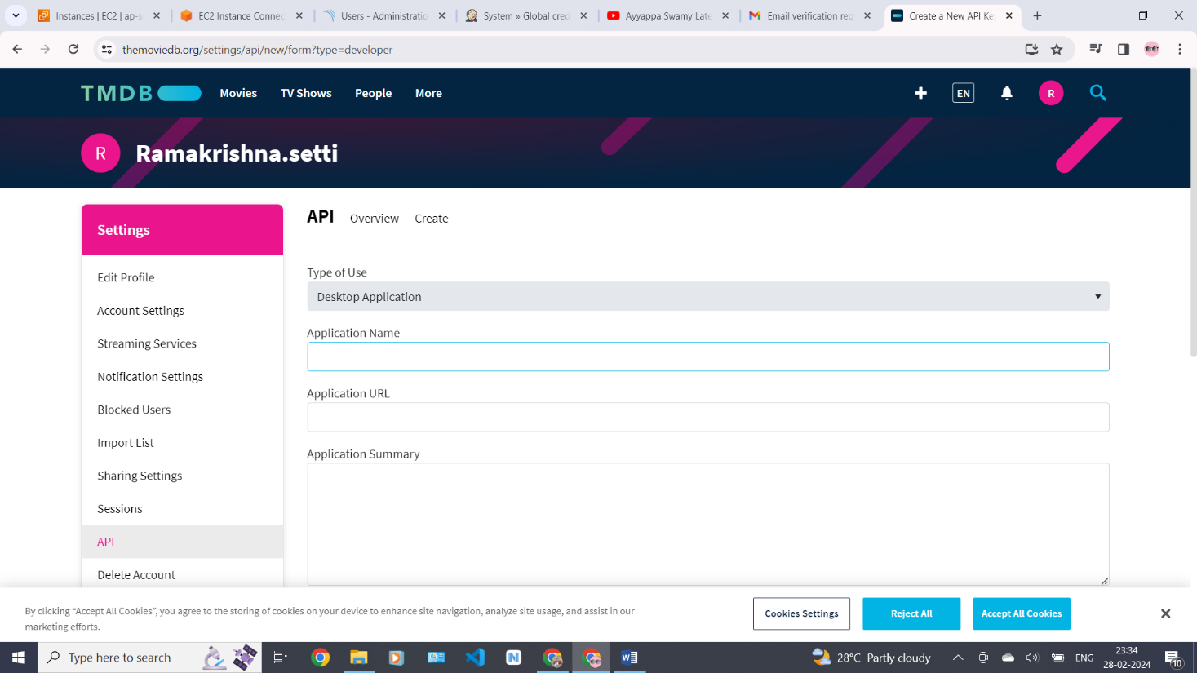

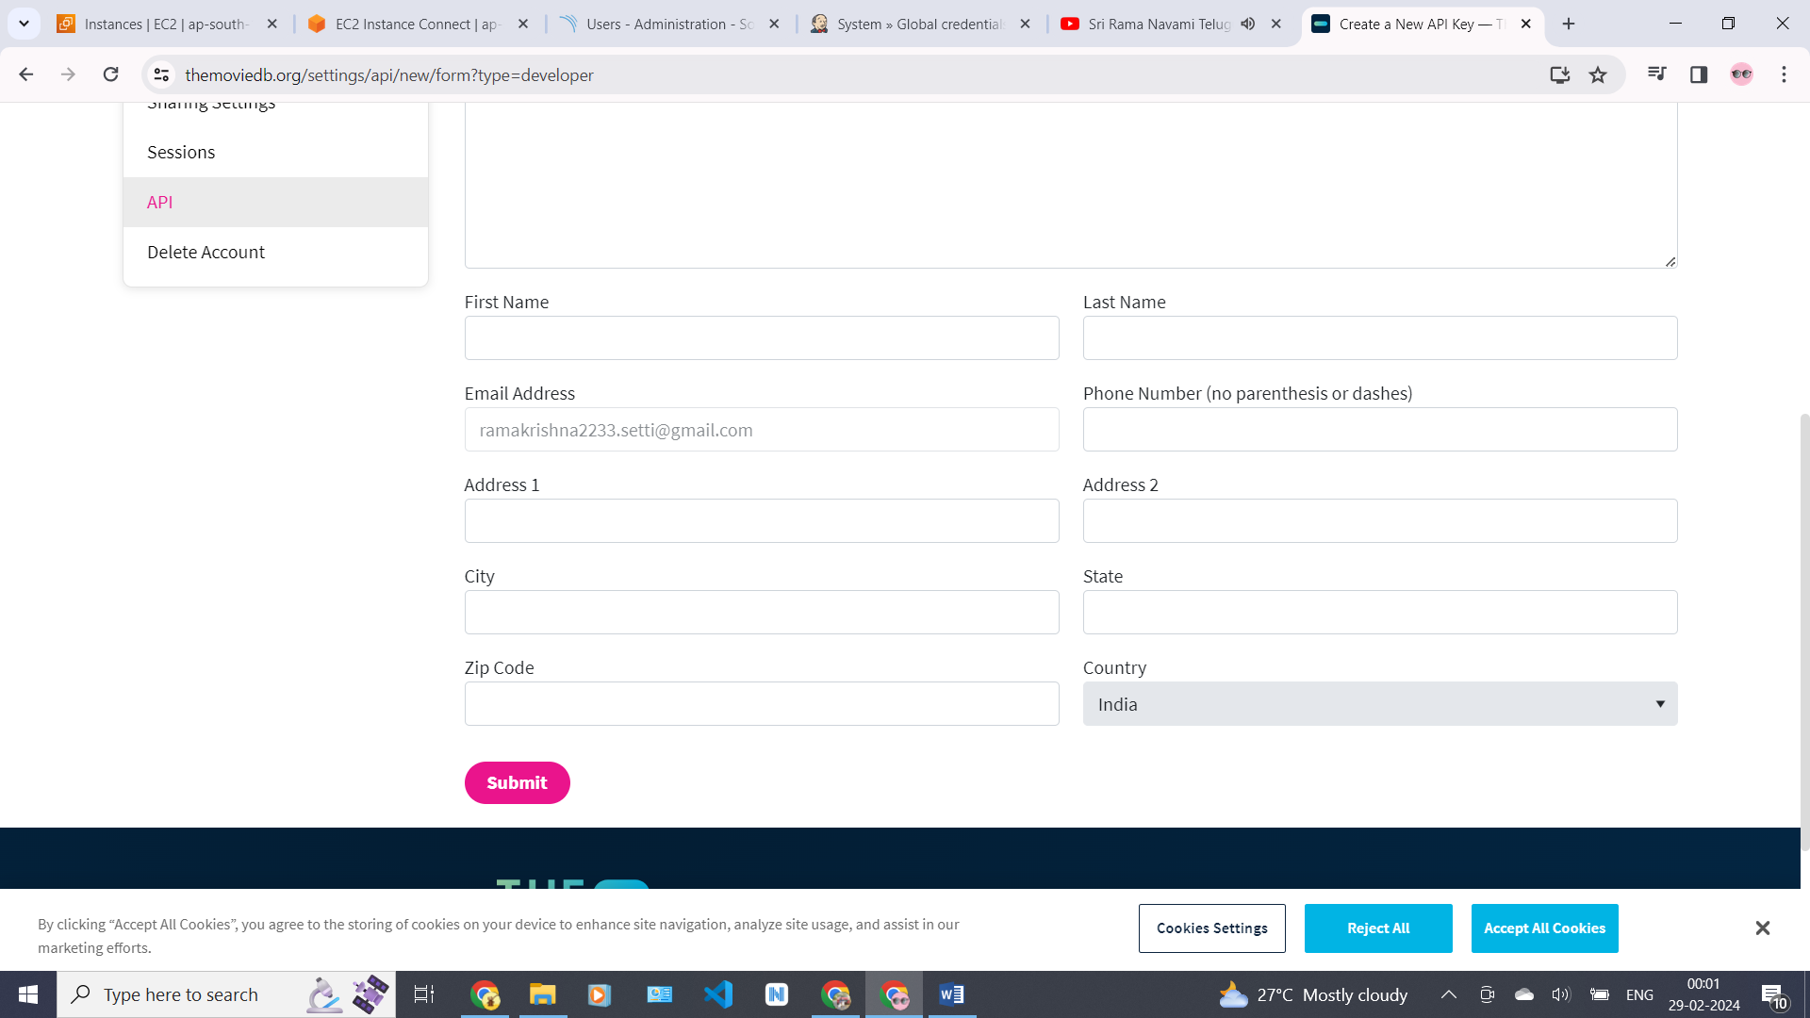

After fill all the details we will see our API-KEY .

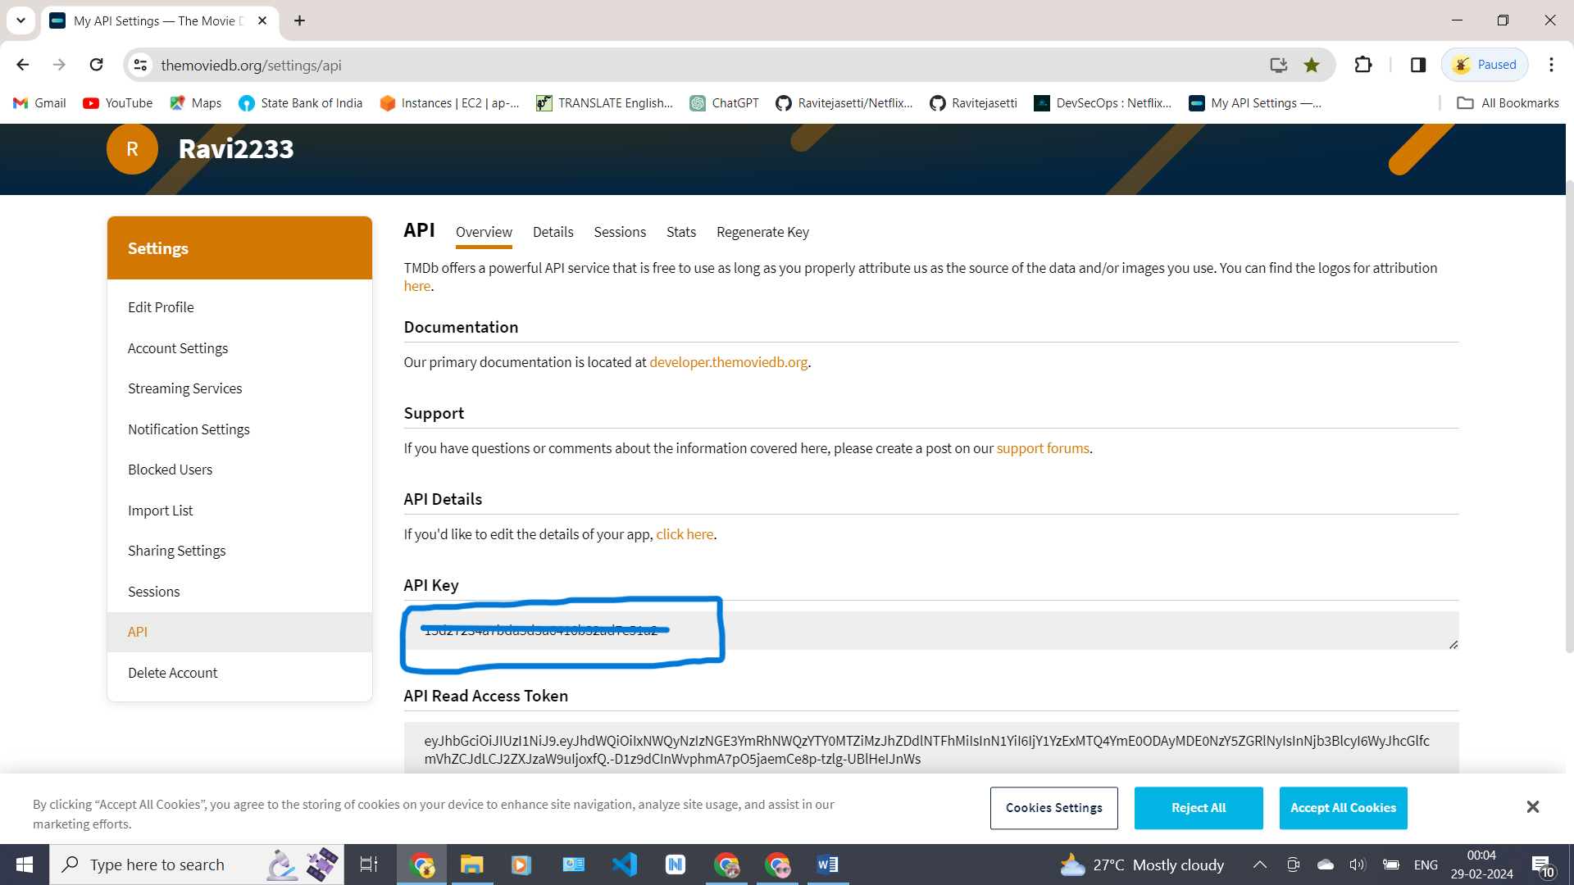

# **Install Prometheus and Grafana On the new Server**

First of all, let’s create a dedicated Linux user sometimes called a system account for Prometheus. Having individual users for each service serves two main purposes

It is a security measure to reduce the impact in case of an incident with the service.

It simplifies administration as it becomes easier to track down what resources belong to which service.

sudo useradd \

--system \

--no-create-home \

--shell /bin/false Prometheus

wget <https://github.com/prometheus/prometheus/releases/download/>

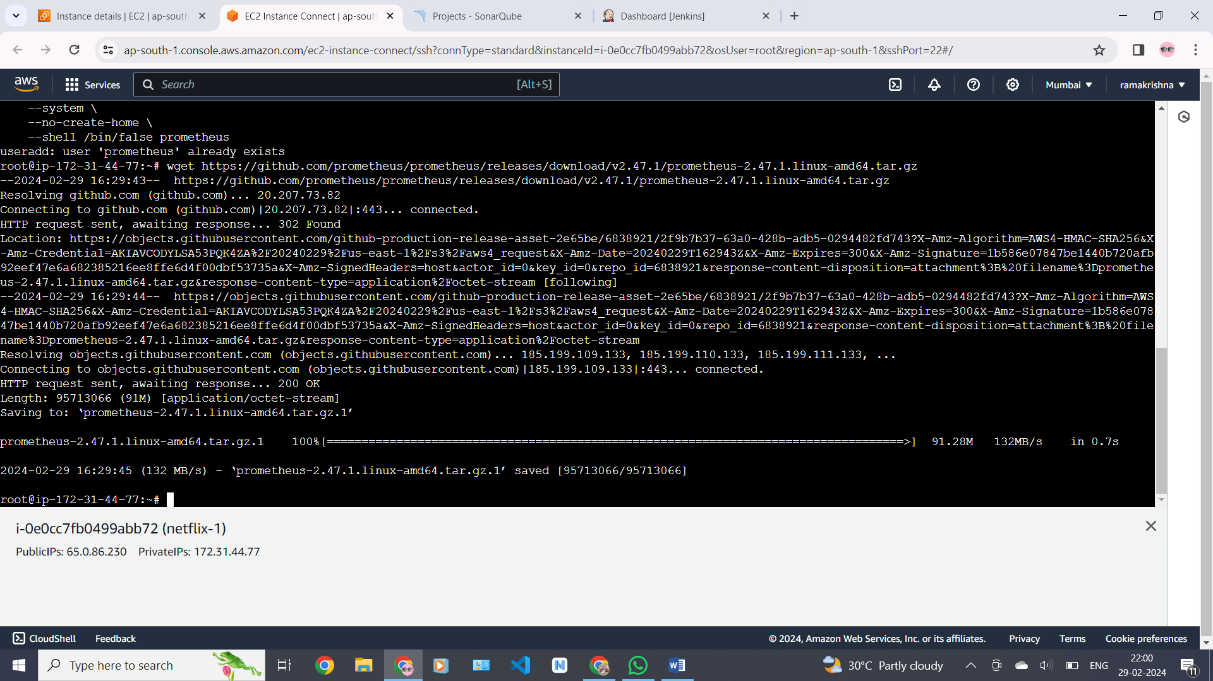v2.47.1/prometheus-2.47.1.linux-amd64.tar.gz

Then, we need to extract all Prometheus files from the archive.

tar -xvf prometheus-2.47.1.linux-amd64.tar.gz

Usually, you would have a disk mounted to the data directory. For this tutorial, I will simply create a /data directory. Also, you need a folder for Prometheus configuration files.

sudo mkdir -p /data /etc/Prometheus

Now, let’s change the directory to Prometheus and move some files.

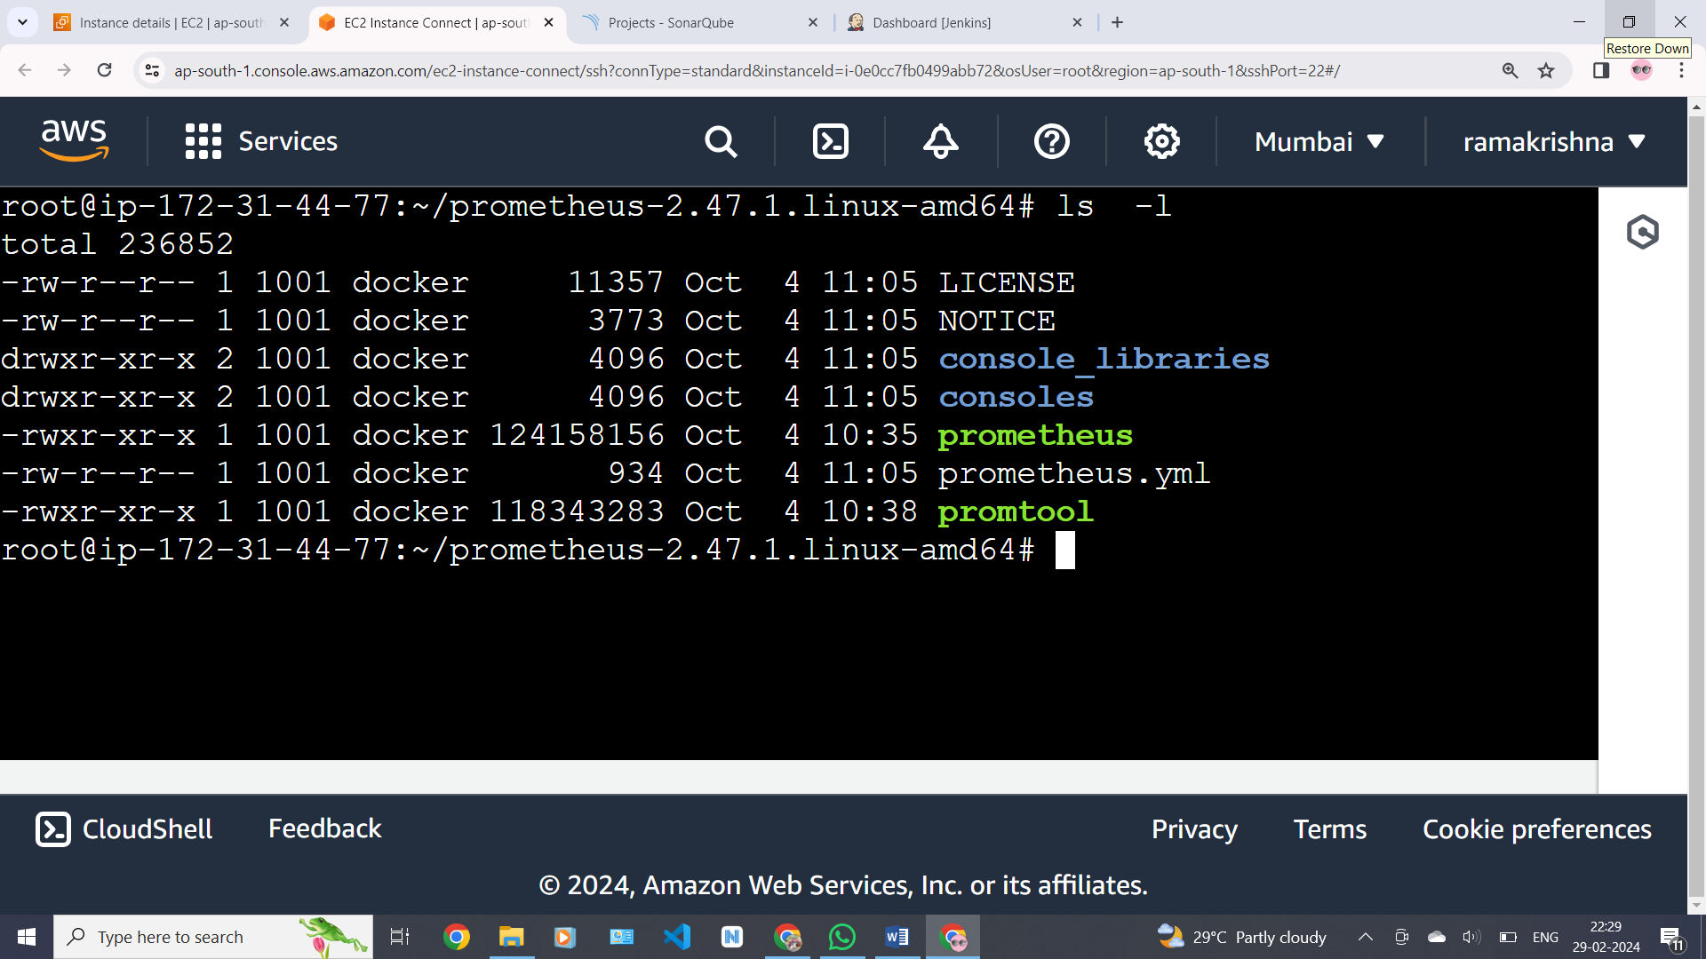

let’s move the Prometheus binary and a promtool to the /usr/local/bin/. promtool is used to check configuration files and Prometheus rules.

sudo mv prometheus promtool /usr/local/bin/

Optionally, we can move console libraries to the Prometheus configuration directory. Console templates allow for the creation of arbitrary consoles using the Go templating language. You don’t need to worry about it if you’re just getting started.

sudo mv consoles/ console_libraries/ /etc/prometheus/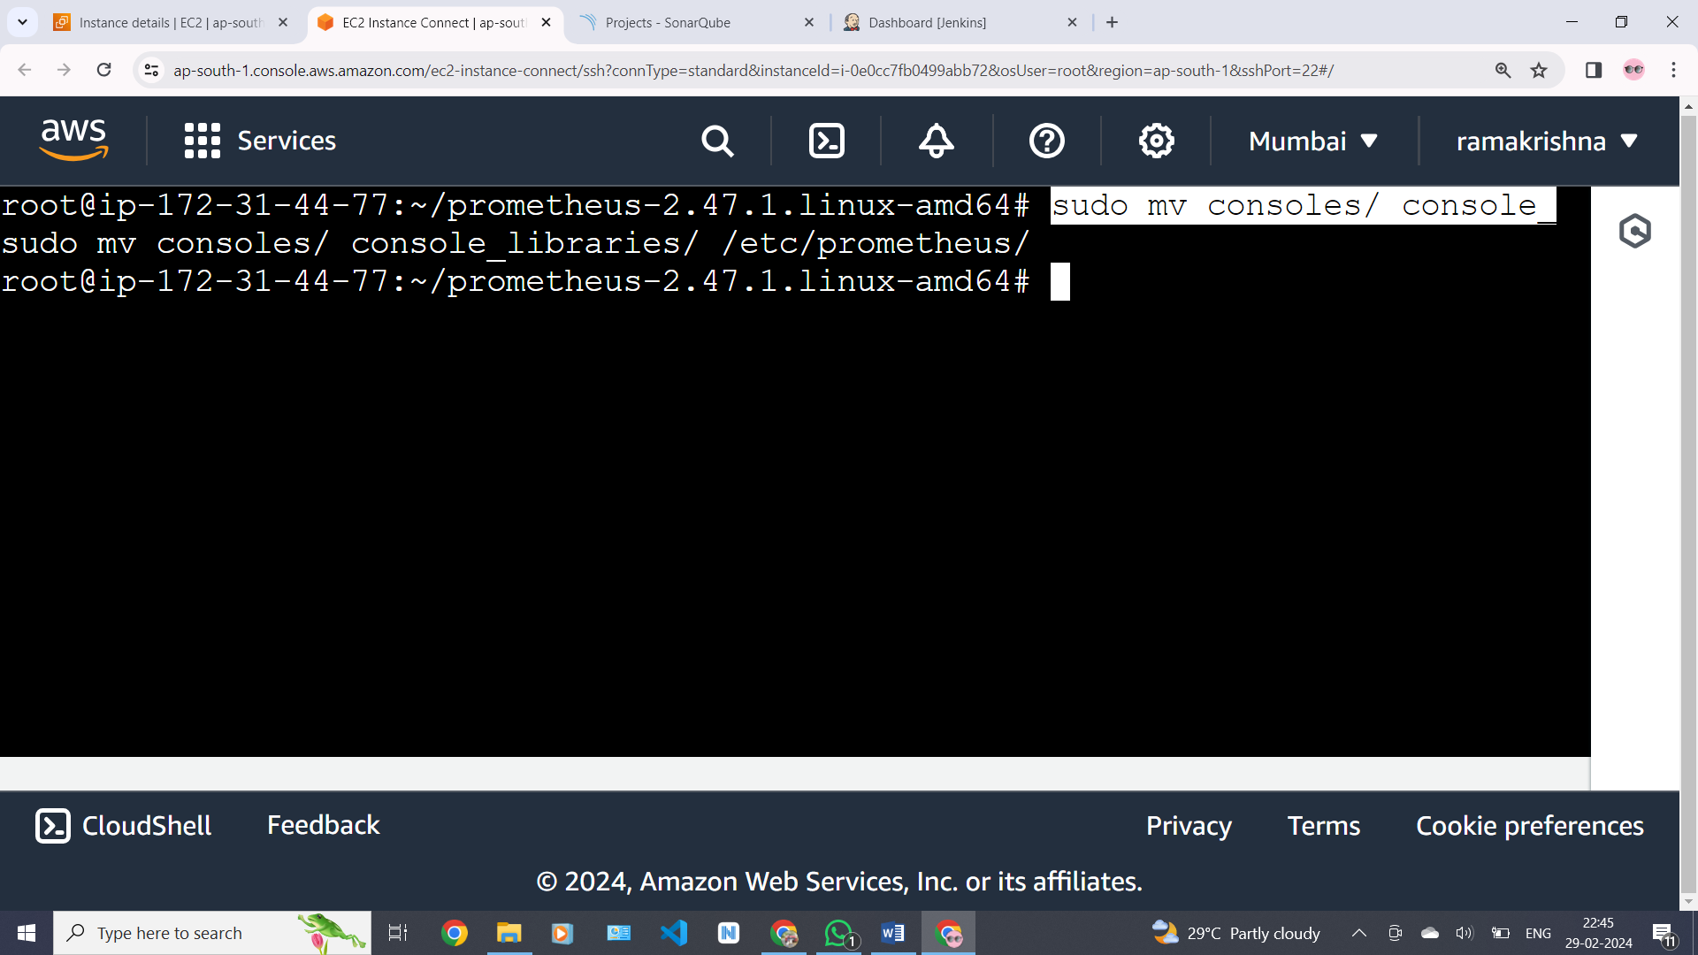

To avoid permission issues, you need to set the correct ownership for the /etc/prometheus/ and data directory.

sudo chown -R prometheus:prometheus /etc/prometheus/ /data/

now check the Prometheus version

#prometheus –version

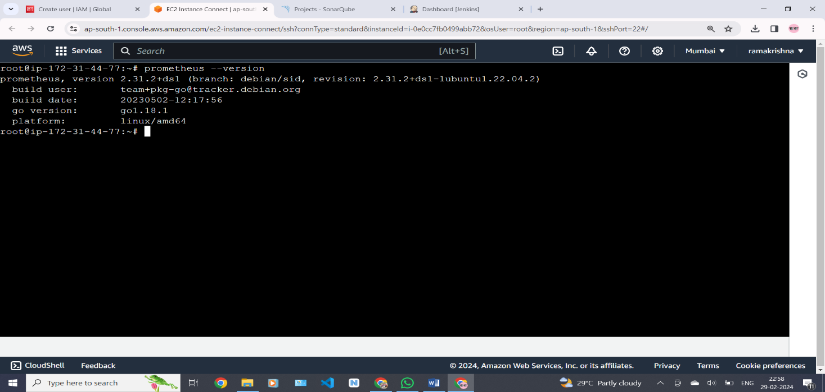

Now copy the ipadress of the instance and open new tab and past the ipadress:9090 (port number of Prometheus)

We can see the Prometheus desktop here as bellow

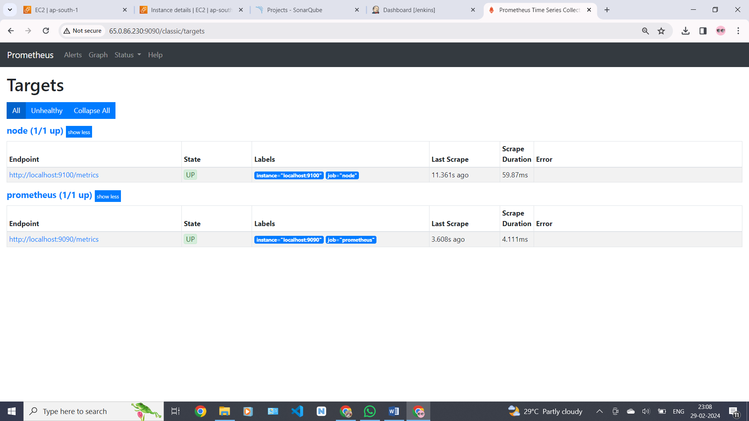

Now install node exporter

we’re going to set up and configure Node Exporter to collect Linux system metrics like CPU load and disk I/O. Node Exporter will expose these as Prometheus-style metrics.

First, let’s create a system user for Node Exporter by running the following command:

sudo useradd \

--system \

--no-create-home \

--shell /bin/false node_exporter

Use the wget command to download the binary.

wget https://github.com/prometheus/node_exporter/releases/download/v1.6.1/node_export

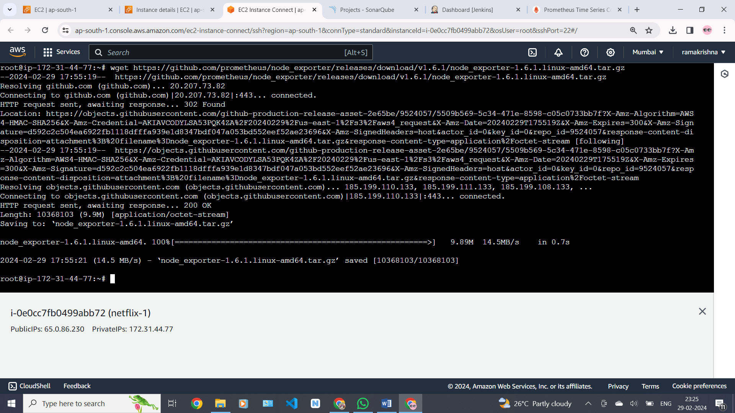

We have tar file for the node-exporter and I am going to untar this file .

# tar –xvf <tar file> 🡪 enter

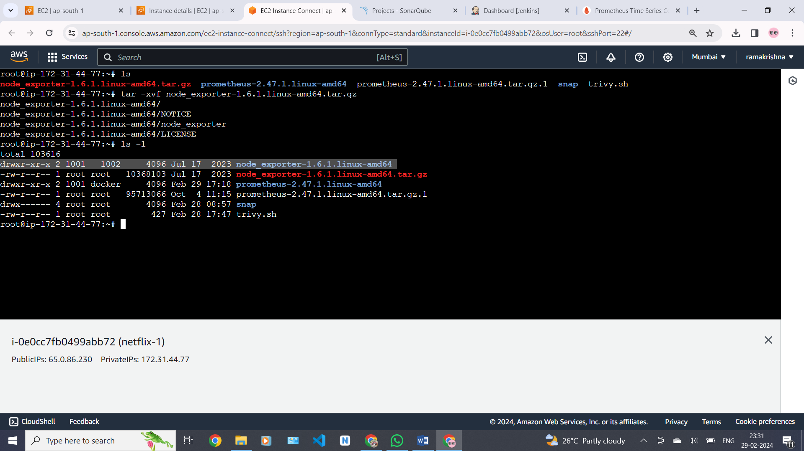

Move binary to the /usr/local/bin.

sudo mv node_exporter-1.6.1.linux-amd64/node_exporter /usr/local/bin/

check thi version of node_exporter

# node_exporter –version

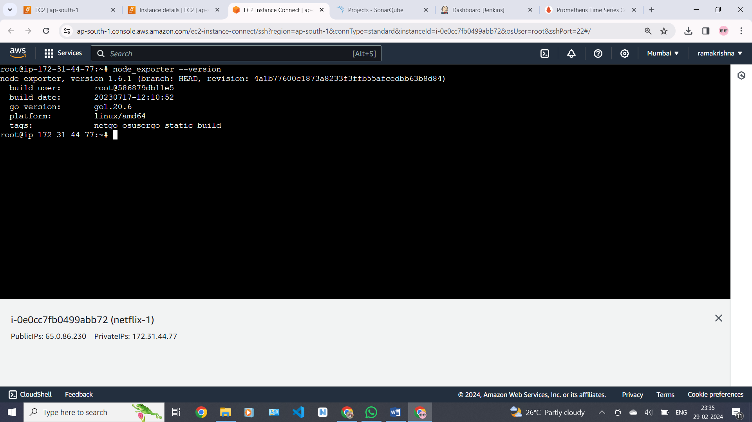

create a similar systemd unit file.

sudo vim /etc/systemd/system/node_exporter.service

**node_exporter.service**

|  |
| --- |
| [Unit]  Description=Node Exporter  Wants=network-online.target  After=network-online.target  StartLimitIntervalSec=500  StartLimitBurst=5  [Service]  User=node_exporter  Group=node_exporter  Type=simple  Restart=on-failure  RestartSec=5s  ExecStart=/usr/local/bin/node_exporter \  --collector.logind  [Install]  WantedBy=multi-user.target |

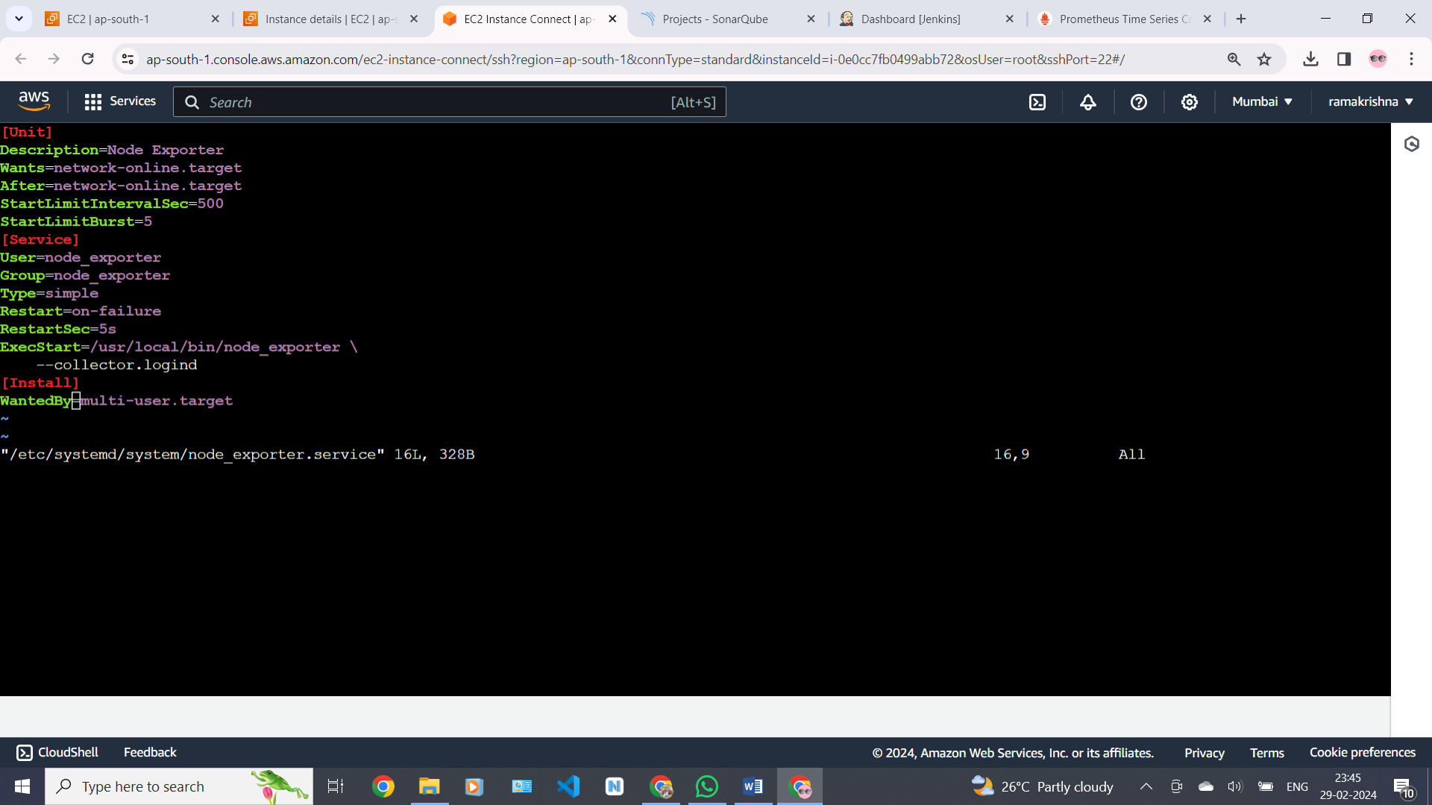

Replace Prometheus user and group to node_exporter, and update the ExecStart command.

To automatically start the Node Exporter after reboot, enable the service.

**#sudo systemctl enable node_exporter**

Then start the Node Exporter.

#sudo systemctl start node_exporter

Check the status of node_exporter

#sudo systemctl status node_exporter

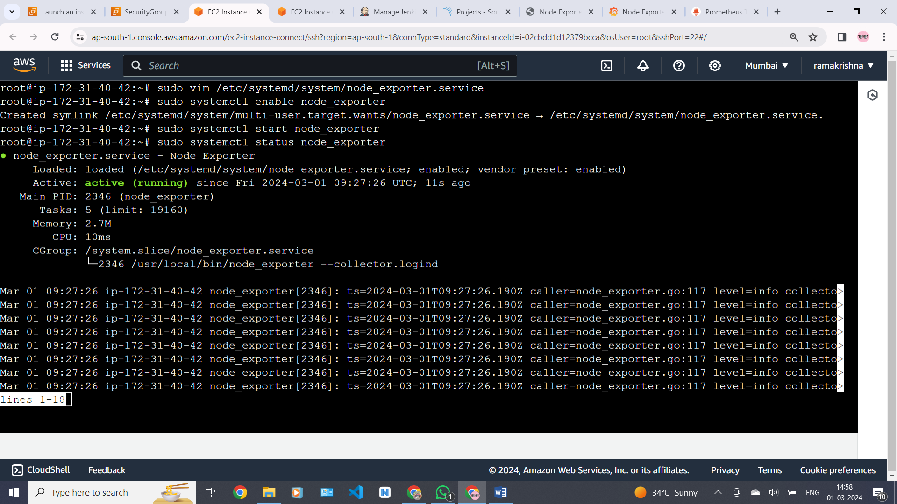

At this point, we have only a single target in our Prometheus. There are many different service discovery mechanisms built into Prometheus. For example, Prometheus can dynamically discover targets in AWS, GCP, and other clouds based on the labels. In the following tutorials, I’ll give you a few examples of deploying Prometheus in a cloud-specific environment. For this tutorial, let’s keep it simple and keep adding static targets. Also, I have a lesson on how to deploy and manage Prometheus in the Kubernetes cluster.

To create a static target, you need to add job name with static configs.

sudo vim /etc/prometheus/prometheus.yml

in this Prometheus .yml file we need to add the node_exporter targets

|  |
| --- |
| - job_name: node_export  static_configs:  - targets: ["localhost:9100"] |

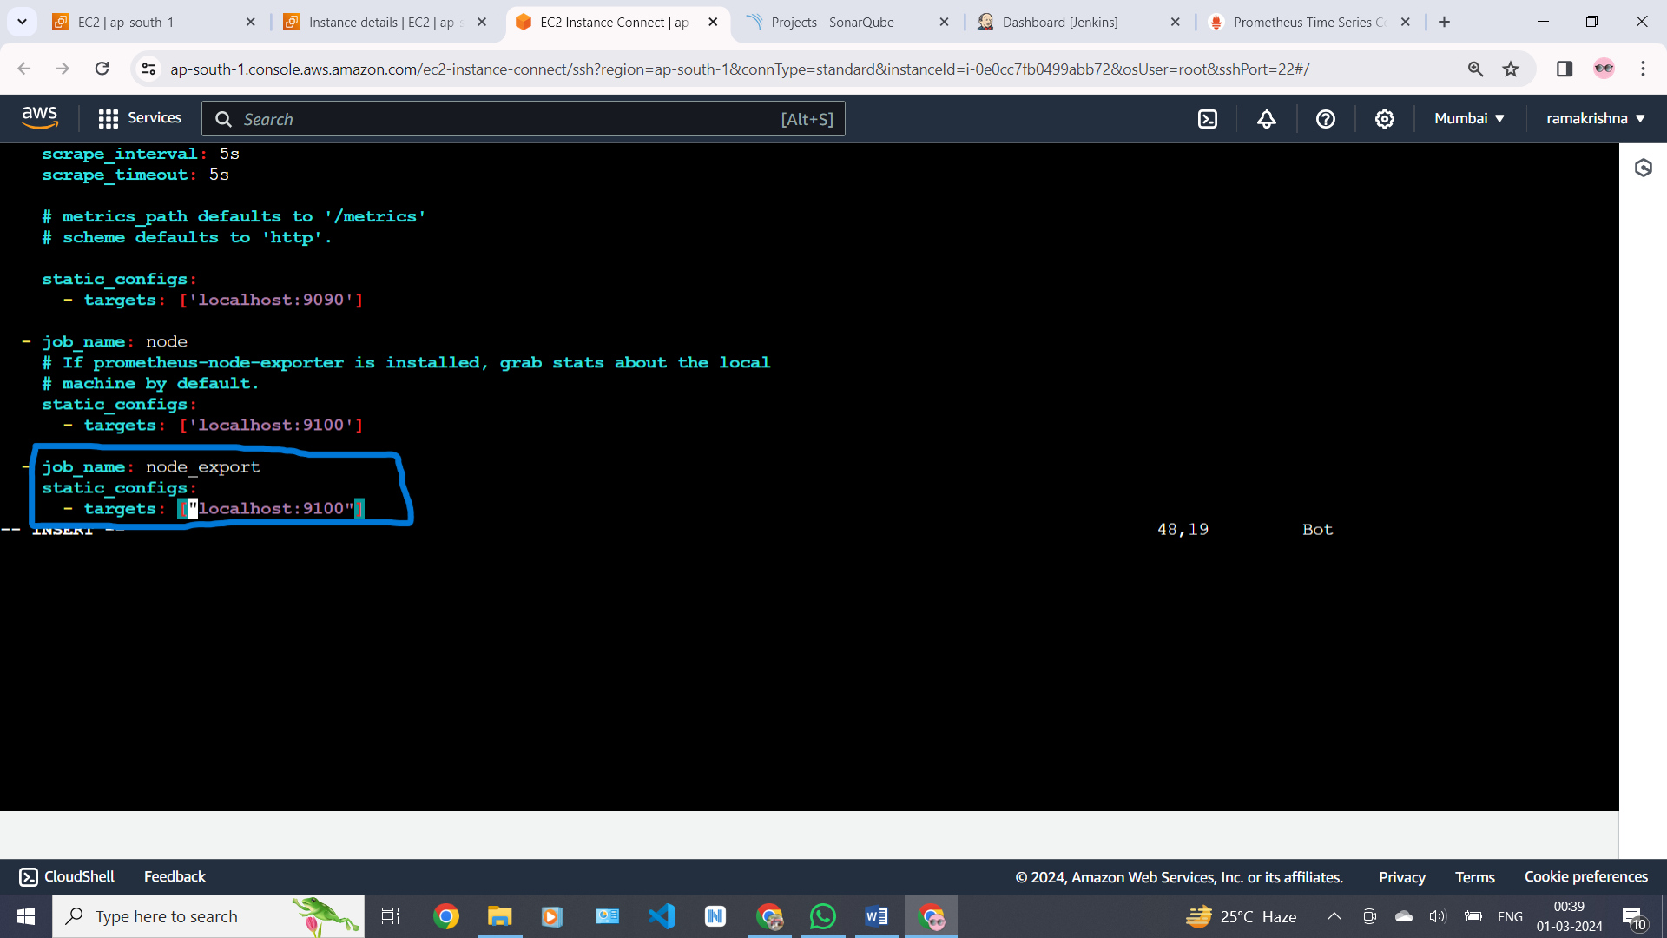

By default, Node Exporter will be exposed on port 9100.

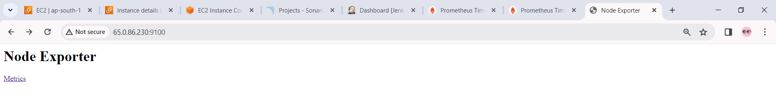

Since we enabled lifecycle management via API calls, we can reload the Prometheus config without restarting the service and causing downtime.

Before, restarting check if the config is valid.

# promtool check config /etc/prometheus/prometheus.yml

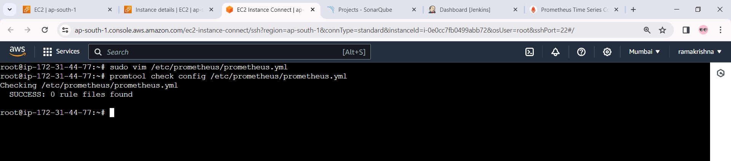

Then, you can use a POST request to reload the config.

# curl -X POST http://localhost:9090/-/reload

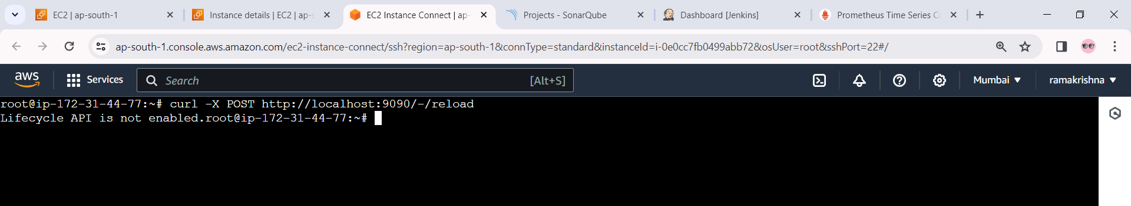

Check the targets section

http://<ip>:9090

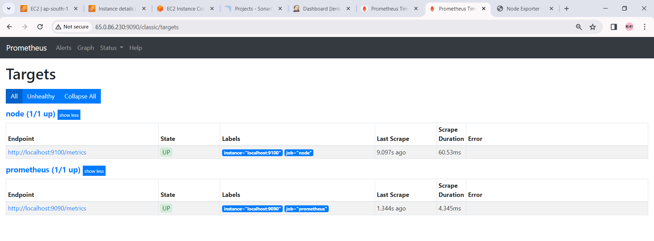

### Install Grafana

To visualize metrics we can use Grafana. There are many different data sources that Grafana supports, one of them is Prometheus.

First, let’s make sure that all the dependencies are installed.

sudo apt-get install -y

Next, add the GPG key

wget -q -O - https://packages.grafana.com/gpg.key | sudo apt-key add –

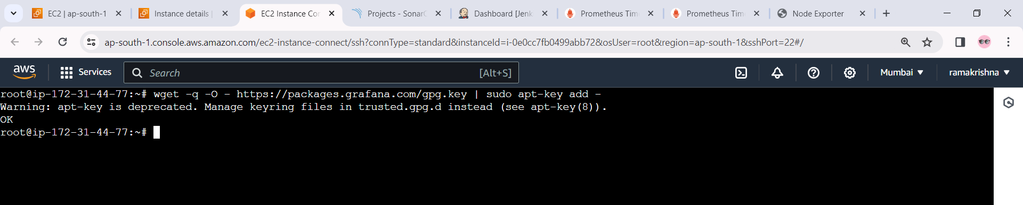

Add this repository for stable releases.

echo "deb https://packages.grafana.com/oss/deb stable main" | sudo tee -a /etc/apt/sources.list.d/grafana.list

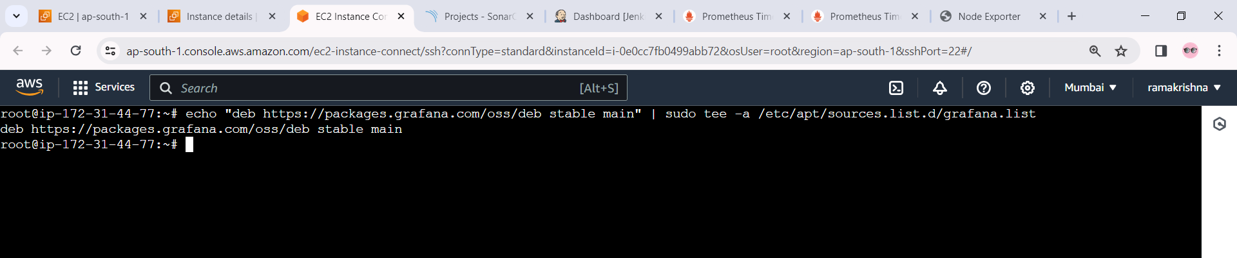

After you add the repository, update and install Garafana.

#sudo apt-get update

**Install grafana** # sudo apt-get -y install grafana

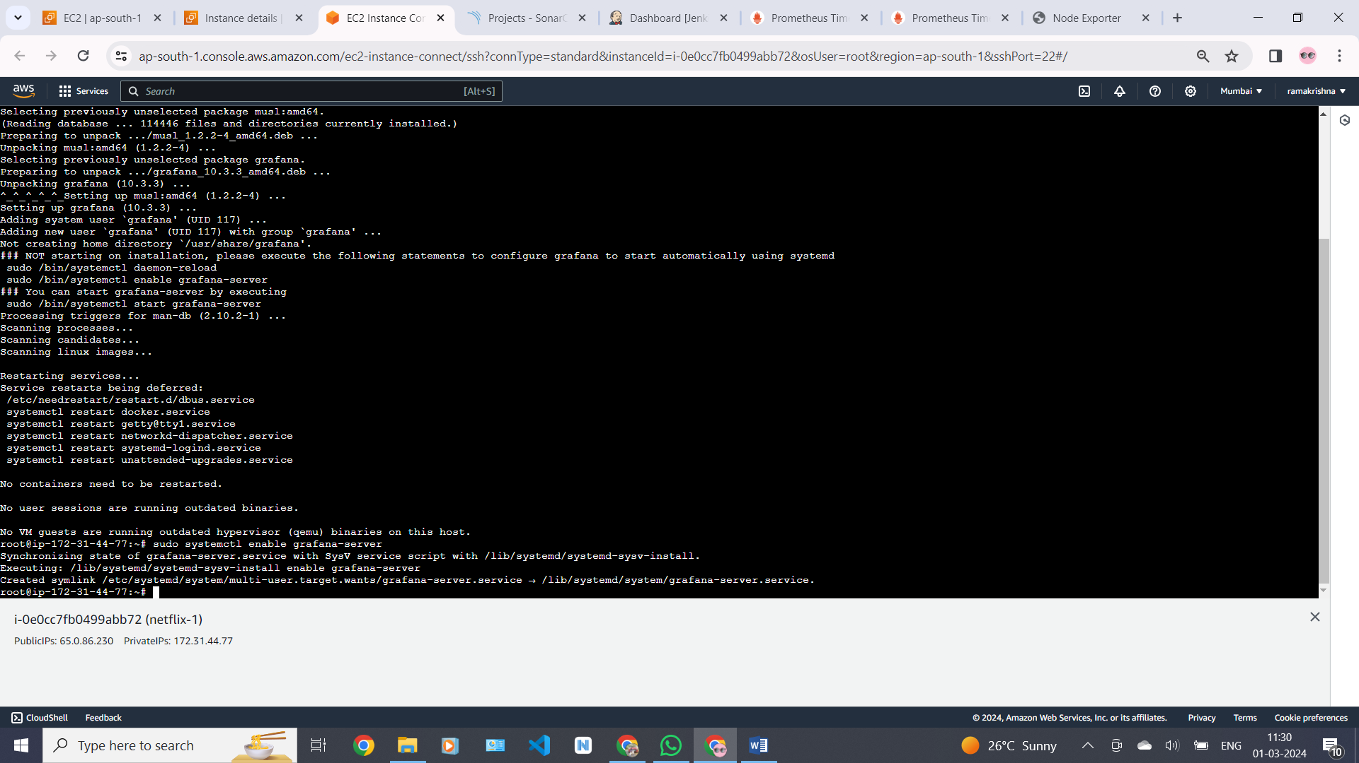

To automatically start the Grafana after reboot, enable the service.

# sudo systemctl enable grafana-server

Then start , check status of the grafana

# sudo systemctl start grafana-server

you see this grafana is in active and running .

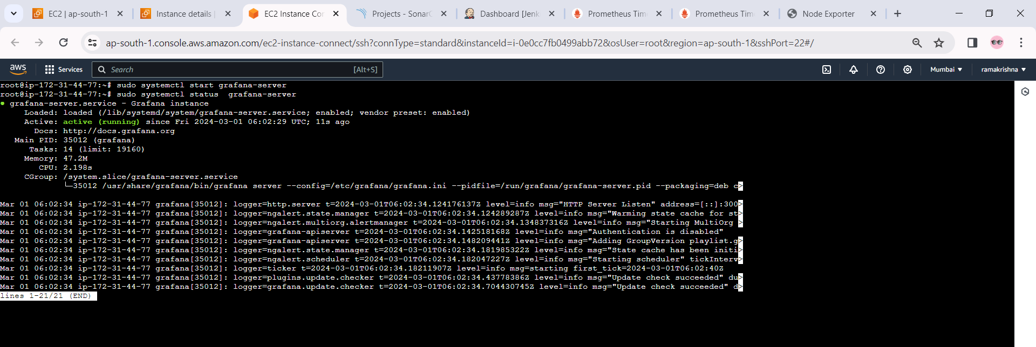

Go to http://<ip>:3000 and log in to the Grafana using default credentials.

The username is “admin” , and the password is “admin “as well.

Create a new password after login with default password .

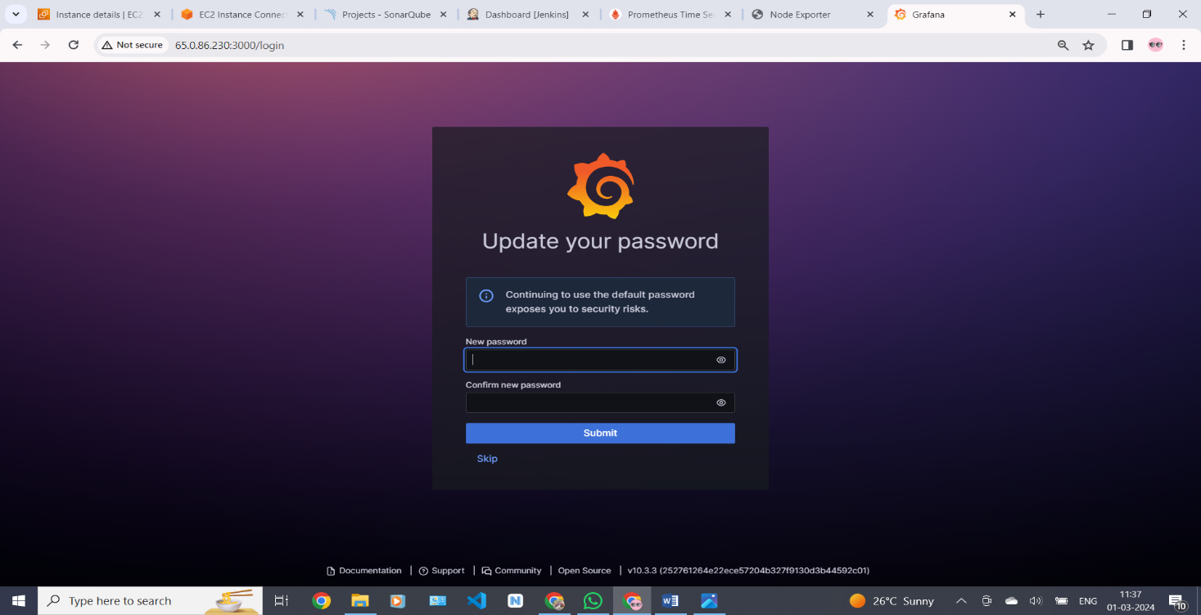

This is the grafana home page in this bellow picture

To visualize metrics, you need to add a data source first.Click Add data source and select Prometheus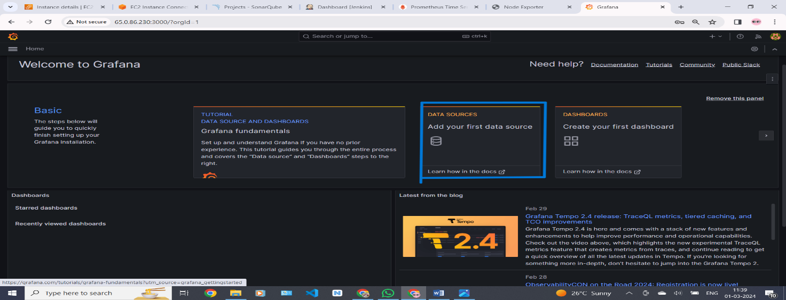

Paste the Prometheus url with port number 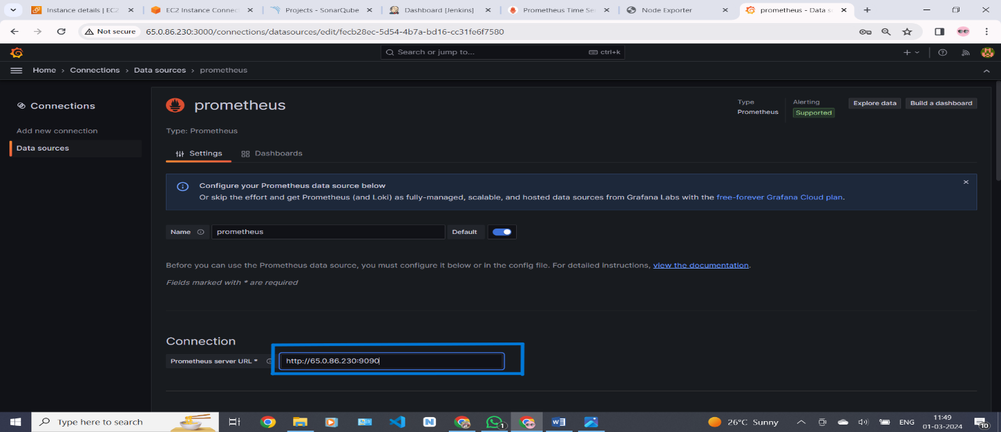

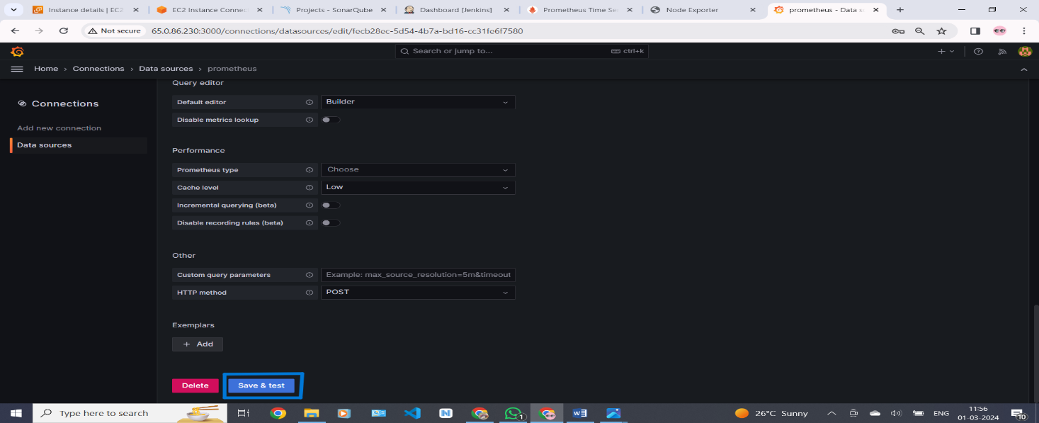 Go down then click on save and test

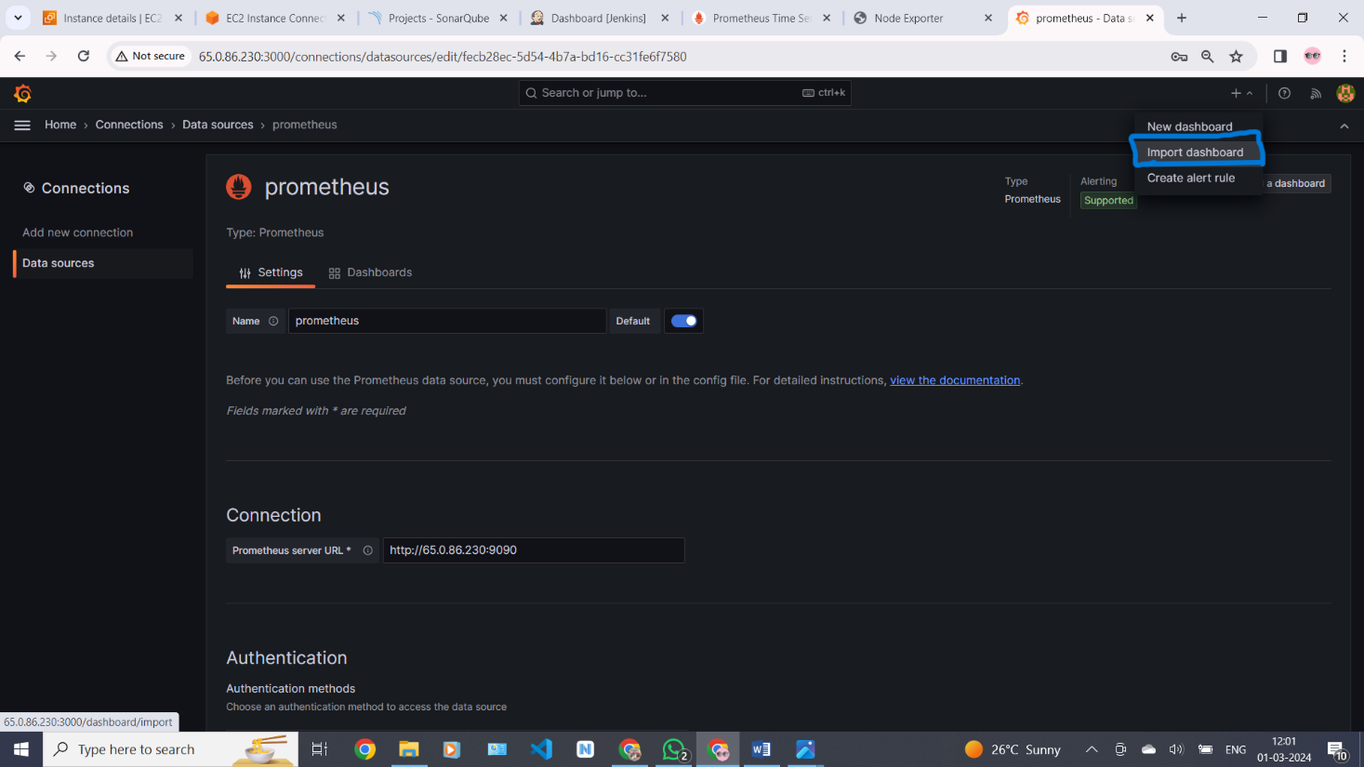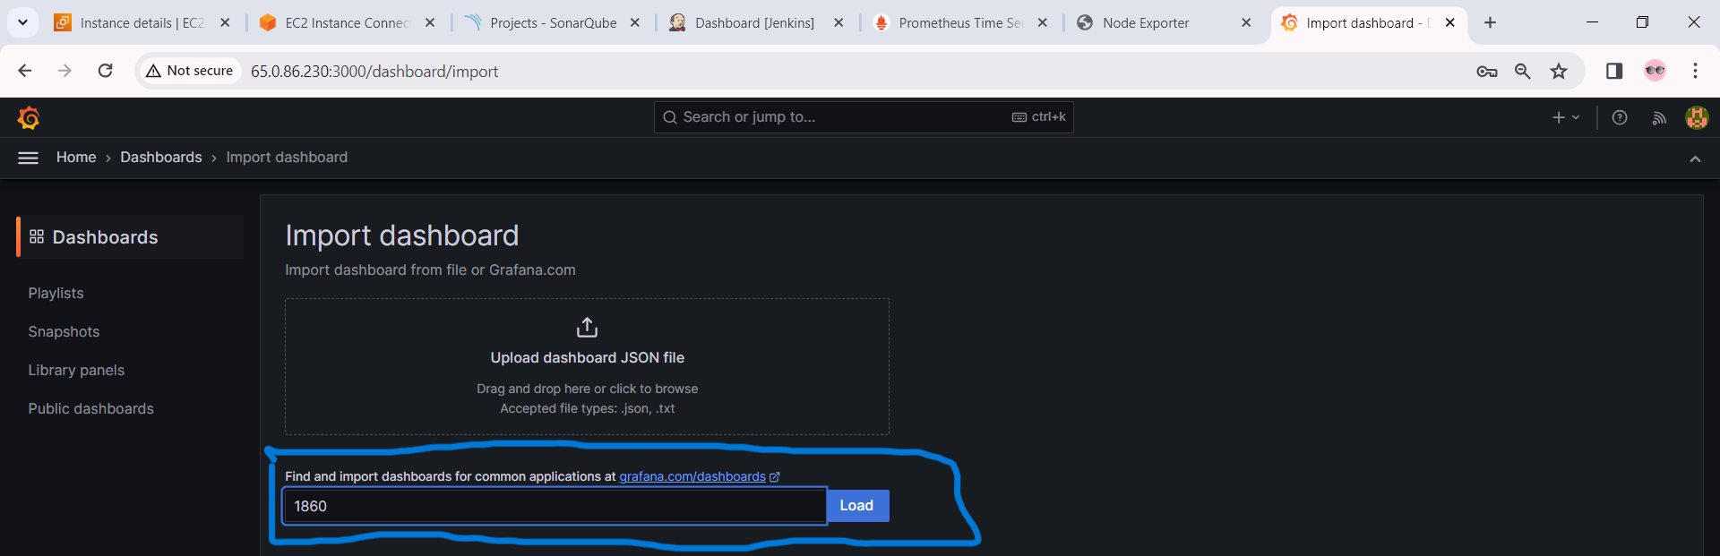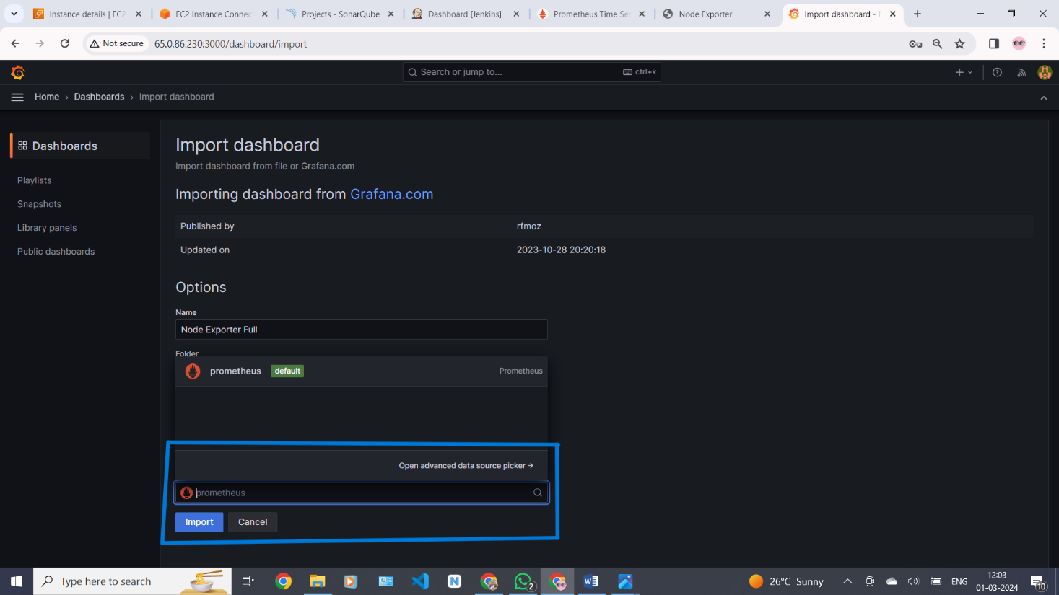

You will see this output of grafana .

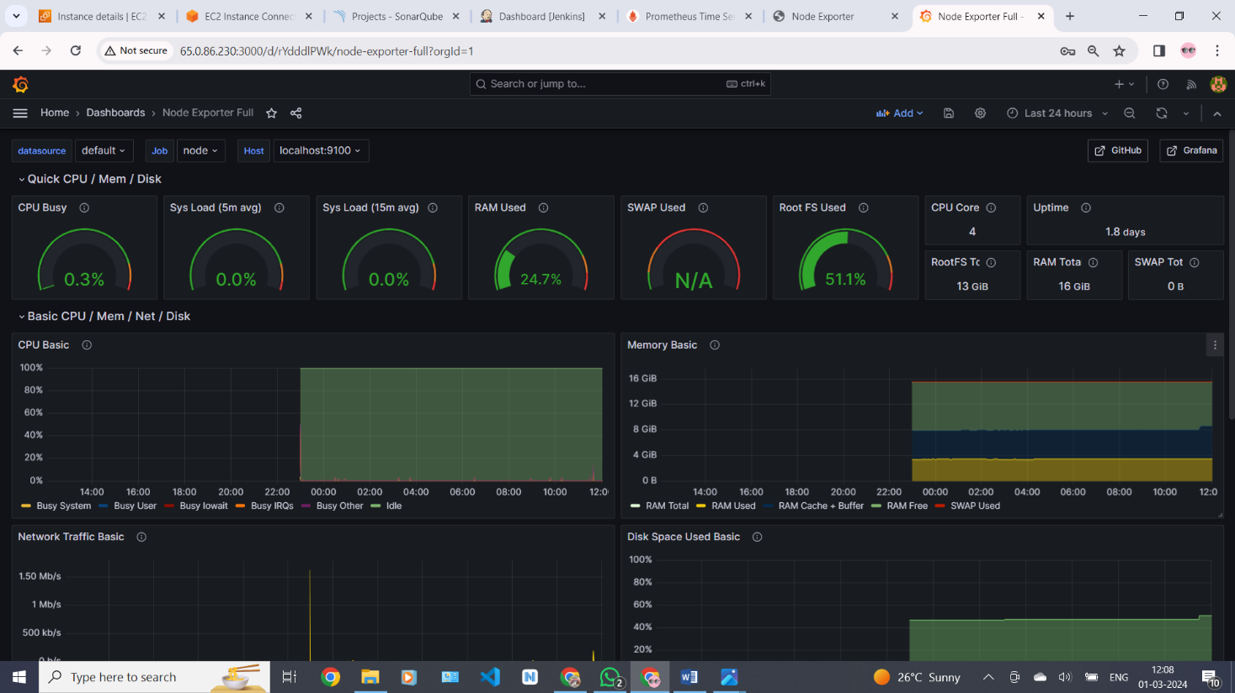

### Install the Prometheus Plugin and Integrate it with the Prometheus server

Let’s Monitor JENKINS SYSTEM

Need Jenkins up and running machine

Goto Manage Jenkins –> Plugins –> Available Plugins

Search for Prometheus and install it

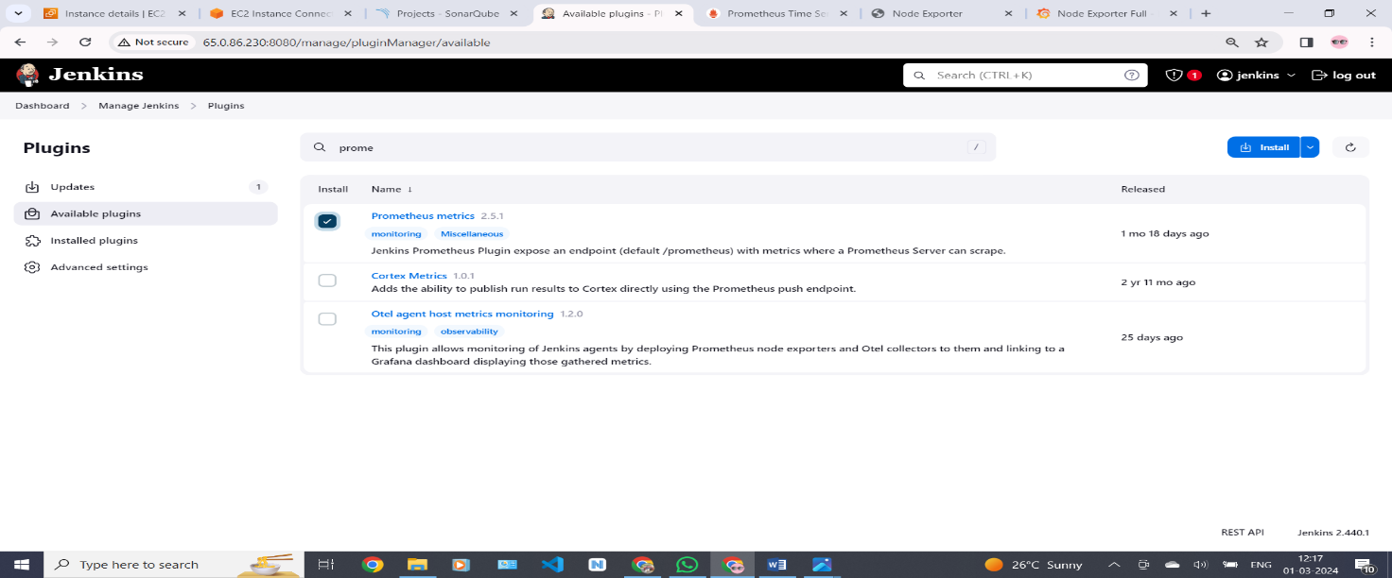

Now check weather Prometheus pluggin is installed or not . for that go to the path jenkins dashboard > manage Jenkins > system go down and we can see the prometheus here . then save no need to change anything

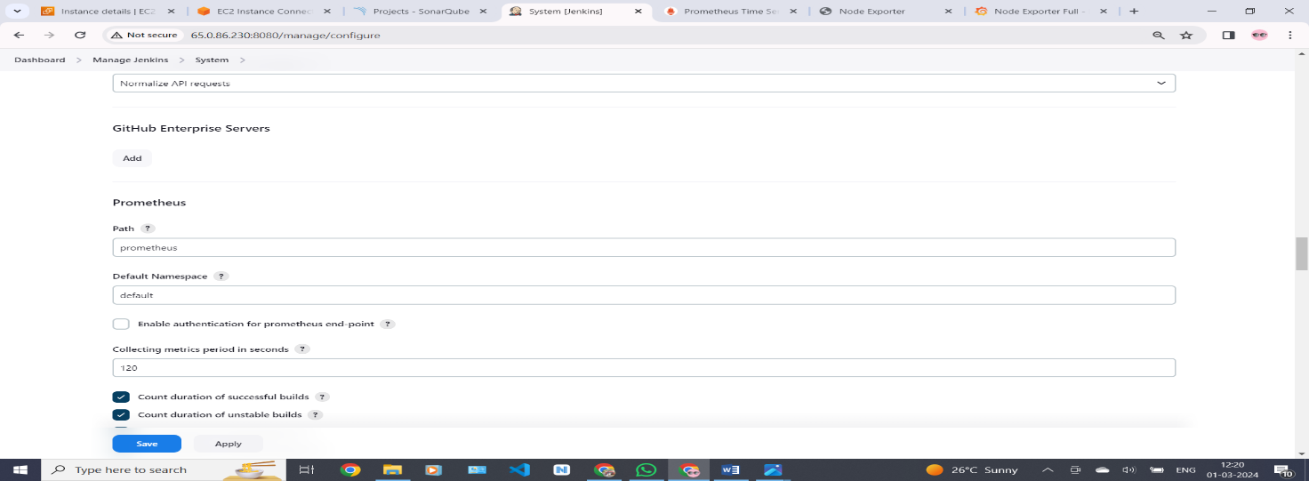

To create a static target, you need to add job_name with static_configs. go to Prometheus server

#sudo vim /etc/prometheus/prometheus.yml

Paste below code

|  |
| --- |
| - job_name: 'jenkins'  metrics_path: '/prometheus'  static_configs:  - targets: ['<jenkins-ip>:8080'] |

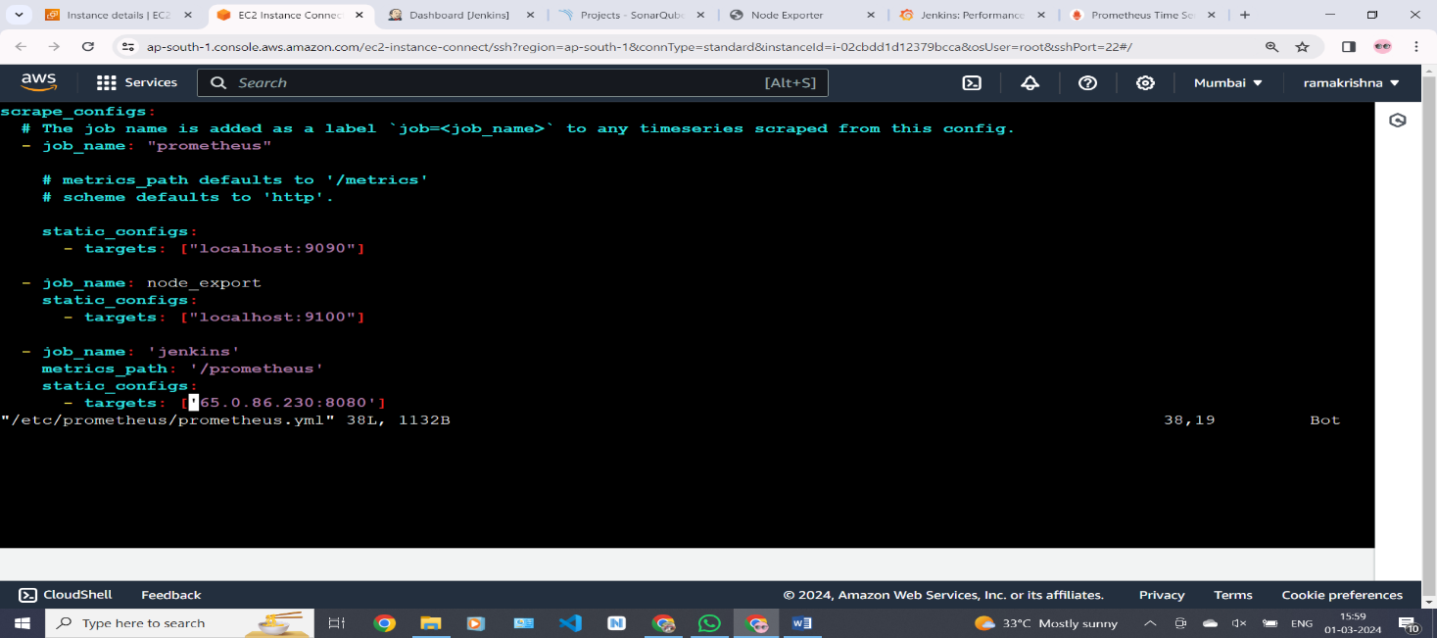

Before, restarting check if the config is valid

. # promtool check config /etc/prometheus/prometheus.yml

Then, you can use a POST request to reload the config.

# curl -X POST http://localhost:9090

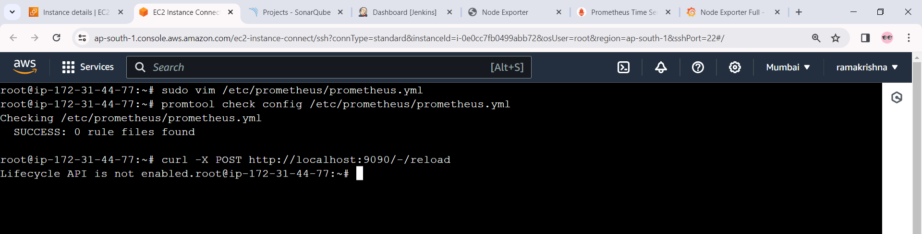

Now we are connected to the node-exporter to Jenkins . we can see in this bellow picture 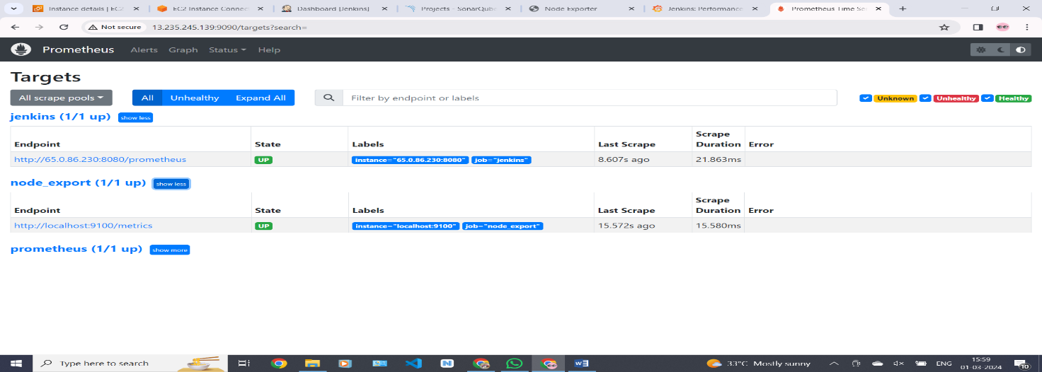

Select the data source and click on Import

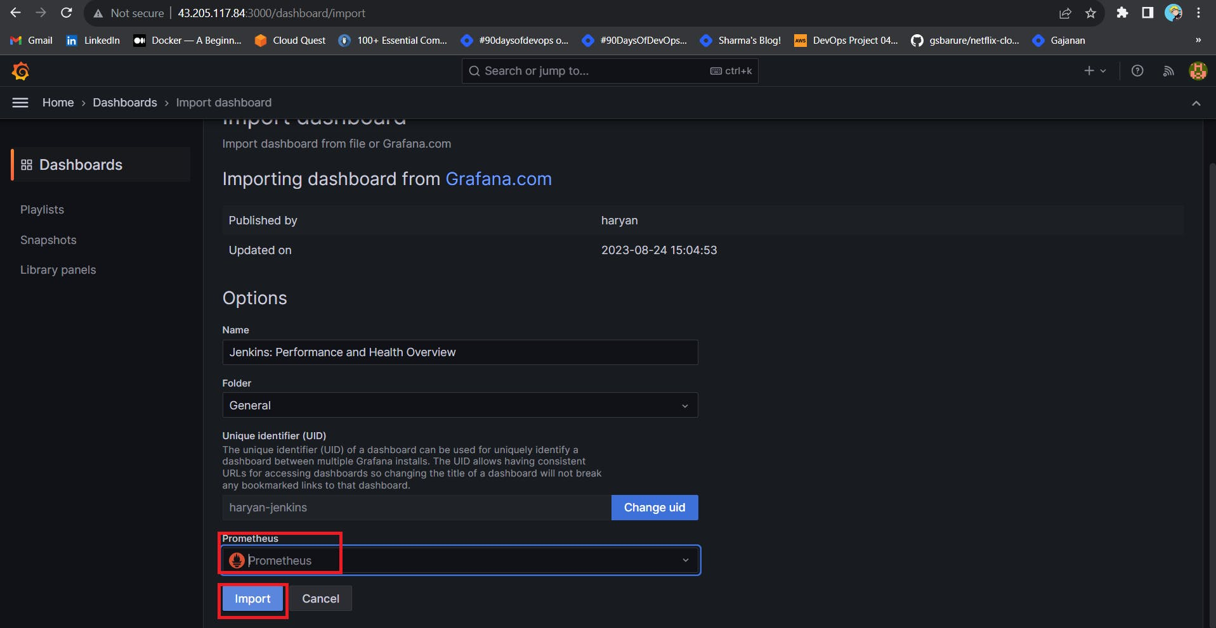

Now you will see the Detailed overview of Jenkins

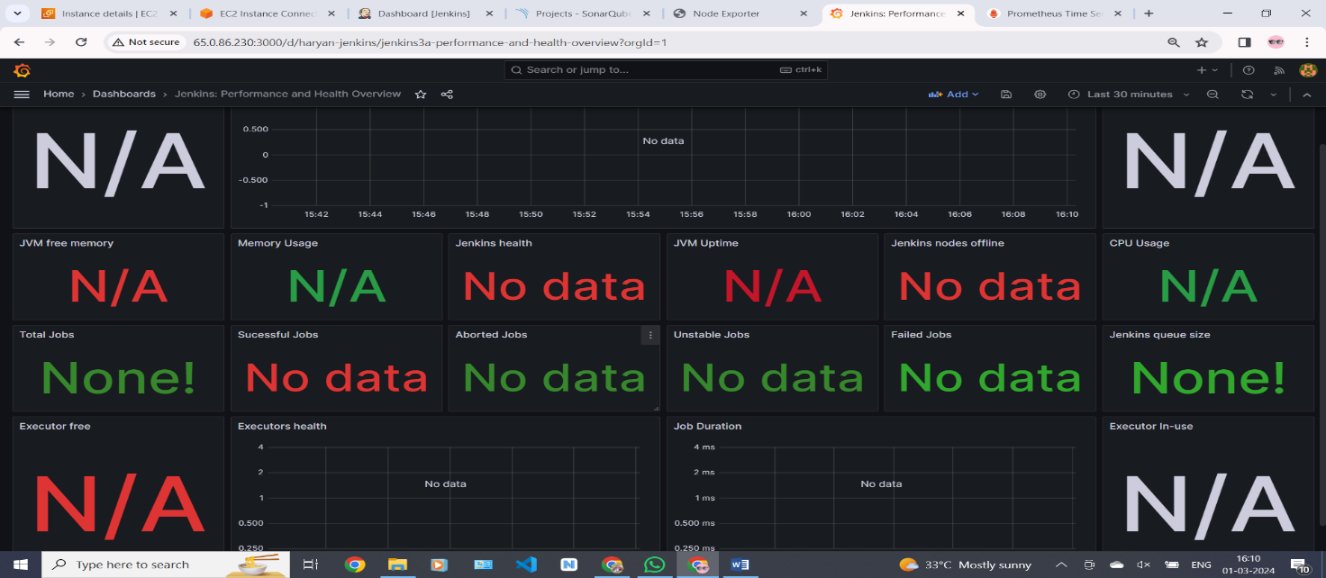

**Step 6 — Email Integration With Jenkins and Plugin Setup . install Email Extension Plugin in Jenkins**

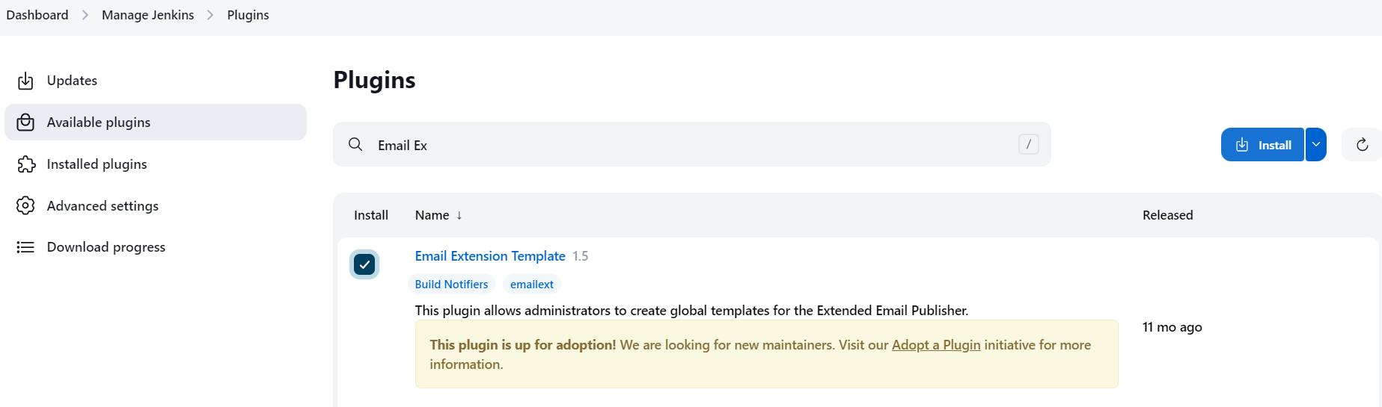s

Go to your Gmail and click on your profile

Then click on Manage Your Google Account –> click on the security tab on the left side panel you will get this page(provide mail password).

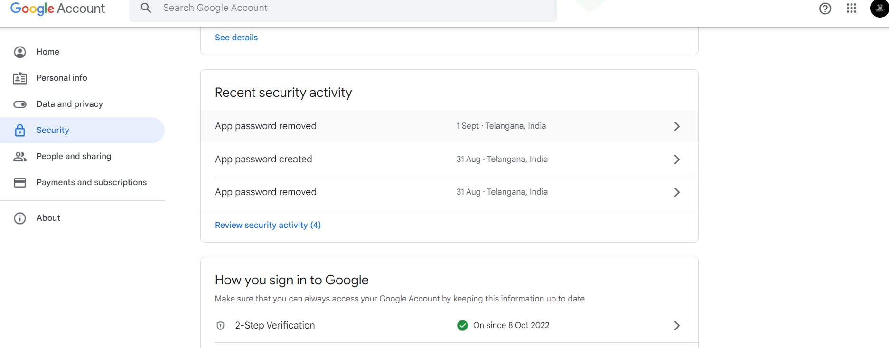

2-step verification should be enabled.

Search for the app in the search bar you will get app passwords like the below image

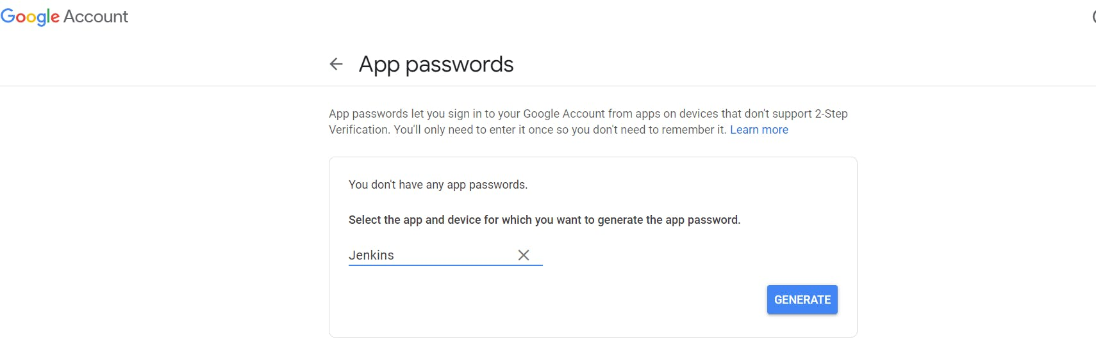

Click on other and provide your name and click on Generate and copy the password

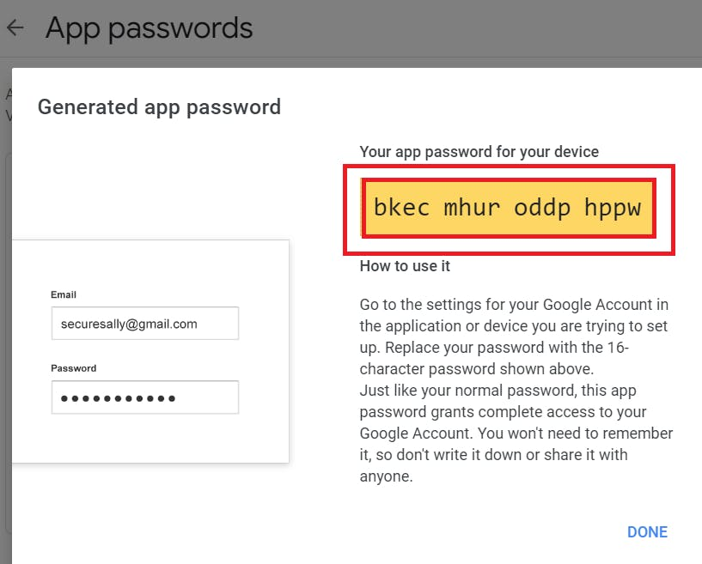

In the new update, you will get a password like this

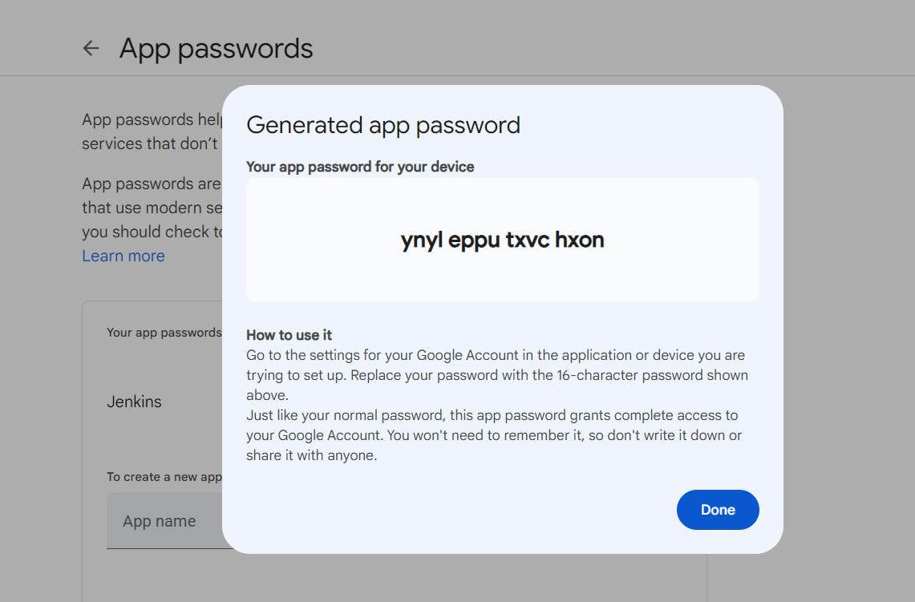

Once the plugin is installed in Jenkins, click on manage Jenkins –> configure system there under the E-mail Notification section configure the details as shown in the below image

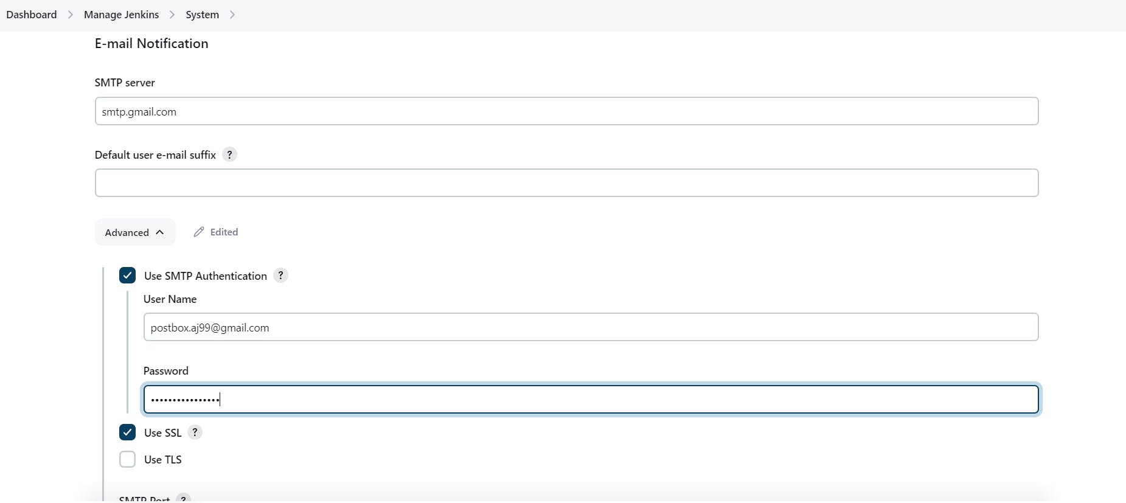

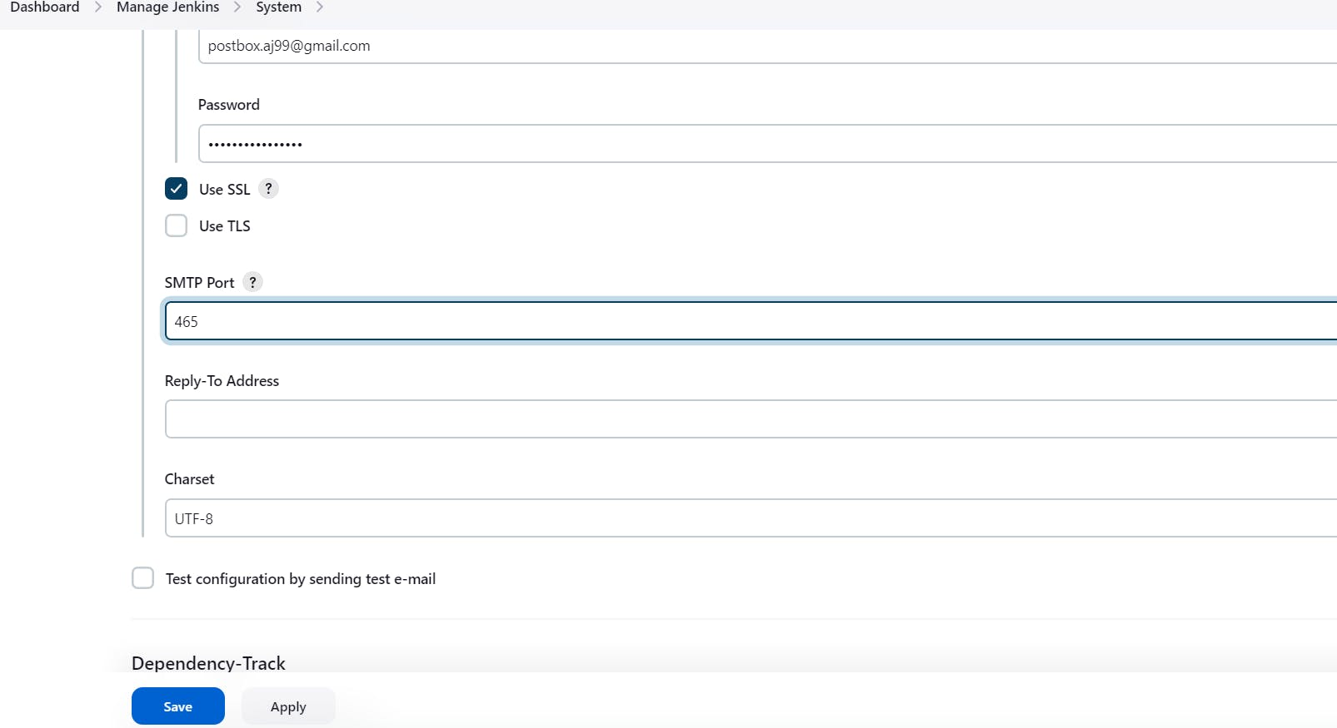

Click on Apply and save.

Click on Manage Jenkins–> credentials and add your mail username and generated password

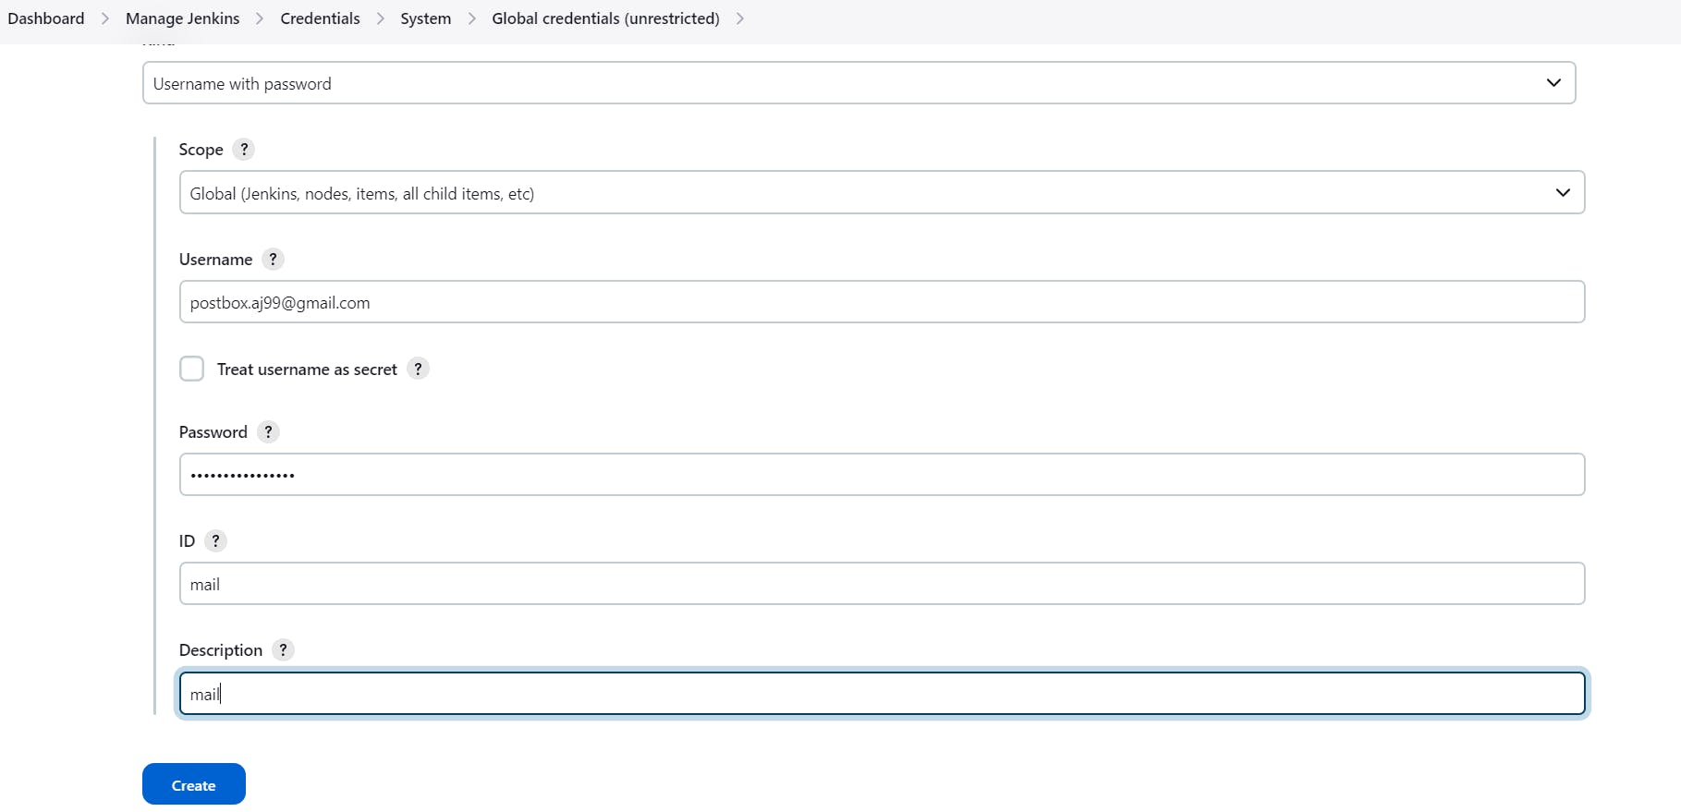

This is to just verify the mail configuration

Now under the Extended E-mail Notification section configure the details as shown in the below images

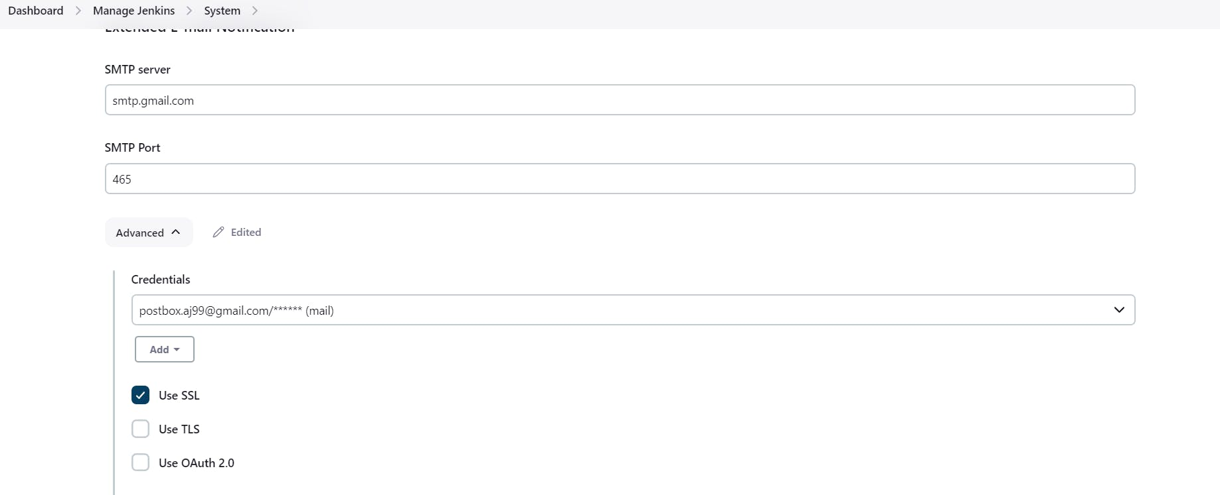

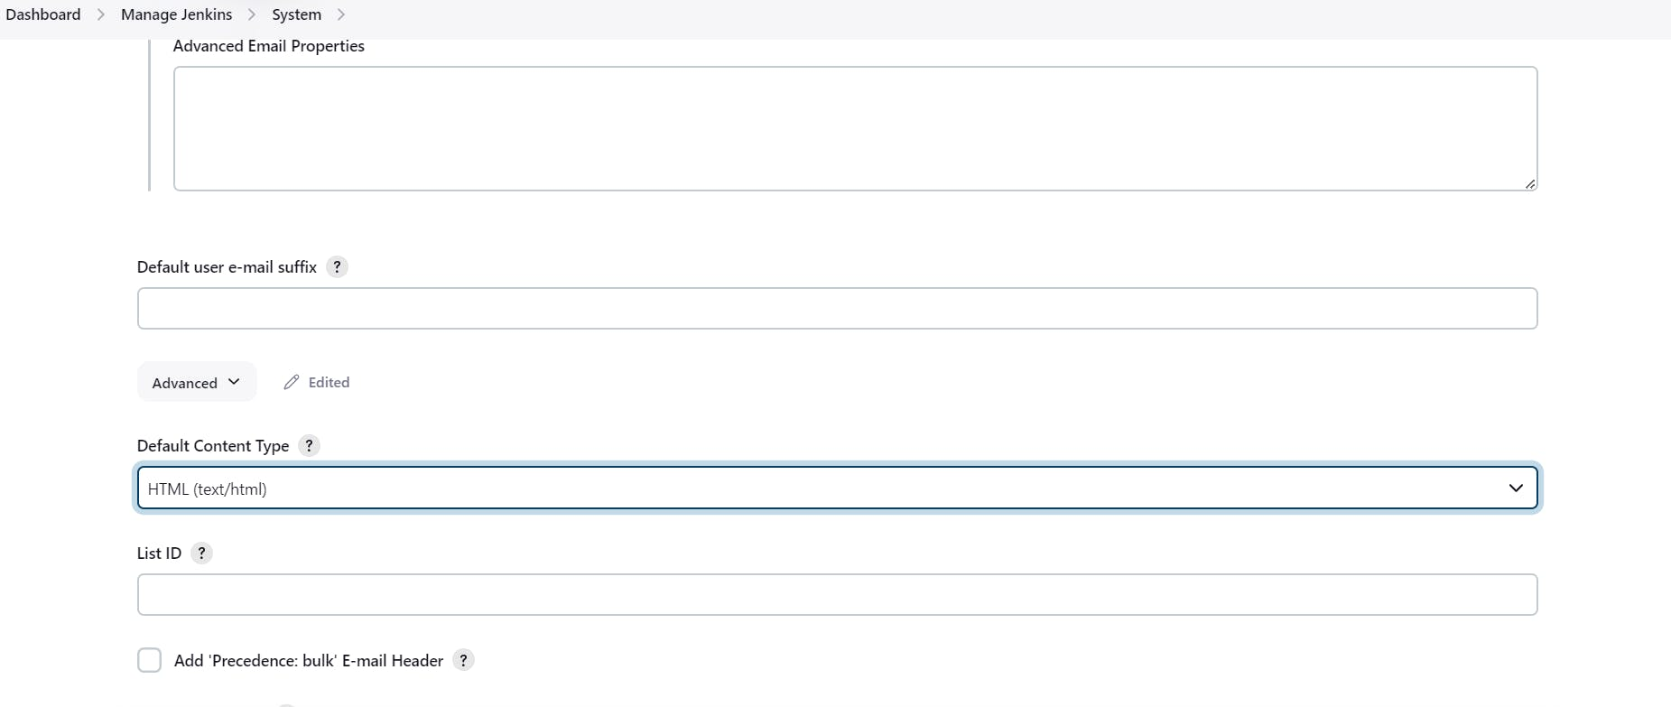

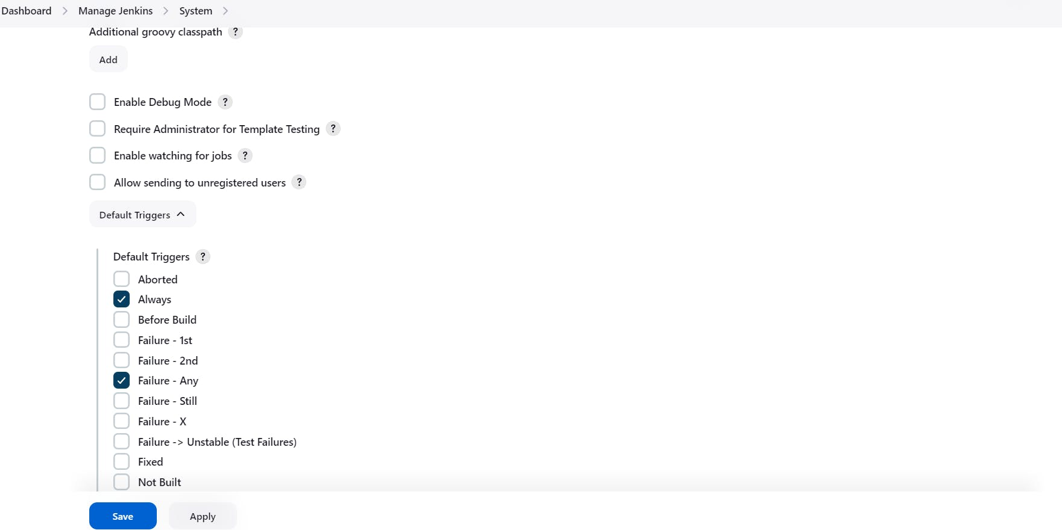

Click on Apply and save.

post {

always {

emailext attachLog: true,

subject: "'${currentBuild.result}'",

body: "Project: ${env.JOB_NAME}<br/>" +

"Build Number: ${env.BUILD_NUMBER}<br/>" +

"URL: ${env.BUILD_URL}<br/>",

to: 'postbox.aj99@gmail.com', #change Your mail

attachmentsPattern: 'trivyfs.txt,trivyimage.txt'

}

}

Next, we will log in to Jenkins and start to configure our Pipeline in Jenkins

## **Step 7 — Install Plugins like JDK, Sonarqube Scanner, NodeJs, OWASP Dependency Check**

### ****7A — Install Plugin****

Goto Manage Jenkins →Plugins → Available Plugins →

Install below plugins

1 → Eclipse Temurin Installer (Install without restart)

2 → SonarQube Scanner (Install without restart)

3 → NodeJs Plugin (Install Without restart)

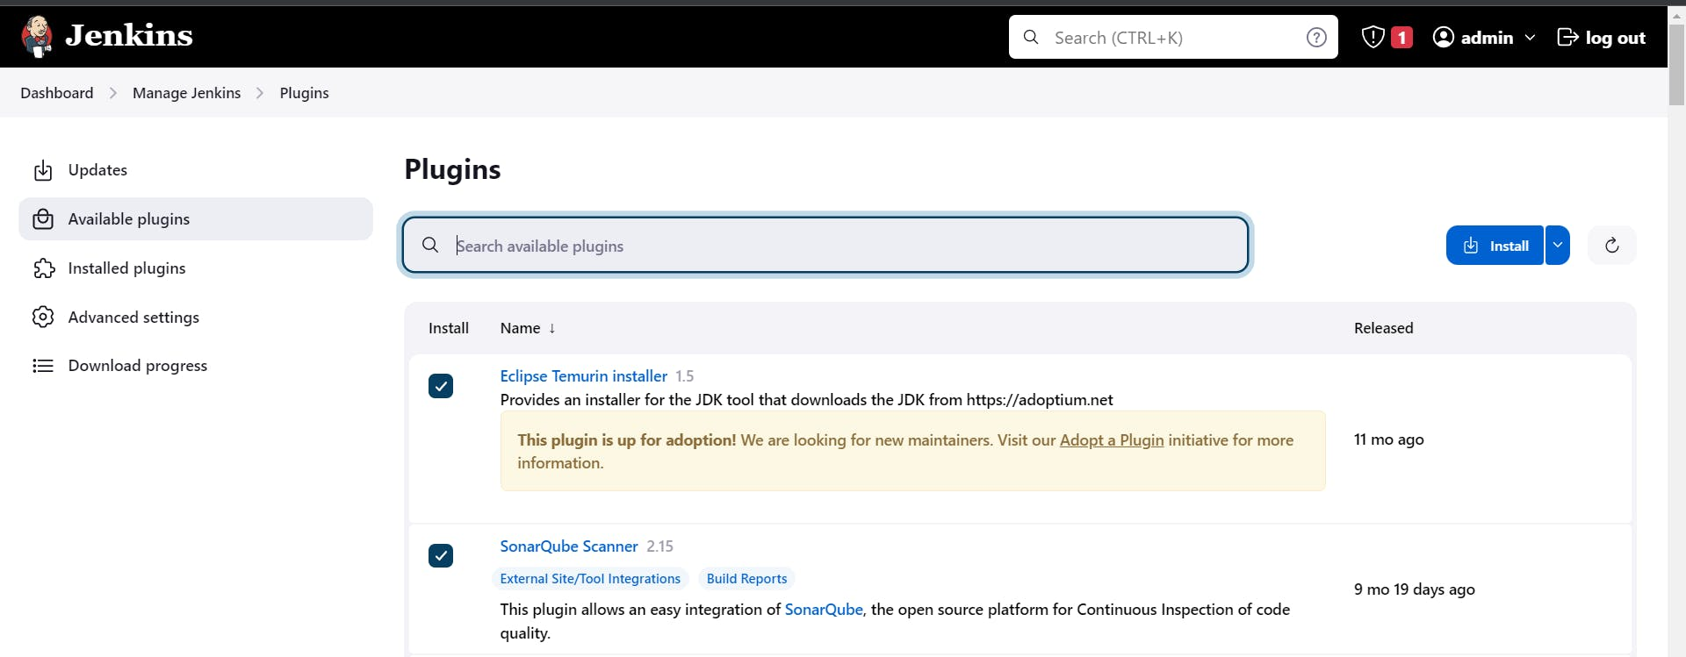

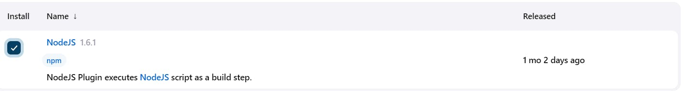

### ****7B — Configure Java and Nodejs in Global Tool Configuration****

Goto Manage Jenkins → Tools → Install JDK(17) and NodeJs(16)→ Click on Apply and Save

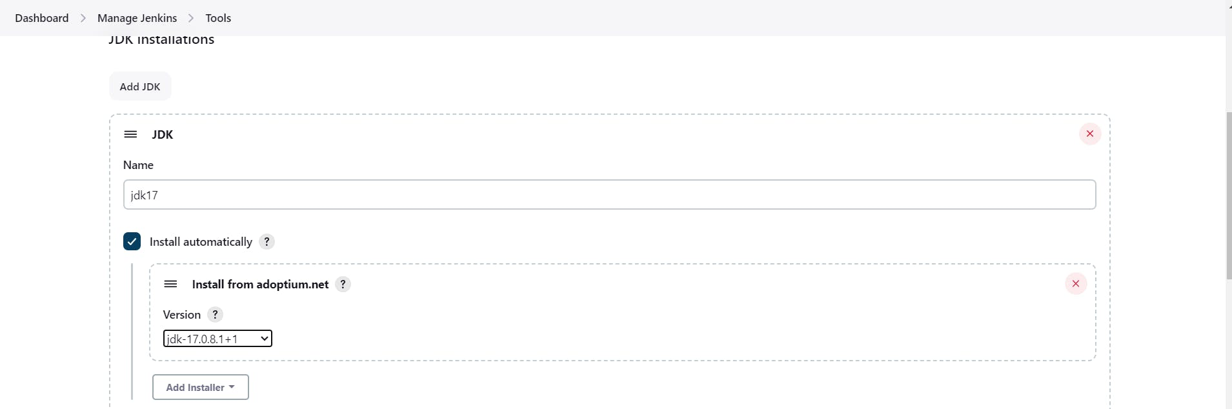

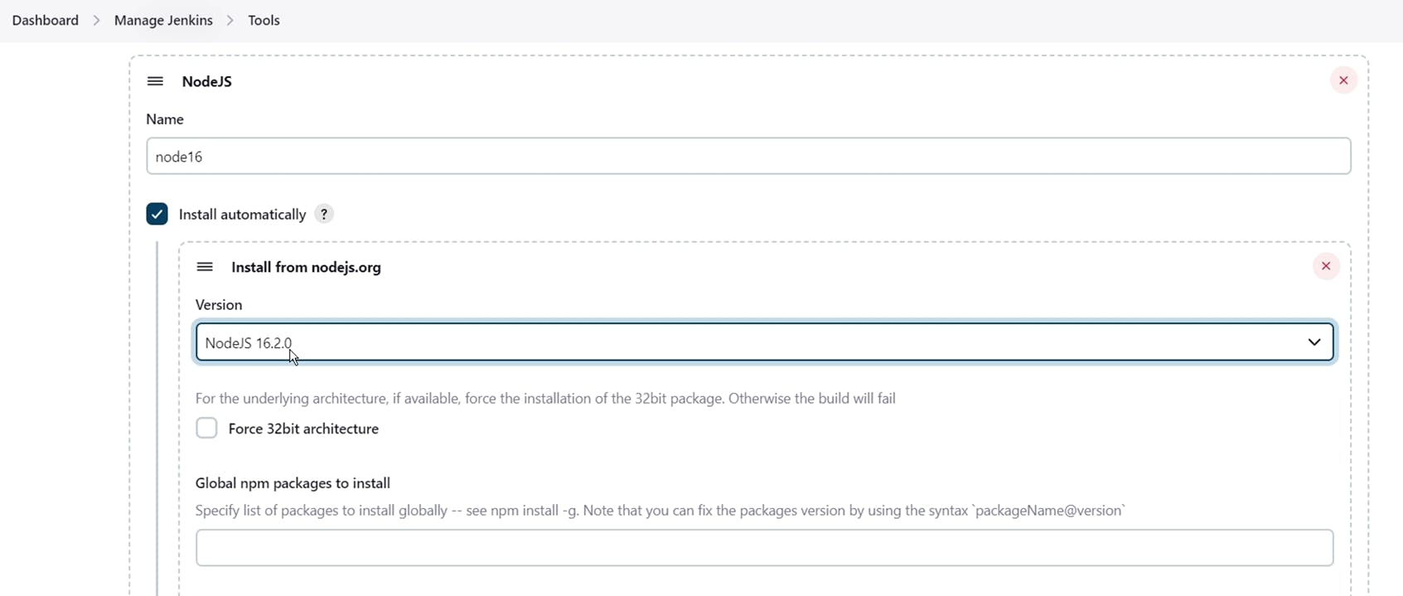

### ****7C — Create a Job****

create a job as Netflix Name, select pipeline and click on ok.

## **Step 8 — Configure Sonar Server in Manage Jenkins**

Grab the Public IP Address of your EC2 Instance, Sonarqube works on Port 9000, so <Public IP>:9000. Goto your Sonarqube Server. Click on Administration → Security → Users → Click on Tokens and Update Token → Give it a name → and click on Generate Token

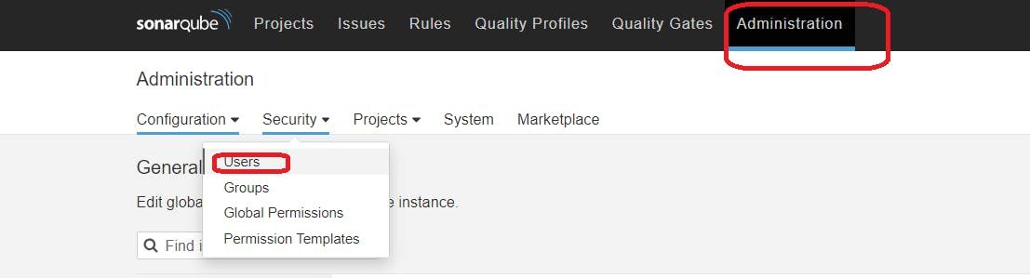

click on update Token

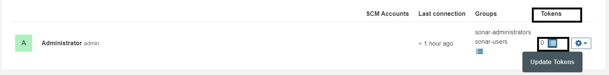

Create a token with a name and generate

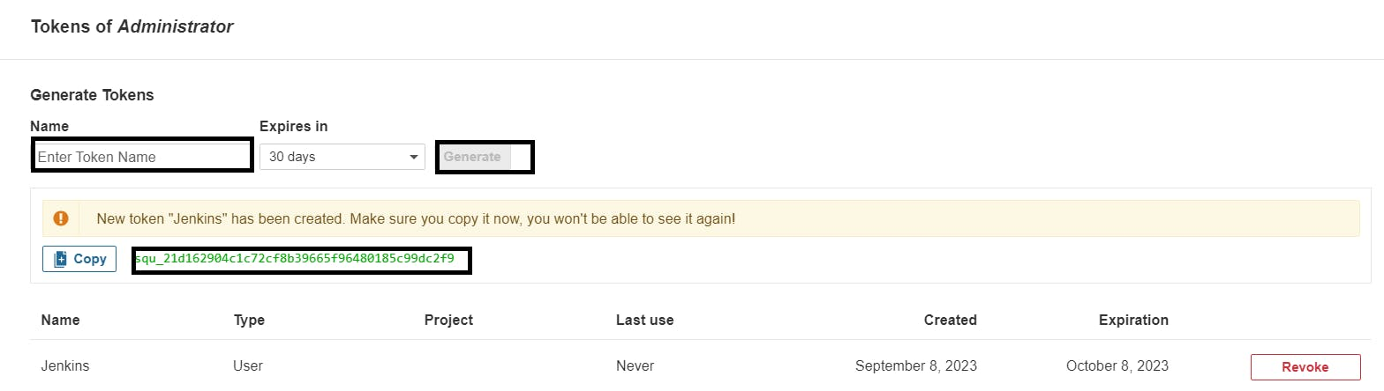

copy Token

Goto Jenkins Dashboard → Manage Jenkins → Credentials → Add Secret Text. It should look like this

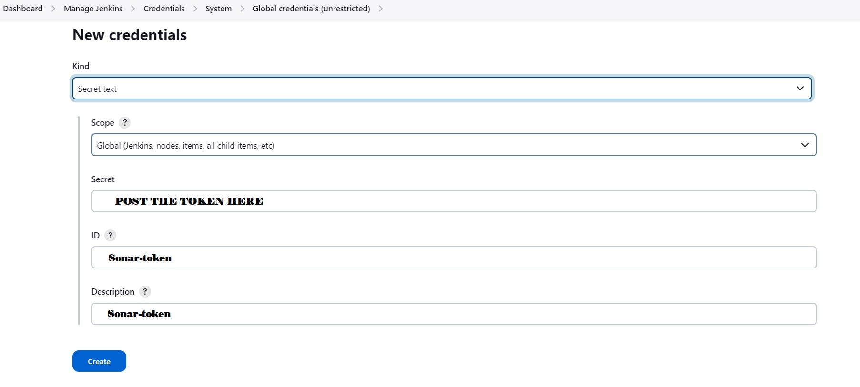

You will this page once you click on create

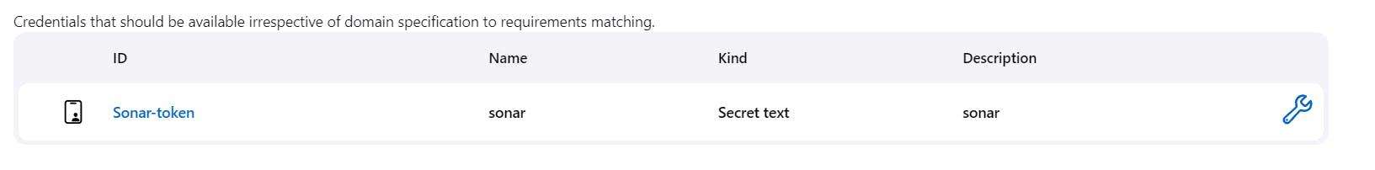

Now, go to Dashboard → Manage Jenkins → System and Add like the below image.

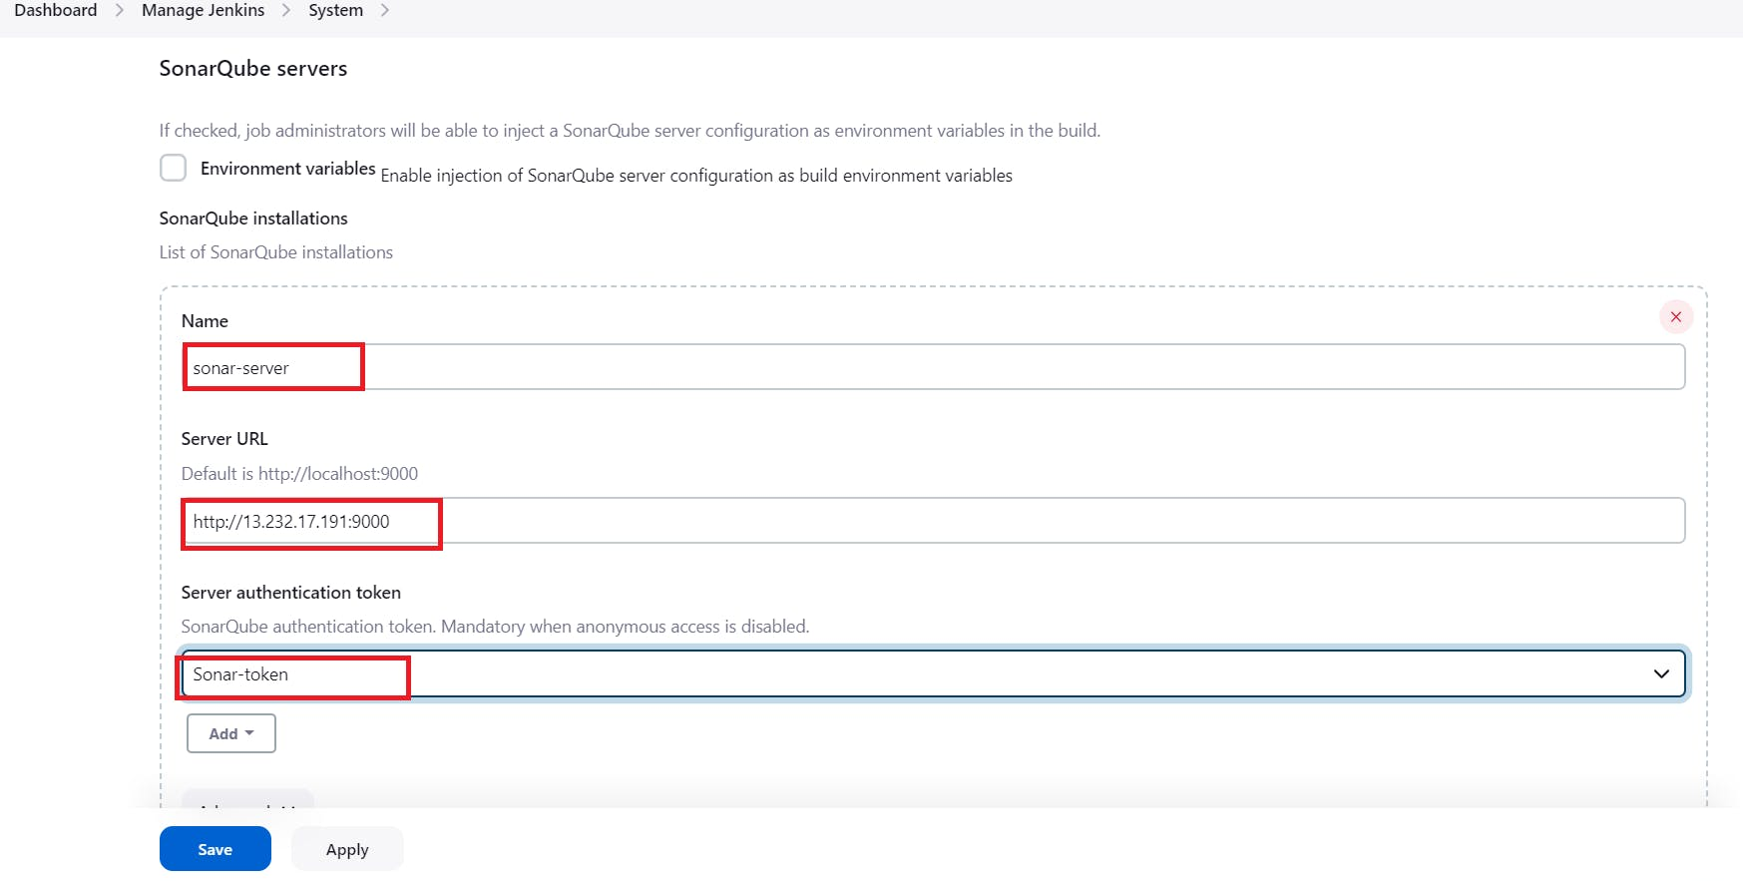

Click on Apply and Save

**The Configure System option** is used in Jenkins to configure different server

**Global Tool Configuration** is used to configure different tools that we install using Plugins

We will install a sonar scanner in the tools.

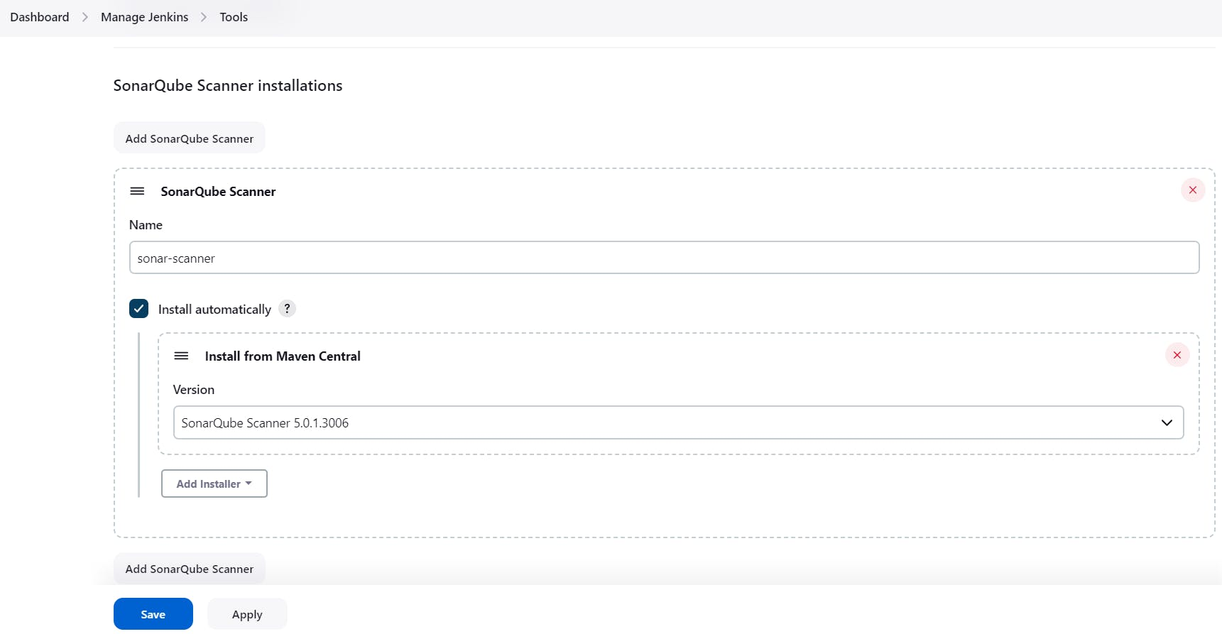

In the Sonarqube Dashboard add a quality gate also

Administration–> Configuration–>Webhooks

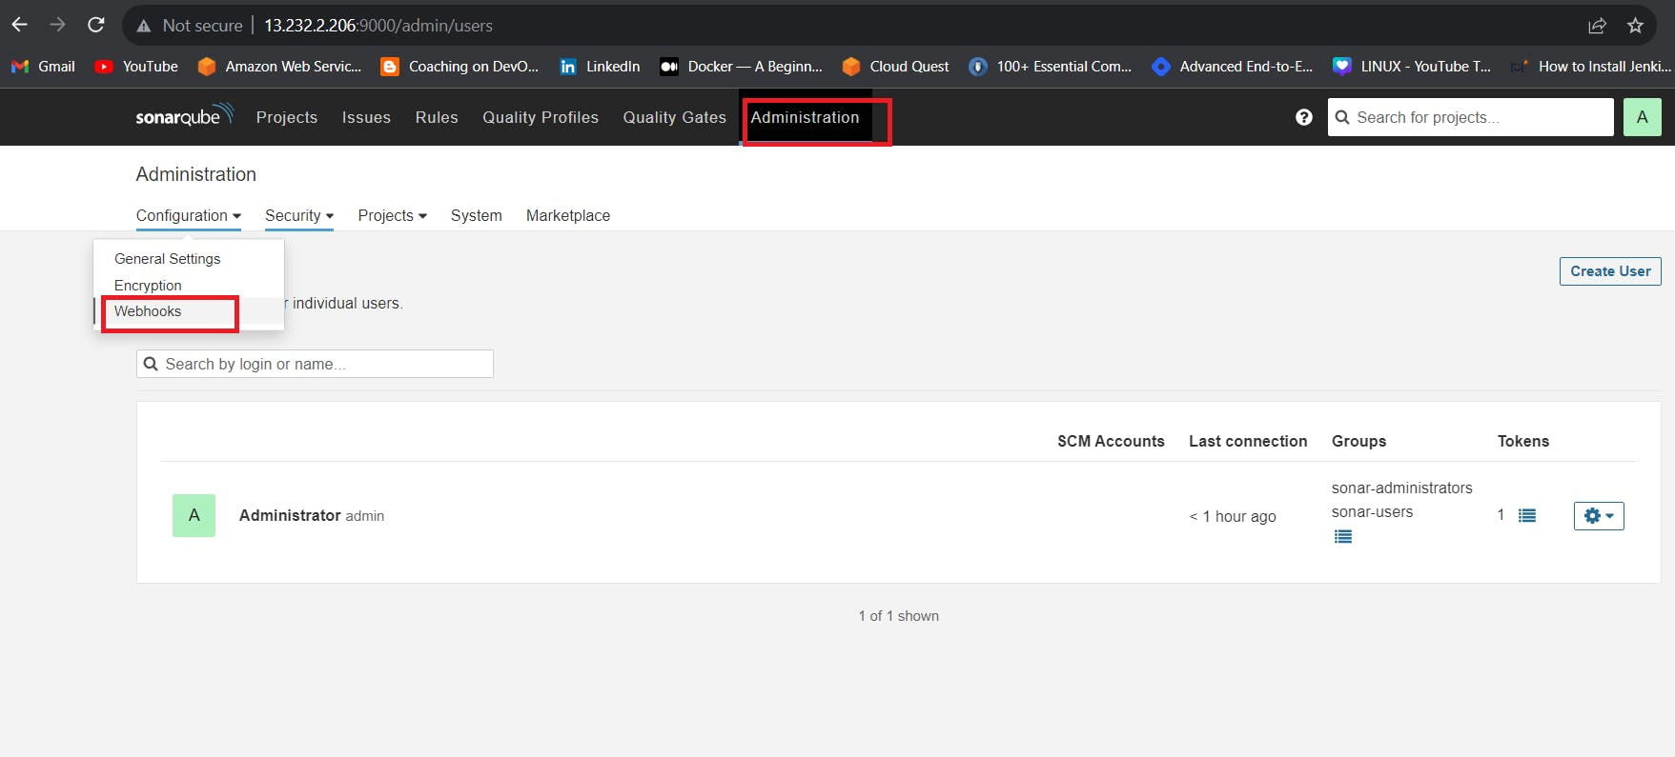

Click on Create

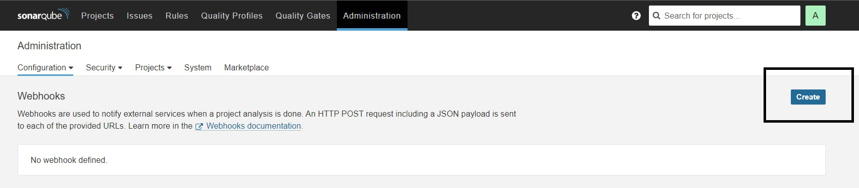

Add details

#in url section of quality gate

<http://jenkins-public-ip:8080>/sonarqube-webhook/

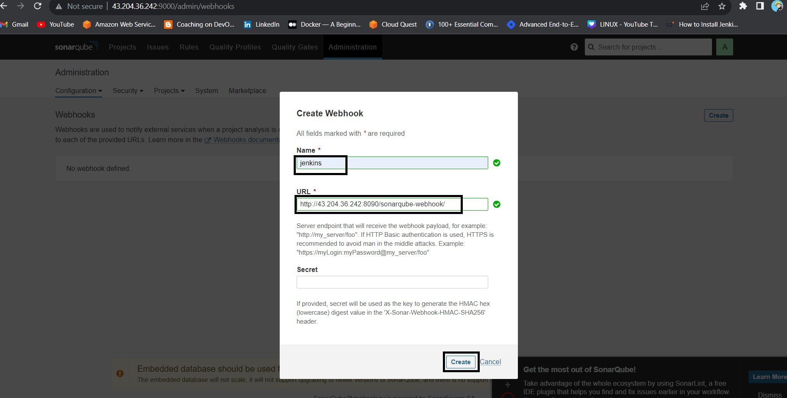

pipeline {

agent any

tools{

jdk 'jdk17'

nodejs 'node16'

}

environment {

SCANNER_HOME=tool 'sonar-scanner'

docker_image_name = "raja"

docker_image_tag = "v1.0.0"

container_name="raja"

}

stages{

stage('clean workspace'){

steps{

cleanWs()

}

}

stage('checkout'){

steps{

checkout scmGit(branches: [[name: '*/main']], extensions: [], userRemoteConfigs: [[url: 'https://github.com/Ravitejasetti/Netflix-clone.git']])

}

}

stage('sonarqube analysis'){

steps{

withSonarQubeEnv('sonar-scanner') {

sh ''' $SCANNER_HOME/bin/sonar-scanner -Dsonar.projectName=netflix \

-Dsonar.projectKey=netflix '''

}

}

}

stage('Install Dependencies') {

steps {

sh "npm install"

}

}

stage('depency check'){

steps{

dependencyCheck additionalArguments: '', odcInstallation: 'Dp-check'

dependencyCheckPublisher pattern: '**/dependency-check-report.xml'

}

}

stage('docker build and push') {

steps {

script{

withDockerRegistry(credentialsId: 'docker-cred', toolName: 'Docker') {

sh"docker stop raja"

sh"docker rm raja"

sh "docker build -t raja223344/raja5:v1.0.0 ."

sh "docker run --name ${container_name} -d -p 8088:8080 raja223344/raja5:v1.0.0"

sh "docker push raja223344/raja5:v1.0.0"

}

}

}

}

stage("TRIVY"){

steps{

sh "trivy image raja223344/raja5:v1.0.0 > trivyimage.txt"

}

}

stage('Deploy to container'){

steps{

sh 'docker run -d --name ravinetflix -p 8086:80 raja223344/raja5:v1.0.0'

}

}

}

post {

always {

emailext body: '''"Project: ${env.JOB_NAME}<br/>" +

"Build Number: ${env.BUILD_NUMBER}<br/>" +

"URL: ${env.Bhttp://65.0.86.230:8080/job/netflix/26/console}<br/>"''', subject: 'this is the project build trigger result', to: 'raviteja.setti@gmail.com'

}

}

}

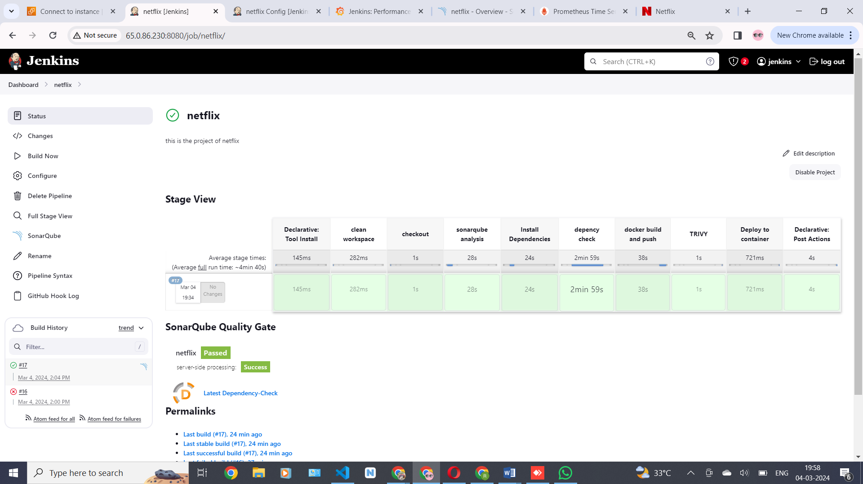

Open with <Jenkins public –ip-address: 8086>

We can see this output

